|  |
| --- |
|  |

|  |
| --- |
| **E:\My Documents\Desktop\Logo_FPT_University_doc.jpgMinistry of education and training** |
| Capstone Project Document |
| Thanh Long Company Business Management System |
|  |
| |  |  | | --- | --- | | **TLS Team** | | | **Group Members** | Nguyễn Tiến Khiêm – 01031  Nguyễn Minh Đức – 01214  Nguyễn Minh Sơn – 01189  Nguyễn Mạnh Linh – 01264  Ngô Văn Thắng – 00978 | | **Supervisor** | Mr. Phan Trường Lâm | | **Ext Supervisor** |  | | **Capstone Project code** | **TLS\_v1.0** | |
| **Hanoi, 18ndDec, 2012** |
| Table of Contents  [A. Introduction 5](#_Toc343785184)  [1. Introduction 5](#_Toc343785185)  [1.1 Project information 5](#_Toc343785186)  [1.2 Purpose 5](#_Toc343785187)  [1.3 Background 5](#_Toc343785188)  [2. Literature review 5](#_Toc343785189)  [3. Proposal 9](#_Toc343785190)  [3.1 Initial idea 9](#_Toc343785191)  [3.2 Main function 9](#_Toc343785192)  [B. Software Project Management Plan 10](#_Toc343785193)  [1. Problem definition 10](#_Toc343785194)  [1.1 Name of this capstone project 10](#_Toc343785195)  [1.2 Boundaries of the system 10](#_Toc343785196)  [1.3 Development environment 10](#_Toc343785197)  [2. Project organization 11](#_Toc343785198)  [2.1 Software process model 11](#_Toc343785199)  [2.2 Role and responsibilities 12](#_Toc343785200)  [2.3 Tool and techniques 14](#_Toc343785201)  [2.3.1 Tools 14](#_Toc343785202)  [2.3.2 Techniques 14](#_Toc343785203)  [3. Project management plan 15](#_Toc343785204)  [3.1 Tasks & Task Sheet: Assignments and timetable 15](#_Toc343785205)  [3.2 Meeting minutes 18](#_Toc343785206)  [4. Coding Convention 18](#_Toc343785207)  [4.1 Purpose 18](#_Toc343785208)  [4.2 Naming Convention 19](#_Toc343785209)  [4.3 Coding Style 19](#_Toc343785210)  [4.4 Comment Style 19](#_Toc343785211)  [5. Risk management plan 19](#_Toc343785212)  [6. Project success criteria 20](#_Toc343785213)  [C. Software Requirement Specifications 21](#_Toc343785214)  [1. User Requirement Specification 21](#_Toc343785215)  [1.1. Administrator requirements. 21](#_Toc343785216)  [1.2. Director. 21](#_Toc343785217)  [1.3. Human Resource Manager. 21](#_Toc343785218)  [1.4. Project Manager. 21](#_Toc343785219)  [1.5. Operator. 22](#_Toc343785220)  [2. System Requirement Specification 22](#_Toc343785221)  [2.1. External Interface Requirements 22](#_Toc343785222)  [2.2. System Features 22](#_Toc343785223)  [3. Software System Attributes 73](#_Toc343785224)  [3.1. Usability 73](#_Toc343785225)  [3.2. Availability 73](#_Toc343785226)  [3.3. Security 73](#_Toc343785227)  [3.4. Maintainability 74](#_Toc343785228)  [3.5. Performance 74](#_Toc343785229)  [3.6. Reliability 74](#_Toc343785230)  [D. Software Design Description 75](#_Toc343785231)  [1. Design Overview 75](#_Toc343785232)  [2. System Architectural Design 75](#_Toc343785233)  [2.1. Overall System Architecture 75](#_Toc343785234)  [2.2. Web Application Architecture 76](#_Toc343785235)  [3. Detailed Design 78](#_Toc343785236)  [3.1. <Human Resource Manager> Staff Management 78](#_Toc343785237)  [3.2. <Human Resource Manager> Specialization management 79](#_Toc343785238)  [3.3. <Human Resource Manager> Project Staff Management 80](#_Toc343785239)  [3.4. <Admin> Account Management 81](#_Toc343785240)  [3.5. <Admin> Project Space Management 82](#_Toc343785241)  [3.6. <Director> Project Management 84](#_Toc343785242)  [3.7. <Director> Project Report Management 85](#_Toc343785243)  [3.8. <Project Management> Project Plan Management 86](#_Toc343785244)  [3.9. <Project Management> Daily report Management 88](#_Toc343785245)  [3.10. <Operator> Daily report Management 90](#_Toc343785246)  [3.11. <Operator> Project Task Management 91](#_Toc343785247)  [3.12. Message Management 92](#_Toc343785248)  [3.13. Document Management 93](#_Toc343785249)  [4. Sequence Diagram 95](#_Toc343785250)  [4.1. Admin sequence diagram 95](#_Toc343785251)  [4.2. Director sequence diagram 97](#_Toc343785252)  [4.3. Human resource manager sequence diagram 99](#_Toc343785253)  [4.4. Project Manager Sequence diagram 100](#_Toc343785254)  [4.5. Operator sequence diagram 102](#_Toc343785255)  [5. User Interface Design 103](#_Toc343785256)  [5.1. Login Screen 103](#_Toc343785257)  [5.2. View list of account screen 103](#_Toc343785258)  [5.3. Create new project space screen 104](#_Toc343785259)  [5.4. Create new an account screen. 105](#_Toc343785260)  [5.5. View list of project screen. 105](#_Toc343785261)  [5.6. View project plan screen. 106](#_Toc343785262)  [5.7. View list of project task screen. 106](#_Toc343785263)  [5.8. View list of daily report screen. 107](#_Toc343785264)  [5.9. Create new a daily report screen. 107](#_Toc343785265)  [6. Entity Relationship Diagram 108](#_Toc343785266)  [E. Software Test Documentation 109](#_Toc343785267)  [1. Introduction 109](#_Toc343785268)  [1.1 Documentation Overview 109](#_Toc343785269)  [1.2 Scope of Testing 109](#_Toc343785270)  [2. Test Plan 110](#_Toc343785271)  [2.1 Features to be tested 110](#_Toc343785272)  [2.2 Features not to be tested 113](#_Toc343785273)  [2.3 Testing Tools and Environments 113](#_Toc343785274)  [2.4 Resource 114](#_Toc343785275)  [3. Test Cases 115](#_Toc343785276)  [3.1 Administrator 115](#_Toc343785277)  [3.2 Director 121](#_Toc343785278)  [3.3 Human Resoure Manager 126](#_Toc343785279)  [3.4 Operator 131](#_Toc343785280)  [3.5 Project Manager 135](#_Toc343785281)  [4. Checklists 139](#_Toc343785282)  [4.1 Checklist of Validation 139](#_Toc343785283)  [4.2 Submission Checklist -2 142](#_Toc343785284)  [4.3 Test Cases 143](#_Toc343785285)  [5. Test Report 143](#_Toc343785286)  [5.1 Test Report 143](#_Toc343785287)  [F. Software User Manual 144](#_Toc343785288)  [1. Installation Guide 144](#_Toc343785289)  [1.1 Introduction 144](#_Toc343785290)  [1.2 Application installation 144](#_Toc343785291)  [1.2.1 Setup Google plugin for Eclipse 3.5 (Gailileo) 144](#_Toc343785292)  [1.2.2 Deploy website 146](#_Toc343785293)  [2. User Guide 149](#_Toc343785294)  [2.1 General guide 149](#_Toc343785295)  [2.1.1 Login 149](#_Toc343785296)  [2.1.2 Message Management 150](#_Toc343785297)  [2.1.3 Change password 152](#_Toc343785298)  [2.2 Administrator guide 153](#_Toc343785299)  [2.2.1 Admin home page 153](#_Toc343785300)  [2.2.2 Project space management 154](#_Toc343785301)  [2.2.3 Account management 155](#_Toc343785302)  [2.3 Project manager guide 156](#_Toc343785303)  [2.3.1 Project manager home page 156](#_Toc343785304)  [2.3.2 Project management 156](#_Toc343785305)  [2.3.3 Project report management 160](#_Toc343785306)  [2.3.4 Daily report management 161](#_Toc343785307)  [2.4 Director guide 163](#_Toc343785308)  [2.4.1 Director home page 163](#_Toc343785309)  [2.4.2 Project management 163](#_Toc343785310)  [2.4.3 Project report management 165](#_Toc343785311)  [2.4.4 Human resource request management 166](#_Toc343785312)  [2.5 Operator guide 168](#_Toc343785313)  [2.5.1 Operator home page 168](#_Toc343785314)  [2.5.2 Task management 168](#_Toc343785315)  [2.5.3 Create daily report 170](#_Toc343785316)  [2.6 Human resource manager guide 171](#_Toc343785317)  [2.6.1 Human resource manager home page 171](#_Toc343785318)  [2.6.2 Staff management 171](#_Toc343785319)  [2.6.3 Human resource management 173](#_Toc343785320)  [2.6.4 Add human resource to project 173](#_Toc343785321)  [G. Appendix 174](#_Toc343785322)  [1. Definitions and acronyms and abbreviation 174](#_Toc343785323)  [2. References 175](#_Toc343785324) |

# Introduction

# Introduction

## Project information

Project name: Thanh Long Company Business Management System

Project code: TLS

Product type: Website

Timeline: From September 9th 2012 to December 2012

## Purpose

This project is registered and implemented as a capstone project for the team members. The purpose of this project is to fulfill the requirements from FPT University studying program and make a system that can be traded. Besides, this is the change for us to research, study, and work together on a project.

## Background

Nodaway, most of construction projects that build transportation infrastructure such as electricity, roads, schools... are using a traditional method to manage most of project’s activity. While those projects often deployed in a long time and have to do a lot of work, so scope management is huge. With traditional management method, it is very difficult for manager to monitor and control all tasks of project. It is the main reason of making projects are delayed and behind schedule.

Derived from the actual needs, we need a tool to help managers to cover all work of project, and easier to manage project implement following project's plan such as budget, schedule, time, material.... That tool will provide a method make manager interact with actual of project and project’s staff tighter. And manager will know more detail about progress and status of project.

# Literature review

In Vietnam, project manager use slot of different tools to help them manage project task. Popular tool to support project manager are SmartBuild and Microsoft Project.

* **SmartBuild**: system has been developed by Hai Hoa Software Company. It is an integrated tool for construction contractors.

In addition to the usual features of project management software, SmartBuild:

* + - The software is designed specifically for construction projects in the continuous environmental changes.
    - A tool to help project managers operating synchronized planning, constantly, sticks to the objectives of the project.
    - Is one of the basic components of the enterprise resource planning system (ERP) for the contractors' construction and installation?

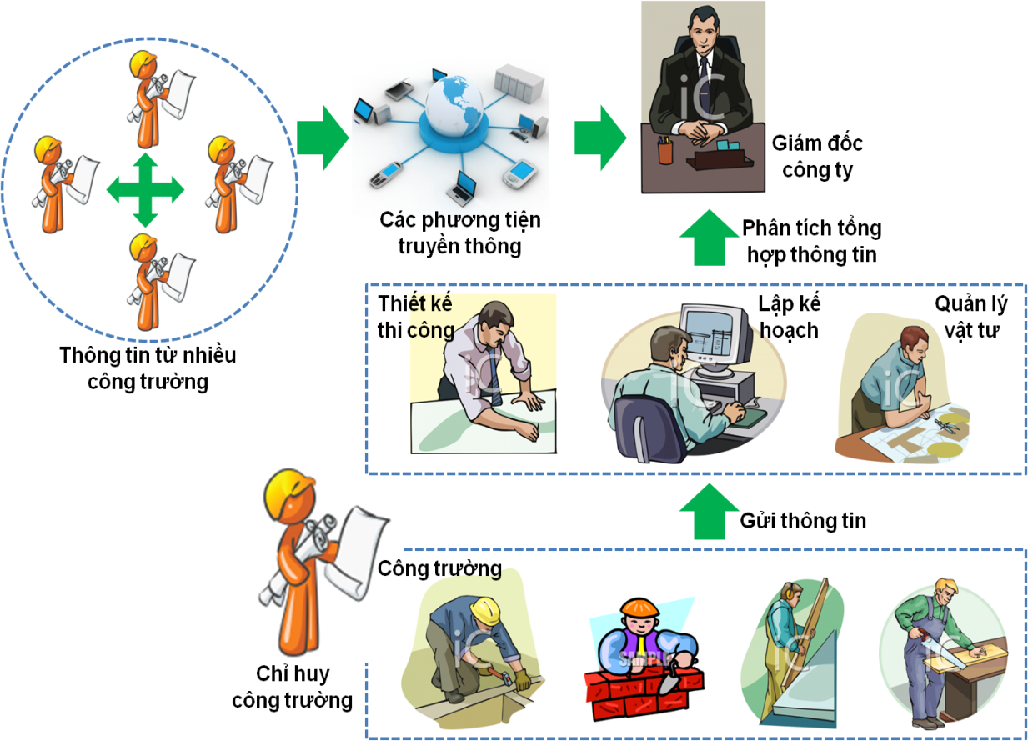

**Figure 1.1**: SmartBuild System Overview

* Some functions of SmartBuild help to manage work:
  + Construction plan
  + Human resource plan
  + Document plan
  + Update actual construction: Construction Diary, Executive jobs

**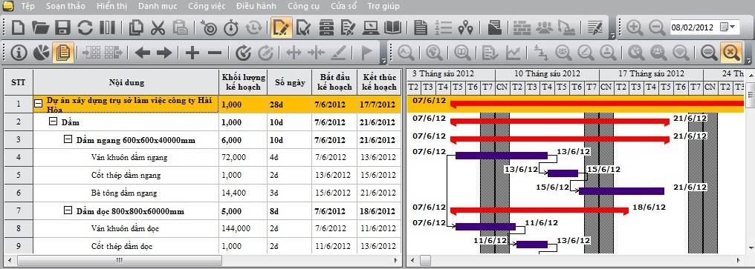**

**Figure 1.2**: Plans to use the materials

* **Microsoft Project:** 
  + Microsoft Project is the world's most popular project management software developed and sold by Microsoft. The application is designed to assist project managers in developing plans, assigning resources to tasks, tracking progress, managing budgets and analyzing workloads.
  + Microsoft Project creates critical path schedules, although critical chain third-party add-ons are available from Prochain and Spherical Angle. Schedules can be resource leveled. The chain is visualized in a Gantt chart.
  + Microsoft Project creates budgets based on assignment work and resource rates. As resources are assigned to tasks and assignment work estimated, Microsoft Project calculates the cost equals the work times the rate. This rolls up to the task level, then to any summary tasks and finally to the project level.
  + Microsoft Project has been extended with Microsoft Office Project Server and Microsoft Project Web Access. Project server stores Project data in a central database.

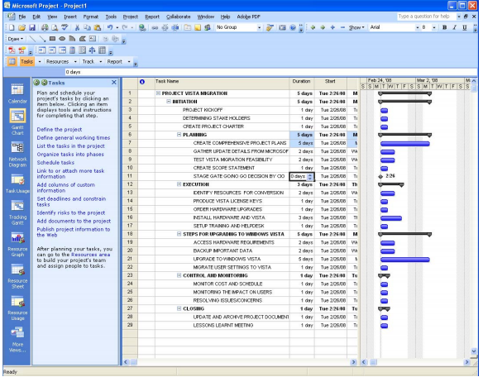

**Figure 1.3:** Filtering Tasks to show Milestones

* + - * Some functions of Microsoft Project
* Ability to create custom templates.
* Any change in the project plan or schedule highlights everything else that is affected.
* Analyze changes without actually committing them. Changes can also be done and undone programmatically, to automate analysis of different changes.
* Improved cost resource management and analysis for projects.
* Project data can be used to automatically create charts and diagrams in Microsoft Office Excel and Microsoft Office Visio, respectively.
* The project schedule can be managed as 3D [Gantt chart](http://en.wikipedia.org/wiki/Gantt_chart)
* Sharing project data with the help of SharePoint Services.

**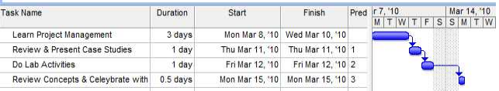**

**Figure 1.4:** Gantt View

**Conclusion:**

Both SmartBuilt and Microsoft Project are good software for project management. But they are desktop application, so they need a server computer and complex installation. In addition, a company has to spend a lot of money to buy license and maintain server. So, we can develop a web-based system with some features simpler and lower price. With the development of the construction industry, this will be an opportunity for us to work and study.

# Proposal

## Initial idea

Thanh Long is a construction company in Cao Bang. At present, the company is having some trouble on the issue of management of construction. Most of the activities of the company are used through the papers as management personnel, material management, employee cost .They have many difficulties in the process of work. By that reason, we decided to build a system that supports the management for the Thanh Long Company.

The system is developed based on Vietnamese language; it is friendly to user and easy to use. This will be a big advantage for the management. In addition; our products also integrate several functions such as materials management, equipment management …

## Main function

This system may have some main functions as following:

* **Project human resource management**
* **Manage Tasks.**
* **Materials management**
* **Equipment management**

We only have 3 months to complete project .Therefore, it very difficult to do all of the above functions. So, we will focus on two functions: project human resource management and manage project tasks.

# Software Project Management Plan

# Problem definition

## Name of this capstone project

The official name of this project is Thanh Long Company Business Management System (TLS) a system that allows managers to cover all work of project, and easier to manage project implement following project's plan. TLS system is specifically customized for Vietnamese market. The product name is TLS but it might be different once the project is completed and come to deployment.

## Boundaries of the system

Scope:

* Project human resource management
* Manage Project Tasks.

Future:

* Resolve all problems that we cannot finish on this project, such as: allow users manage materials, equipment and cost of project.

## Development environment

Below is the list of software and hardware requirement needed for development environment

***Software environment***

Operating system: Windows XP/Windows Vista/Windows 7

Browser: Mozilla Firefox 6.0.0 or later, Google Chrome

Runtime environment:

+ Java Development Toolkit

+Google apps engine

+Eclipse

***Hardware environment***

*Required (minimum) Specs*

CPU: Intel(R) Pentium(R) 4 2.4 GHz or better supported

RAM: 512MB RAM (768MB for Windows Vista/Win7)

Hard Drive: 2GB of free space

*Recommended Specs*

CPU: 2.0 GHz dual core or better supported

RAM: 1G for XP; 2G for Vista/ Win7

Hard Drive: 2GB of free space

# Project organization

## Software process model

In this project, we have chosen Waterfall development as software process model.

Waterfall is not new; it’s software development that proceeds sequentially through a series of phases, starting with system requirements analysis and leading up to product release and maintenance in software development. Feedback loops exist between each phase, so that as new information is uncovered or problems are discovered, it is possible to "go back" a phase and make appropriate modification. Progress "flows" from one stage to the next, much like the waterfall that gives the model its name.In general, the model may be considered as having six distinct phases, described below:

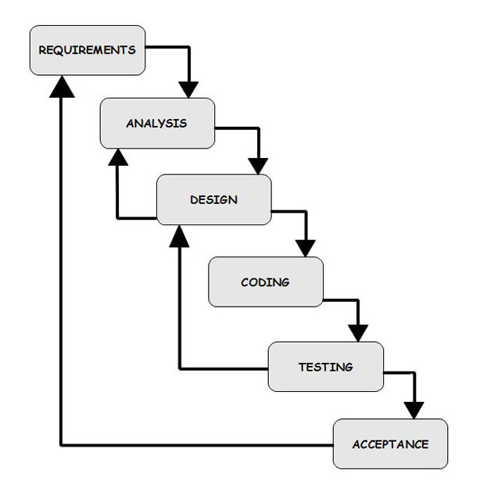

**Figure 2.1:** Waterfall process model

The waterfall model, as described above, offers numerous advantages for software developers.

* The staged development cycle enforces discipline: every phase has a defined start and end point, and progress can be conclusively identified (through the use of milestones).
* It's much easier to catch and correct possible flaws at the design stage than at the testing stage, after all the components have been integrated and tracking down specific errors is more complex.
* Finally, because the first two phases end in the production of a formal specification, the waterfall model can aid efficient knowledge transfer when team members are dispersed in different locations.

## Role and responsibilities

Developer

Analysis and design team

QA & Tester

DucNM

KhiemNT

KhiemNT

DucNM

LinhNM

SonNM

ThangNV

SonNM

Project Manager

DucNM

**Figure 2.2:** Project organization chart in TLS project

Below are brief responsibilities descriptions, skills of all members in TLS project.

|  |  |  |  |
| --- | --- | --- | --- |
| **No.** | **Name** | **Role** | **Responsibility** |
| **1** | Nguyễn Minh Đức | PM, Developer and Designer | 1. Manage project progress 2. Controlling and solving issues(Resource, productivity, progress) 3. Coding some module 4. Control team working progress and report to manager 5. Study requirement and Design Documents 6. Manage the test result and test progress of the team 7. Analysis requirement and create basic design |
| **2** | Nguyễn Tiến Khiêm | Analysis and designer, Developer | 1. Analysis requirement and create basic design 2. Study requirements 3. Coding main modules 4. Study requirement and Design Documents 5. Do other engineering tasks |
| **3** | Nguyễn Mạnh Linh | Developer and  Technical | 1. Review design 2. Support technical and system understanding (Answer Q&A, issues, etc.) 3. Study requirements. 4. Coding main modules 5. Do coding review, unit test 6. Do other engineering tasks |
| **4** | Ngô Văn Thắng | QA-Tester | 1. Analysis requirement 2. Coding some modules 3. Create test case and execute test   4. Write meeting minutes |
| **5** | Nguyễn Minh Sơn | QA-Tester, Developer | 1. Analysis requirement 2. Coding main modules 3. Create test case and execute test 4. Create test report 5. Do other engineering tasks |

## Tool and techniques

### *Tools*

|  |  |  |
| --- | --- | --- |
| **Tool** | **Description** | **Version** |
| **Google code (Google Project Hosting)** | Web server system provided by Google that allow users store all their project documents, source code, etc. |  |
| **Subversion** | Tools for managing source code and document thro Google code. | TortoiseSVN1.6.16.21511-win32-svn-1.6.17 |
| **MS Project (MSP)** | A project management software program, developed and sold by Microsoft, which is designed to assist a project manager in developing a plan, assigning resources to tasks, tracking progress, managing the budget and analyzing workloads | MSP 2010 |
| **MS Office** | Mainly using Microsoft Office Excel Worksheet and Word Document to record meeting minute reports design the structure of project process and observe member tasks. | MS Office 2010. |
| **Photoshop** | Edit logo, photo, theme, etc. | CS4 |
| **Eclipse** | A powerful IDE that ensures quality code throughout the entire application lifecycle, from design to deployment | Eclipse Helios 3.6 |
| **Google Apps Engine** | Create apps on Google’s platform that are easy to manage and scale. Benefit from the same systems and infrastructure that power Google’s applications. |  |

### *Techniques*

|  |  |
| --- | --- |
| **Name** | **Description** |
| **Java** | A language programing helps for create web applications |
| **JavaScript** | A prototype-based scripting language that is dynamic, weakly typed and has first-class functions. It is a multi-paradigm language, supporting object-oriented, imperative, and functional programming styles. |
| **HTML** | The predominant markup language for web pages. HTML elements are the basic building-blocks of web pages. |
| **CSS** | A style language that defines layout of HTML documents. Using CSS to design master page and item layout. |

# Project management plan

## Tasks & Task Sheet: Assignments and timetable

***3.1.1. Sprint 1***

**Description**

+Collecting requirements and creating Software Requirement Specification document.

+Duration of Sprint 1 is 2 weeks.

**Output**

Software requirement of the project

**Deliverables**

Software Requirement Specification document

**Resources Needed**

5 people for 2 weeks.

**Dependencies and Constraints**

Collecting requirement depend on customers who not being familiar with IT aspect.

**Risks**

Because there is no actual user, and the requirements come from all the team members, conflicts may happen regularly.

***3.1.2. Sprint 2***

**Description**

+Documenting Software Design Description of half-number of functions

+Coding and creating unit test case and System test case for these documents.

+Executing created test case and fix all bugs.

+Duration of Sprint 2 is 3 weeks.

**Output**

Software design of the project

**Deliverables**

Software Design Description document

**Resources Needed**

+5 members in 3 weeks

+Dependencies and Constraints .SRS document must be completed and verified.

**Risks**

SRS may not be detailed enough to capture the business rules, causing the design to be inappropriate or will be changed much in the future.

***3.1.3. Sprint 3***

**Description**

+Documenting Software Design Description of entire functions

+Duration of Sprint 3 is 3 weeks.

**Output**

As well as output of Sprint 2

**Deliverables**

Software Design Description document

**Resources Needed**

5 members in 3 weeks

**Dependencies and Constraints**

N/A

**Risks**

As well as Risk of Sprint 2

***3.1.4. Sprint 4***

**Description**

+Finish coding and testing for entire functions.

+Duration of Sprint 4 is 3 weeks.

**Output**

+Entire function of the project

+Deliverables source code of project.

+Unit test report.

**Resources Needed**

5 people in 3 weeks.

**Dependencies and Constraints**

N/A

**Risks**

N/A

***3.1.5. Sprint 5***

**Description**

+Update all documents.

+Create manual document.

+Duration of Sprint 5 is 3 weeks.

**Output**

All the relating information of the project

**Deliverables**

All documents: Software Requirement Specification, Software Design Description, Unit Test and System Test Report, Manual Document.

**Resources Needed**

5 people in 3 weeks.

**Dependencies and Constraints**

N/A

**Risks**

N/A

## Meeting minutes

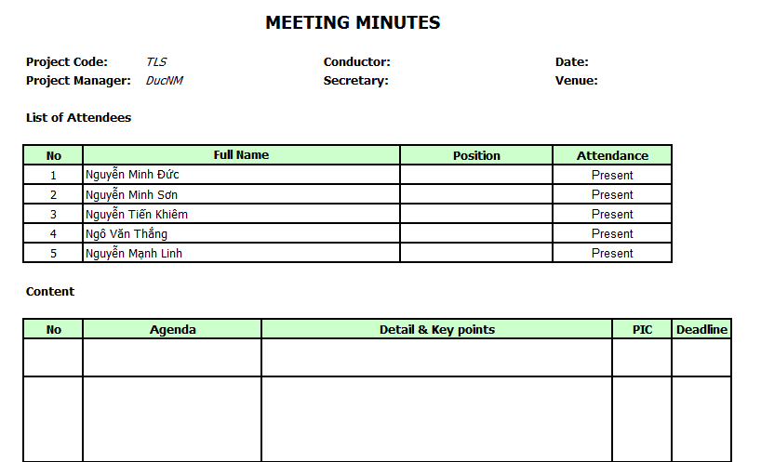

**Figure 2.3: Meeting minutes template**

# Coding Convention

## Purpose

This part of document provides the coding standard. The goal is to archive a good quality of code with the following criteria:

* Reliable: Avoidance of errors/bugs.
* Maintainable: by promoting some proven design principles and requiring a certain unity of style.
* Performance: by dissuading wasteful practices.

The naming conventions, coding standards and best practices described in this document are compiled from our own experience and by referring to various Sun guidelines.

This link use for parts 4.2, 4.3, and 4.4:

<http://www.oracle.com/technetwork/java/javase/documentation/codeconvtoc-136057.html>

## Naming Convention

View 4.1

## Coding Style

View 4.1

## Comment Style

View 4.1

# Risk management plan

|  |  |  |  |  |  |
| --- | --- | --- | --- | --- | --- |
| Risk Description | Risk type | Probability | Impact | Risk Strategy | Fallback plan |
| Member is ill at critical times in the project­­­ | People | Moderate | Serious | Organize team so that there is more overlap of work and people therefore understand each other’s jobs | Using buffer time (Saturday and Sunday) to recover jobs |
| Inexperience with Project process, project management and designing e-commerce project | People | High | Catastrophic | Prepare weekly meeting to get the advice from supervisor | Team members have to spend time to study more about the software process model, management and project’s business |
| Bad attitude of team member: Member is in-cohesive with team, breach of discipline | People | High | Serious | 1. Engage the members in activities that require them to work together. 2. Create cross-review tasks to tracking member’s working process | Change team’s policies; increase the punishments for team members. Member is required to work in common space daily( library, etc.) from 9 a.m. to 5 p.m. |
| SRS is in inconsistent with user requirement | Requirement | Moderate | Serious | Set up meeting so that develop team can discuss and give the final requirements: functions, non-functions and domain requirements. Make sure that the team goals are clear and completely understood. | Change requirements as soon as possible, make sure that new requirements are correct |
| Database used in the system cannot process as many transactions per second as expect | Technical | Moderate | Catastrophic | Investigate the possibility of bidding a higher-performance database | Upgrade to a new database version that can solve more user |
| Design difficulty: Interface is not attractive, interactive with user | Technical | Moderate | Serious | Before designing, team member should participate in existing system to find out their advantage and disadvantage. | Redesign the interface with the instructions of an expert |
| Failure to meet agree schedule | Estimation | High | Serious | Create buffer in Plan | Use Saturday and Sunday as Buffer time. |

# Project success criteria

|  |  |  |
| --- | --- | --- |
| **Project success criteria** | **Measurement** | **Weight** |
| All high-priority functions defined in the requirement specification must be finished at the end of project | All high-priority functions are tested and released on time | 40 |
| Complete all tasks within the predetermined time | All team member’s tasks have to meet the deadline | 30 |
| Team working | Team members can support and help each other. Software process must be carried out correctly. | 15 |
| Number of defects per function is acceptable | Number of defects per function is not exceed 10 | 15 |

# Software Requirement Specifications

## User Requirement Specification

Our system orientate to five kinds of user in system: Administrator, Director, Human Resource Manager, Project Manager, Operator.

### *1.1. Administrator requirements.*

* Log-in, log-out, view general information.
* View list of project space, search, create, update, and delete project space.
* View list of user accounts, add, update or delete user account.
* View list of messages, add, search and view detail message, feedback.

### *1.2. Director.*

* Log-in, log-out, view general information.
* View task list & project information, view project documentation list, view subcontractor list, view Gantt chart, view projects list, search project.
* View project report list, view project report information, and search project report.
* View project list, decide require human resource.
* View list of messages, add, search and view detail message, feedback.

### *1.3. Human Resource Manager.*

* Log-in, log-out, view general information.
* View staff list, delete, add, update, and search staff.
* View specialty list, delete, add, update specialty.
* View project list, search project, view project's staff list, view project information.
* Search staff, add resource to project.
* View project list, search project, provide requirement human resource, and view human resource information.
* View list of messages, add, search and view detail & feedback message.

### *1.4. Project Manager.*

* Log-in, log-out, view general information.
* View task list, require staff, add, update, delete, search task.
* View list, add, update, delete subcontractor.
* View task information, change task status, manage task constraint, manage document task, create line chart.
* View project list, search project, view project information & task list, change project status, view project documentation list, update project's information, and view Gantt chart.
* View project list, search project, provide requirement human resource, and view human resource information.
* View list, search staff and accept human resource, remove human resource, assign task.
* View human resource information, send requirement human resource.
* View list, view detail & feedback and search daily report.
* View list, view detail & feedback, create, and search project report.
* View list of messages, add, search and view detail & feedback message.

### *1.5. Operator.*

* Log-in, log-out, view general information.
* View task list & project information, view task information, view task constraint list, view task documentation list, create line chart
* View list, view detail & feedback, create, and search daily report.
* View list of messages, add, search and view detail & feedback message.

## System Requirement Specification

### *2.1. External Interface Requirements*

#### *2.1.1. User Interfaces*

* The system to be used in internal company so UI is not important requirements. UI must be easy-to-use and clear as much as possible.

#### *2.1.2. Hardware Interfaces*

* The system requires users to have computer that supported network connection.

#### *2.1.3. Software Interfaces*

*Supported browsers:*

* FF 3.6 or higher.
* IE 9.0 or higher.
* Google Chrome 20 or higher.

### *2.2. System Features*

This section will describe the system being built through a list of Use cases. First, we will have an over-view of the whole system and what it will do through a use case diagram. There’re 5 main functions: Administrator, Director, Human resource manager, Project manager and Operator.



**Figure 3.0.Use Case diagram**

#### *2.2.1 Administrator Use Case Diagram:*

**Figure 3.1.Administrator Use Case diagram**

|  |  |  |  |  |
| --- | --- | --- | --- | --- |
| **Id** | **Name** | **Use-case No** | **Version** | **Priority** |
| **1** | [**Log-in**](#_Use_case_01:) | **UC1.01** | **1.1** | **High** |
| **2** | [**Log-out**](#_Use_case_02:) | **UC1.02** | **1.1** | **High** |
| **3** | [**View Staff List**](#_Use_case_03:) | **UC1.03** | **1.1** | **High** |
| **4** | [**Add Account**](#_Use_case_04:) | **UC1.04** | **1.1** | **High** |
| **5** | [**Update Account**](#_Use_case_05:) | **UC1.05** | **1.1** | **High** |
| **6** | [**Search Account**](#_Use_case_06:) | **UC1.06** | **1.1** | **High** |
| **7** | [**View Project Space List**](#_Use_case_07:) | **UC1.07** | **1.1** | **High** |
| **8** | [**Create Project Space**](#_Use_case_08:) | **UC1.08** | **1.1** | **High** |
| **9** | [**Update Project Space**](#_Use_case_09:) | **UC1.09** | **1.1** | **High** |
| **10** | [**Delete Project Space**](#_Use_case_10:) | **UC1.10** | **1.1** | **High** |
| **11** | [**Search Project Space**](#_Use_case_11:) | **UC1.11** | **1.1** | **High** |
| **12** | [**View Message List**](#_Use_case_12:) | **UC1.12** | **1.1** | **High** |
| **13** | [**Add Message**](#_Use_case_13:) | **UC1.13** | **1.1** | **High** |
| **14** | [**Search Message**](#_Use_case_014:) | **UC1.14** | **1.1** | **High** |
| **15** | [**View Message Detail & Feedback**](#_Use_case_15:_3) | **UC1.15** | **1.1** | **High** |
| **16** | [**View General Information**](#_Use_case_16:_2) | **UC1.16** | **1.1** | **High** |

##### Use case 01: Log-in

|  |  |  |  |  |
| --- | --- | --- | --- | --- |
| **USE CASE-01 SPECIFICATION** | | | | |
| **Use-case No.** | UC1.01 | **Use-case Version** | | 1.1 |
| **Use-case Name** | Log-in | | | |
| **Author** | ThangNV | | | |
| **Date** | 17/09/2012 | **Priority** | High | |
| **Actor:** Administrator  **Summary:** Log in the Thanh Long System, in order to use other function.  **Triggers:** Click on “Đăng nhập” button.  **Preconditions:** Must have an account in Thanh Long System.  **Post Conditions:** Administrator can use other Thanh Long System function.  **Main Success Scenario:**   * Input “Tài khoản”,”Mật khẩu”. * Click on “Đăng nhập” button.   **Alternative Scenario:** N/A  **Exceptions:** N/A  **Relationships:** N/A  **Business Rules:** N/A | | | | |

##### Use case 02: Log-out

|  |  |  |  |  |
| --- | --- | --- | --- | --- |
| **USE CASE-02 SPECIFICATION** | | | | |
| **Use-case No.** | UC1.02 | **Use-case Version** | | 1.1 |
| **Use-case Name** | Log-out | | | |
| **Author** | ThangNV | | | |
| **Date** | 17/09/2012 | **Priority** | High | |
| **Actor:** Administrator  **Summary:** Log out the Thanh Long System.  **Triggers:** Click on “Đăng xuất” hyperlink.  **Preconditions:** Logged into the system.  **Post Conditions:** By clicking this user will log out of website. Displayed user as guest.  **Main Success Scenario:**   * Click on “Đăng xuất” hyperlink. * Redirect to home page.   **Alternative Scenario:** N/A  **Exceptions:** N/A  **Relationships:** N/A  **Business Rules:** N/A | | | | |

##### Use case 03: View Staff List

|  |  |  |  |  |
| --- | --- | --- | --- | --- |
| **USE CASE-03 SPECIFICATION** | | | | |
| **Use-case No.** | UC1.03 | **Use-case Version** | | 1.1 |
| **Use-case Name** | View Staff List | | | |
| **Author** | ThangNV | | | |
| **Date** | 17/09/2012 | **Priority** | High | |
| **Actor:** Administrator  **Summary:** View Staff List.  **Triggers:** Click on “Quản lý tài khoản” button.  **Preconditions:** Logged into the Thanh Long System.  **Post Conditions:** A List of Staff is shown.  **Main Success Scenario:**   * Click on “Quản lý tài khoản” button. * A List Staff will be displayed   **Alternative Scenario:** N/A  **Exceptions:** N/A  **Relationships:** N/A  **Business Rules:** N/A | | | | |

##### Use case 04: Add Account

|  |  |  |  |  |
| --- | --- | --- | --- | --- |
| **USE CASE-04 SPECIFICATION** | | | | |
| **Use-case No.** | UC1.04 | **Use-case Version** | | 1.1 |
| **Use-case Name** | Add Account | | | |
| **Author** | ThangNV | | | |
| **Date** | 17/09/2012 | **Priority** | High | |
| **Actor:** Administrator  **Summary:** Add new account in Thanh Long System.  **Triggers:** Click on “Tạo tài khoản” button.  **Preconditions:** Logged into the system with Admin role and go to account management page.  **Post Conditions:** A new account added and be saved into database.  **Main Success Scenario:**   * Choose only one checkbox in list of staff. * Clicks on “Tạo tài khoản" button. * “Tạo tài khoản mới” page is shown. * Input:Tên đăng nhập, Mật khẩu,Nhóm tài khoản. * Press “Lưu lại” button to save or press “Hủy bỏ” button to cancel. * “Tạo tài khoản thành công” message will be display.   **Alternative Scenario:** N/A  **Exceptions:** Information of new account is not saved into database.  **Relationships:** N/A  **Business Rules:** N/A | | | | |

##### Use case 05: Update Account

|  |  |  |  |  |
| --- | --- | --- | --- | --- |
| **USE CASE-05 SPECIFICATION** | | | | |
| **Use-case No.** | UC1.05 | **Use-case Version** | | 1.1 |
| **Use-case Name** | Update Account | | | |
| **Author** | ThangNV | | | |
| **Date** | 17/09/2012 | **Priority** | High | |
| **Actor:** Administrator  **Summary:** Update Account information.  **Triggers:**  Click on “Mã nhân viên” hyperlink.  **Preconditions:** Logged into the system with Admin role and go to account management.  **Post Conditions:** An Account Information updated and saved to database.  **Main Success Scenario:**   * Click “Mã nhân viên” hyperlink. * “Taoj tài khoản mới” page is shown. * Update information: Tên đăng nhập, Mật khẩu, Nhóm tài khoản. * Press “Lưu lại” button to save or press “Hủy bỏ” button to cancel. * Success message will be displayed.   **Alternative Scenario:** N/A  **Exceptions:** Information of account is not saved into database.  **Relationships:** N/A  **Business Rules:** N/A | | | | |

##### Use case 06: Search Account

|  |  |  |  |  |
| --- | --- | --- | --- | --- |
| **USE CASE-06 SPECIFICATION** | | | | |
| **Use-case No.** | UC1.06 | **Use-case Version** | | 1.1 |
| **Use-case Name** | Search Account | | | |
| **Author** | ThangNV | | | |
| **Date** | 17/09/2012 | **Priority** | High | |
| **Actor:** Administrator  **Summary:** Search an account from database.  **Triggers:** Click on “Tìm kiếm” button.  **Preconditions:** Logged into the system with Admin role and go to account management page.  **Post Conditions:** List of account is shown.  **Main Success Scenario:**   * Input: Tên tài khoản, Mã nhân viên, Tên nhân viên, Tình trạng, Nhóm tài khoản. * Clicks on “Tìm kiếm" button. * List of account will be displayed.   **Alternative Scenario:** N/A  **Exceptions:** N/A  **Relationships:** N/A  **Business Rules:** N/A | | | | |

##### Use case 07: View Project Space List

|  |  |  |  |  |
| --- | --- | --- | --- | --- |
| **USE CASE-07 SPECIFICATION** | | | | |
| **Use-case No.** | UC1.07 | **Use-case Version** | | 1.1 |
| **Use-case Name** | View Project Space List | | | |
| **Author** | ThangNV | | | |
| **Date** | 17/09/2012 | **Priority** | High | |
| **Actor:** Administrator  **Summary:** Access system and view list of project space.  **Triggers:** Click on “Danh mục dự án” button.  **Preconditions:** Logged into the Thanh Long System.  **Post Conditions:** A list of project space will be displayed.  **Main Success Scenario:**   * Click on “Danh mục dự án” button. * List of project space is shown.   **Alternative Scenario:** N/A  **Exceptions:** N/A  **Relationships:** N/A  **Business Rules:** N/A | | | | |

##### Use case 08: Create Project Space

|  |  |  |  |  |
| --- | --- | --- | --- | --- |
| **USE CASE-08 SPECIFICATION** | | | | |
| **Use-case No.** | UC1.08 | **Use-case Version** | | 1.1 |
| **Use-case Name** | Create Project Space | | | |
| **Author** | ThangNV | | | |
| **Date** | 17/09/2012 | **Priority** | High | |
| **Actor:** Administrator  **Summary:** Creates a new project space in system.  **Triggers:** Click on “Thêm mới” button.  **Preconditions:** Logged into the system with Admin role and go to project space management page.  **Post Conditions:** A new project space created and saved into database.  **Main Success Scenario:**   * Clicks on “Thêm mới" button. * “Thêm mới dự án” page are shown to Administrator. * Input Mã dự án,Tên dự án,Quản trị dự án,Ngày bắt đầu,Ngày kết thúc,Địa điểm, Đơn vị tư vấn, Số điện thoại, Fax,Chủ đầu tư, Số điện thoại,Fax,Ghi chú. * Press “Lưu lại” button to save or press “Hủy bỏ” to cancel. * Success message will be displayed.   **Alternative Scenario:** N/A  **Exceptions:** N/A  **Relationships:** N/A  **Business Rules:** N/A | | | | |

##### Use case 09: Update Project Space

|  |  |  |  |  |
| --- | --- | --- | --- | --- |
| **USE CASE-09 SPECIFICATION** | | | | |
| **Use-case No.** | UC1.09 | **Use-case Version** | | 1.1 |
| **Use-case Name** | Update Project Space | | | |
| **Author** | ThangNV | | | |
| **Date** | 17/09/2012 | **Priority** | High | |
| **Actor:** Administrator  **Summary:** Update project space information.  **Triggers:** Click “Mã dự án” hyperlink.  **Preconditions:** Logged into the system with Admin role and go to project space management.  **Post Conditions:** Project space information updated and saved to database.  **Main Success Scenario:**   * Click “Mã dự án” hyperlink. * “Cập nhật thông tin dự án” page is shown. * Update information: Mã dự án, Tên dự án, Quản trị dự án, Ngày bắt đầu, Ngày kết thúc. * Press “Lưu lại” button to save or press “Hủy bỏ” button to cancel. * Success message will be displayed.   **Alternative Scenario:** N/A  **Exceptions:** N/A  **Relationships:** N/A  **Business Rules:** N/A | | | | |

##### 

##### Use case 10: Delete Project Space

|  |  |  |  |  |
| --- | --- | --- | --- | --- |
| **USE CASE-10 SPECIFICATION** | | | | |
| **Use-case No.** | UC1.10 | **Use-case Version** | | 1.1 |
| **Use-case Name** | Delete Project Space | | | |
| **Author** | ThangNV | | | |
| **Date** | 17/09/2012 | **Priority** | High | |
| **Actor:** Administrator  **Summary:** Delete project space from database.  **Triggers:** Click on “Xóa” button.  **Preconditions:** Logged into the system with Admin role and go to project space management page.  **Post Conditions:** The project space deleted.  **Main Success Scenario:**   * Choose checkbox in list of project space * Click on “Xóa" button. * “Bạn có chắc chắn muốn xóa?” message displayed. * Press “Xác nhận” button to delete or press “Hủy bỏ” to cancel.   **Alternative Scenario:** N/A  **Exceptions:** N/A  **Relationships:** N/A  **Business Rules:** N/A | | | | |

##### Use case 11: Search Project Space

|  |  |  |  |  |
| --- | --- | --- | --- | --- |
| **USE CASE-11 SPECIFICATION** | | | | |
| **Use-case No.** | UC1.11 | **Use-case Version** | | 1.1 |
| **Use-case Name** | Search Project Space | | | |
| **Author** | ThangNV | | | |
| **Date** | 17/09/2012 | **Priority** | High | |
| **Actor:** Administrator  **Summary:** Search an account from database.  **Triggers:** Click on “Tìm kiếm” button.  **Preconditions:** Logged into the system with Admin role and go to project space management page.  **Post Conditions:** List of project space is shown.  **Main Success Scenario:**   * Input: Mã dự án, Tên dự án, Tình trạng. * Click on “Tìm kiếm" button. * List of project space will be displayed.   **Alternative Scenario:** N/A  **Exceptions:** N/A  **Relationships:** N/A  **Business Rules:** N/A | | | | |

##### Use case 12: View Message List

|  |  |  |  |  |
| --- | --- | --- | --- | --- |
| **USE CASE-12 SPECIFICATION** | | | | |
| **Use-case No.** | UC1.12 | **Use-case Version** | | 1.1 |
| **Use-case Name** | View Message List | | | |
| **Author** | ThangNV | | | |
| **Date** | 17/09/2012 | **Priority** | High | |
| **Actor:** Administrator  **Summary:** Access system and view list of message.  **Triggers:** Click on “Quản lý message” button.  **Preconditions:** Logged into the Thanh Long System.  **Post Conditions:** List of message is shown.  **Main Success Scenario:**   * Click on “Quản lý message” button. * A list of message will be displayed.   **Alternative Scenario:** N/A  **Exceptions:** N/A  **Relationships:** N/A  **Business Rules:** N/A | | | | |

##### Use case 13: Add Message

|  |  |  |  |  |
| --- | --- | --- | --- | --- |
| **USE CASE-13 SPECIFICATION** | | | | |
| **Use-case No.** | UC1.13 | **Use-case Version** | | 1.1 |
| **Use-case Name** | Add Message | | | |
| **Author** | ThangNV | | | |
| **Date** | 17/09/2012 | **Priority** | High | |
| **Actor:** Administrator  **Summary:** Creates a new message in system.  **Triggers:** Click on “Soạn tin nhắn” button.  **Preconditions:** Logged into the system with Admin role and go to message management page.  **Post Conditions:** New message created and saved into database.  **Main Success Scenario:**   * Click on “Soạn tin nhắn “button. * “Gửi tin nhắn” page are shown. * Input: Tài khoản, Chức vụ. * Click on “Tìm kiếm người” button. * Input: Người nhận,Tiêu đề, nội dung * Press ”Choose File” button to attach a file * Press”xóa trắng” to clear all text. * Press “Gửi” button to send message or press “Quay lại trang tin nhắn” to cancel. * Success message will be displayed.   **Alternative Scenario:** N/A  **Exceptions:** N/A  **Relationships:** N/A  **Business Rules:** N/A | | | | |

##### Use case 14: Search Message

|  |  |  |  |  |
| --- | --- | --- | --- | --- |
| **USE CASE-14 SPECIFICATION** | | | | |
| **Use-case No.** | UC1.14 | **Use-case Version** | | 1.1 |
| **Use-case Name** | Search Message | | | |
| **Author** | ThangNV | | | |
| **Date** | 17/09/2012 | **Priority** | High | |
| **Actor:** Administrator  **Summary:** Search Message information.  **Triggers:** Click on “Tìm kiếm” button.  **Preconditions:** Logged into the system with Admin role and go to message management page.  **Post Conditions:** List of message is shown.  **Main Success Scenario:**   * Input: Người gửi, chủ đề, Tin nhắn, Tình trạng. * Clicks on “Tìm kiếm" button. * List of message will be displayed.   **Alternative Scenario:** N/A  **Exceptions:** N/A  **Relationships:** N/A  **Business Rules:** N/A | | | | |

##### Use case 15: View Message Detail & Feedback

|  |  |  |  |  |
| --- | --- | --- | --- | --- |
| **USE CASE-15 SPECIFICATION** | | | | |
| **Use-case No.** | UC1.15 | **Use-case Version** | | 1.1 |
| **Use-case Name** | View Message Detail & Feedback | | | |
| **Author** | ThangNV | | | |
| **Date** | 17/09/2012 | **Priority** | High | |
| **Actor:** Administrator  **Summary:** Access system, view message detail and feedback.  **Triggers:** Click on “Tiêu đề” hyperlink.  **Preconditions:** Logged into the system with Admin role.  **Post Conditions:** Message information is shown.  **Main Success Scenario:**   * Click on “Tiêu đề” hyperlink. * Message information will be displayed. * Input: Text. * Press “Gửi phản hồi” button to send or press “Quay về danh sách tin nhắn” button to cancel. * Success message will be displayed.   **Alternative Scenario:** N/A  **Exceptions:** N/A  **Relationships:** N/A  **Business Rules:** N/A | | | | |

##### Use case 16: View General Information

|  |  |  |  |  |
| --- | --- | --- | --- | --- |
| **USE CASE-16 SPECIFICATION** | | | | |
| **Use-case No.** | UC1.16 | **Use-case Version** | | 1.1 |
| **Use-case Name** | View General Information | | | |
| **Author** | ThangNV | | | |
| **Date** | 17/09/2012 | **Priority** | High | |
| **Actor:** Administrator  **Summary:** Access system and view general information.  **Triggers:** Click on “Thông tin tổng hợp” button.  **Preconditions:** Logged into the system with Admin role.  **Post Conditions:** General information is shown.  **Main Success Scenario:**   * Click on “Thông tin tổng hợp” button. * General information will be displayed.   **Alternative Scenario:** N/A  **Exceptions:** N/A  **Relationships:** N/A  **Business Rules:** N/A | | | | |

#### *2.2.2 Director Use Case Diagram:*



**Figure 3.2.Director Use Case diagram**

|  |  |  |  |  |
| --- | --- | --- | --- | --- |
| **Id** | **Name** | **Use-case No** | **Version** | **Priority** |
| **1** | [**Log-in**](#_Use_case_01:_4) | **UC2.01** | **1.1** | **High** |
| **2** | [**Log-out**](#_Use_case_02:_4) | **UC2.02** | **1.1** | **High** |
| **3** | [**View Projects List**](#_Use_case_03:_3) | **UC2.03** | **1.1** | **High** |
| **4** | [**View Task List &Project Information**](#_Use_case_04:_3) | **UC2.04** | **1.1** | **High** |
| **5** | [**View Subcontractor List**](#_Use_case_05:_2) | **UC2.05** | **1.1** | **High** |
| **6** | [**View Project Documentation List**](#_Use_case_06:_6) | **UC2.06** | **1.1** | **High** |
| **7** | [**View Gantt Chart**](#_Use_case_07:_6) | **UC2.07** | **1.1** | **High** |
| **8** | [**Search Project**](#_Use_case_08:_5) | **UC2.08** | **1.1** | **High** |
| **9** | [**View Project Report List**](#_Use_case_6:) | **UC2.09** | **1.1** | **High** |
| **10** | [**View Project Report Detail & Feedback**](#_Use_case_10:_3) | **UC2.10** | **1.1** | **High** |
| **11** | [**Search Project Report**](#_Use_case_12:_3) | **UC2.11** | **1.1** | **High** |
| **12** | [**View Human Resource Information**](#_Use_case_13:_3) | **UC2.12** | **1.1** | **High** |
| **13** | [**Decide Require Human Resource**](#_Use_case_14:_2) | **UC2.13** | **1.1** | **High** |
| **14** | [**View Message List**](#_Use_case_15:_4) | **UC2.14** | **1.1** | **High** |
| **15** | [**Add Message**](#_Use_case_16:_3) | **UC2.15** | **1.1** | **High** |
| **16** | [**Search Message**](#_Use_case_17:_2) | **UC2.16** | **1.1** | **High** |
| **17** | [**View Message Detail &Feedback**](#_Use_case_18:_2) | **UC2.17** | **1.1** | **High** |
| **18** | [**View General Information**](#_Use_case_19:_2) | **UC2.18** | **1.1** | **High** |

##### Use case 01: Log-in

##### You can see “Use case [UC1.01](#_Use_case_01:): Log-in” of Administrator.

##### Use case 02: Log-out

##### You can see “Use case [UC1.02](#_Use_case_02:): Log-out” of Administrator.

##### Use case 03: View Project List

##### You can see “Use case [UC1.07](#_Use_case_07:): View Project Space List” of Administrator.

##### Use case 04: View Task List & Project Information

|  |  |  |  |  |
| --- | --- | --- | --- | --- |
| **USE CASE-04 SPECIFICATION** | | | | |
| **Use-case No.** | UC2.04 | **Use-case Version** | | 1.1 |
| **Use-case Name** | View Task List & Project Information | | | |
| **Author** | ThangNV | | | |
| **Date** | 17/09/2012 | **Priority** | High | |
| **Actor:** Director  **Summary:** Access system and view list of task & project information.  **Triggers:** Click on “Tên dự án” hyperlink.  **Preconditions:** Logged into the System with Director role and go to project management.  **Post Conditions:** A list of task and project information will be displayed.  **Main Success Scenario:**   * Click on “Tên dự án” button. * List of task and project information is shown.   **Alternative Scenario:** N/A  **Exceptions:** N/A  **Relationships:** N/A  **Business Rules:** N/A | | | | |

##### 

##### Use case 05: View Subcontractor List

|  |  |  |  |  |
| --- | --- | --- | --- | --- |
| **USE CASE-05 SPECIFICATION** | | | | |
| **Use-case No.** | UC2.05 | **Use-case Version** | | 1.1 |
| **Use-case Name** | View Subcontractor List | | | |
| **Author** | ThangNV | | | |
| **Date** | 17/09/2012 | **Priority** | High | |
| **Actor:** Director  **Summary:** Access system and view list of subcontractor.  **Triggers:** Click on “Danh sách nhà thầu phụ” button.  **Preconditions:** Logged into the System with Director role and go to project detail page.  **Post Conditions:** A list of operator will be displayed.  **Main Success Scenario:**   * Click on “Danh sách nhà thầu phụ” button. * List of subcontractor is shown.   **Alternative Scenario:** N/A  **Exceptions:** N/A  **Relationships:** N/A  **Business Rules:** N/A | | | | |

##### Use case 06: View Project Documentation List

|  |  |  |  |  |
| --- | --- | --- | --- | --- |
| **USE CASE-06 SPECIFICATION** | | | | |
| **Use-case No.** | UC2.06 | **Use-case Version** | | 1.1 |
| **Use-case Name** | View Project Documentation List | | | |
| **Author** | ThangNV | | | |
| **Date** | 17/09/2012 | **Priority** | High | |
| **Actor:** Director  **Summary:** Access system and view list of project documentation.  **Triggers:** Click on “Tài liệu dự án” button.  **Preconditions:** Logged into the System with Director role and go to project detail page.  **Post Conditions:** A list of project documentation will be displayed.  **Main Success Scenario:**   * Click on “Tài liệu dự án” button. * List of project documentation is shown.   **Alternative Scenario:** N/A  **Exceptions:** N/A  **Relationships:** N/A  **Business Rules:** N/A | | | | |

##### 

##### Use case 07: View Gantt chart

|  |  |  |  |  |
| --- | --- | --- | --- | --- |
| **USE CASE-07 SPECIFICATION** | | | | |
| **Use-case No.** | UC2.07 | **Use-case Version** | | 1.1 |
| **Use-case Name** | View Gantt Chart | | | |
| **Author** | ThangNV | | | |
| **Date** | 17/09/2012 | **Priority** | High | |
| **Actor:** Director  **Summary:** Access system and view gantt chart.  **Triggers:** Click on “Xem biểu đồ” button.  **Preconditions:** Logged into the System with Director role and go to “Kế hoạch dự án” page.  **Post Conditions:** Gantt chart will be displayed.  **Main Success Scenario:**   * Click on “Xem biểu đồ” button. * Gantt chart is shown.   **Alternative Scenario:** N/A  **Exceptions:** N/A  **Relationships:** N/A  **Business Rules:** N/A | | | | |

##### Use case 08: Search Project

|  |  |  |  |  |
| --- | --- | --- | --- | --- |
| **USE CASE-08 SPECIFICATION** | | | | |
| **Use-case No.** | UC2.08 | **Use-case Version** | | 1.1 |
| **Use-case Name** | Search Project | | | |
| **Author** | ThangNV | | | |
| **Date** | 17/09/2012 | **Priority** | High | |
| **Actor:** Director  **Summary:** Search project from database.  **Triggers:** Click on “Tìm kiếm” button.  **Preconditions:** Logged into the system with Director role and go to project management page.  **Post Conditions:** List of project is shown.  **Main Success Scenario:**   * Input: Mã dự án,Quản lý,Tình trạng. * Click on “Tìm kiếm" button. * List of project will be displayed.   **Alternative Scenario:** N/A  **Exceptions:** N/A  **Relationships:** N/A  **Business Rules:** N/A | | | | |

##### Use case 09: View Project Report List

|  |  |  |  |  |
| --- | --- | --- | --- | --- |
| **USE CASE-09 SPECIFICATION** | | | | |
| **Use-case No.** | UC2.09 | **Use-case Version** | | 1.1 |
| **Use-case Name** | View Project Report List | | | |
| **Author** | ThangNV | | | |
| **Date** | 17/09/2012 | **Priority** | High | |
| **Actor:** Director  **Summary:** Access system and view list of project report.  **Triggers:** Click on “Danh mục báo cáo dự án” button.  **Preconditions:** Logged into the System with Director role and go to project report management page.  **Post Conditions:** A list of project report will be displayed.  **Main Success Scenario:**   * Click on “Danh mục báo cáo dự án” button. * List of project report is shown.   **Alternative Scenario:** N/A  **Exceptions:** N/A  **Relationships:** N/A  **Business Rules:** N/A | | | | |

##### Use case 10: View Project Report Detail & Feedback

|  |  |  |  |  |
| --- | --- | --- | --- | --- |
| **USE CASE-10 SPECIFICATION** | | | | |
| **Use-case No.** | UC2.10 | **Use-case Version** | | 1.1 |
| **Use-case Name** | View Project Report Detail & Feedback | | | |
| **Author** | ThangNV | | | |
| **Date** | 17/09/2012 | **Priority** | High | |
| **Actor:** Director  **Summary:** Access system, view list of project report detail and feedback.  **Triggers:** Click on “Báo cáo dự án” hyperlink.  **Preconditions:** Logged into the System with Director role and go to project report management page.  **Post Conditions:** Project report information will be displayed.  **Main Success Scenario:**   * Click on “Báo cáo dự án” hyperlink. * Project report detail is shown. * Input: Text. * Press “Gửi phản hồi” button to send or press “Quay về danh sách báo cáo” button to cancel. * Success message will be displayed.   **Alternative Scenario:** N/A  **Exceptions:** N/A  **Relationships:** N/A  **Business Rules:** N/A | | | | |

##### Use case 11: Search Project Report

|  |  |  |  |  |
| --- | --- | --- | --- | --- |
| **USE CASE-11 SPECIFICATION** | | | | |
| **Use-case No.** | UC2.11 | **Use-case Version** | | 1.1 |
| **Use-case Name** | Search Project Report | | | |
| **Author** | ThangNV | | | |
| **Date** | 17/09/2012 | **Priority** | High | |
| **Actor:** Director  **Summary:** Search project report from database.  **Triggers:** Click on “Tìm kiếm” button.  **Preconditions:** Logged into the System with Director role and go to project report management page.  **Post Conditions:** List of project report is shown.  **Main Success Scenario:**   * Input: Dự án, Tình trạng, Đội trưởng. * Click on “Tìm kiếm” button. * List of project report will be displayed.   **Alternative Scenario:** N/A  **Exceptions:** N/A  **Relationships:** N/A  **Business Rules:** N/A | | | | |

##### Use case 12: View Human Resource Information

|  |  |  |  |  |
| --- | --- | --- | --- | --- |
| **USE CASE-12 SPECIFICATION** | | | | |
| **Use-case No.** | UC2.12 | **Use-case Version** | | 1.1 |
| **Use-case Name** | View Human Resource Information | | | |
| **Author** | ThangNV | | | |
| **Date** | 17/09/2012 | **Priority** | High | |
| **Actor:** Director  **Summary:** Access system and view human resource information.  **Triggers:** Click on “Số lượng” hyperlink.  **Preconditions:** Logged into the System with Director role and go to “Kế hoạch nhân sự dự án” page.  **Post Conditions:** Human resource information will be displayed.  **Main Success Scenario:**   * Click on “Số lượng” hyperlink. * Human resource information is shown.   **Alternative Scenario:** N/A  **Exceptions:** N/A  **Relationships:** N/A  **Business Rules:** N/A | | | | |

##### Use case 13: Decide Require Human Resource

|  |  |  |  |  |
| --- | --- | --- | --- | --- |
| **USE CASE-13 SPECIFICATION** | | | | |
| **Use-case No.** | UC2.13 | **Use-case Version** | | 1.1 |
| **Use-case Name** | Decide Require Human Resource | | | |
| **Author** | ThangNV | | | |
| **Date** | 17/09/2012 | **Priority** | High | |
| **Actor:** Director  **Summary:** Access system and decide require human resource.  **Triggers:** Click on “Phê duyệt” button or “Hủy yêu cầu” button.  **Preconditions:** Logged into the System with Director role and go to “Kế hoạch nhân sự dự án” page.  **Post Conditions:** Require human resource decided and saved to database.  **Main Success Scenario:**   * Press “Phê duyệt” button to approve or press “Quay về danh sách báo cáo” button to cancel. * Success message will be display.   **Alternative Scenario:** N/A  **Exceptions:** N/A  **Relationships:** N/A  **Business Rules:** N/A | | | | |

##### Use case 14: View Message List

##### You can see “Use case [UC1.12](#_Use_case_12:): View Message List” of Administrator.

##### Use case 15: Add Message

##### You can see “Use case [UC1.13](#_Use_case_13:): Add Message” of Administrator.

##### Use case 16: Search Message

##### You can see “Use case [UC1.14](#_Use_case_014:): Search Message” of Administrator.

##### Use case 17: View Message Detail & Feedback

##### You can see “Use case [UC1.15](#_Use_case_15:_3): View Message Detail & Feedback” of Administrator.

##### Use case 18: View General Information

##### You can see “Use case [UC1.16](#_Use_case_16:_2): View General Information” of Administrator.

#### *2.2.3 Human Resource Manager Use Case Diagram:*

 **Figure 3.3.Human Resource Manager Use Case diagram**

|  |  |  |  |  |
| --- | --- | --- | --- | --- |
| **Id** | **Name** | **Use-case No** | **Version** | **Priority** |
| **1** | [**Log-in**](#_Use_case_01:_3) | **UC3.01** | **1.1** | **High** |
| **2** | [**Log-out**](#_Use_case_02:_1) | **UC3.02** | **1.1** | **High** |
| **3** | [**View Staff List**](#_Use_case_03:_2) | **UC3.03** | **1.1** | **High** |
| **4** | [**Add Staff**](#_Use_case_04:_2) | **UC3.04** | **1.1** | **High** |
| **5** | [**Update Staff’s Information**](#_Use_case_05:_3) | **UC3.05** | **1.1** | **High** |
| **6** | [**Delete Staff**](#_Use_case_06:_7) | **UC3.06** | **1.1** | **High** |
| **7** | [**Search Staff**](#_Use_case_07:_7) | **UC3.07** | **1.1** | **High** |
| **8** | [**View Specialty List**](#_Use_case_08:_6) | **UC3.08** | **1.1** | **High** |
| **9** | [**Add Specialty**](#_Use_case_09:_4) | **UC3.09** | **1.1** | **High** |
| **10** | [**Update Specialty**](#_Use_case_10:_4) | **UC3.10** | **1.1** | **High** |
| **11** | [**Delete Specialty**](#_Use_case_11:_4) | **UC3.11** | **1.1** | **High** |
| **12** | [**View Project List**](#_Use_case_12:_4) | **UC3.12** | **1.1** | **High** |
| **13** | [**View Project Information**](#_Use_case_13:_2) | **UC3.13** | **1.1** | **High** |
| **14** | [**View Project’s Staff List**](#_Use_case_14:_1) | **UC3.14** | **1.1** | **High** |
| **15** | [**Search Project**](#_Use_case_13:_2) | **UC3.15** | **1.1** | **High** |
| **16** | [**Search Staff**](#_Use_case_16:_1) | **UC3.16** | **1.1** | **High** |
| **17** | [**Add Resource To Project**](#_Use_case_17:_3) | **UC3.17** | **1.1** | **High** |
| **18** | [**View Human Resource Information**](#_Use_case_18:_3) | **UC3.18** | **1.1** | **High** |
| **19** | [**Provide Requirement Human Resource**](#_Use_case_19:_3) | **UC3.19** | **1.1** | **High** |
| **20** | [**View Message List**](#_Use_case_20:_1) | **UC3.20** | **1.1** | **High** |
| **21** | [**Add Message**](#_Use_case_21:_2) | **UC3.21** | **1.1** | **High** |
| **22** | [**Search Message**](#_Use_case_22:_2) | **UC3.22** | **1.1** | **High** |
| **23** | [**View Message Detail & Feedback**](#_Use_case_23:_1) | **UC3.23** | **1.1** | **High** |
| **24** | [**View General Information**](#_Use_case_24:_1) | **UC3.24** | **1.1** | **High** |

##### Use case 01: Log-in

##### You can see “Use case [UC1.01](#_Use_case_01:): Log-in” of Administrator.

##### Use case 02: Log-out

##### You can see “Use case [UC1.02](#_Use_case_02:): Log-out” of Administrator.

##### Use case 03: View Staff List

##### You can see “Use case [UC1.07](#_Use_case_07:): View Project Space List” of Administrator.

##### Use case 04: Add Staff

|  |  |  |  |  |
| --- | --- | --- | --- | --- |
| **USE CASE-04 SPECIFICATION** | | | | |
| **Use-case No.** | UC3.04 | **Use-case Version** | | 1.1 |
| **Use-case Name** | Add Staff | | | |
| **Author** | ThangNV | | | |
| **Date** | 17/09/2012 | **Priority** | High | |
| **Actor:** Human Resource Manager  **Summary:** Add new staff in Thanh Long System.  **Triggers:** Click on “Thêm mới” button.  **Preconditions:** Logged into the system with Human Resource Manager role.  **Post Conditions:** A new staff added and be saved into database.  **Main Success Scenario:**   * Clicks on “Thêm mới" button. * “Thông tin nhân viên” page are shown to Human Resource Manager. * Input: Mã nhân viên,Họ và tên,Ngày sinh,Nơi sinh, Giơí tính,CMT,Địa chỉ,Di động,Email,Chuyên môn,Kinh nghiệm,Mô tả. * Press “Khởi tạo” button to clear all text. * Press “Lưu lại” button to save or press “Quay lại” button to cancel. * Success message will be display.   **Alternative Scenario:** N/A  **Exceptions:** N/A  **Relationships:** N/A  **Business Rules:** N/A | | | | |

##### Use case 05: Update Staff’s Information

|  |  |  |  |  |
| --- | --- | --- | --- | --- |
| **USE CASE-05 SPECIFICATION** | | | | |
| **Use-case No.** | UC3.05 | **Use-case Version** | | 1.1 |
| **Use-case Name** | Update Staff’s Information | | | |
| **Author** | ThangNV | | | |
| **Date** | 17/09/2012 | **Priority** | High | |
| **Actor:** Human Resource Manager  **Summary:** Update staff’s information.  **Triggers:** Click “Mã nhân viên” hyperlink.  **Preconditions:** Logged into the system with Human Resource Manager role and go to Staff management.  **Post Conditions:** Staff’s information updated and saved to database.  **Main Success Scenario:**   * Click “Mã nhân viên” hyperlink. * “Thông tin nhân viên” page are shown. * Update information: Mã nhân viên,Họ và tên,Ngày sinh,Nơi sinh, Giơí tính,CMT,Địa chỉ,Di động,Email,Chuyên môn,Kinh nghiệm,Mô tả. * Press “Khởi tạo” button to clear all text. * Press “Lưu lại” button to save or press “Hủy bỏ” button to cancel. * Success message will be display.   **Alternative Scenario:** N/A  **Exceptions:** N/A  **Relationships:** N/A  **Business Rules:** N/A | | | | |

##### Use case 06: Delete Staff

|  |  |  |  |  |
| --- | --- | --- | --- | --- |
| **USE CASE-06 SPECIFICATION** | | | | |
| **Use-case No.** | UC3.6 | **Use-case Version** | | 1.1 |
| **Use-case Name** | Delete Staff | | | |
| **Author** | ThangNV | | | |
| **Date** | 17/09/2012 | **Priority** | High | |
| **Actor:** Human Resource Manager  **Summary:** Delete staff from database.  **Triggers:** Click on “Xóa” button.  **Preconditions:** Logged into the system with Human Resource Manager role and go to staff management page.  **Post Conditions:** Staff will be deleted.  **Main Success Scenario:**  - Choose checkbox in list of staff  -Click on “Xóa" button.  -“Bạn có chắc chắn muốn xóa?” message displayed.  -Press “Xác nhận” button to delete or press “Hủy bỏ” to cancel.  **Alternative Scenario:** N/A  **Exceptions:** N/A  **Relationships:** N/A  **Business Rules:** N/A | | | | |

##### Use case 07: Search Staff

|  |  |  |  |  |
| --- | --- | --- | --- | --- |
| **USE CASE-07 SPECIFICATION** | | | | |
| **Use-case No.** | UC3.07 | **Use-case Version** | | 1.1 |
| **Use-case Name** | Search Staff | | | |
| **Author** | ThangNV | | | |
| **Date** | 17/09/2012 | **Priority** | High | |
| **Actor:** Human Resource Manager  **Summary:** Search staff from database.  **Triggers:** Click on “Tìm kiếm” button.  **Preconditions:** Logged into the system with Human Resource Manager role and go to staff management page.  **Post Conditions:** List of staff is shown.  **Main Success Scenario:**   * Input: Tên nhân viên, Dự án,Chuyên môn, Kinh nghiệm, Tình trạng. * Click on “Tìm kiếm" button. * List of staff will be displayed.   **Alternative Scenario:** N/A  **Exceptions:** N/A  **Relationships:** N/A  **Business Rules:** N/A | | | | |

##### Use case 08: View Specialty List

|  |  |  |  |  |
| --- | --- | --- | --- | --- |
| **USE CASE-08 SPECIFICATION** | | | | |
| **Use-case No.** | UC3.08 | **Use-case Version** | | 1.1 |
| **Use-case Name** | View Specialty List | | | |
| **Author** | ThangNV | | | |
| **Date** | 17/09/2012 | **Priority** | High | |
| **Actor:** Human Resource Manager  **Summary:** Access system and view list of specialty.  **Triggers:** Click on “Danh mục chuyên môn” button.  **Preconditions:** Logged into the Thanh Long System.  **Post Conditions:** A list of specialty will be displayed.  **Main Success Scenario:**   * Click on “Danh mục chuyên môn” button. * List of specialty is shown to Human Resource Manager.   **Alternative Scenario:** N/A  **Exceptions:** N/A  **Relationships:** N/A  **Business Rules:** N/A | | | | |

##### Use case 09: Add Specialty

|  |  |  |  |  |
| --- | --- | --- | --- | --- |
| **USE CASE-09 SPECIFICATION** | | | | |
| **Use-case No.** | UC3.09 | **Use-case Version** | | 1.1 |
| **Use-case Name** | Add Specialty | | | |
| **Author** | ThangNV | | | |
| **Date** | 17/09/2012 | **Priority** | High | |
| **Actor:** Human Resource Manager  **Summary:** Creates new specialty in system.  **Triggers:** Click on “Thêm mới” button.  **Preconditions:** Logged into the system with Human Resource Manager role and go to specialty management page.  **Post Conditions:** A new specialtys added and saved into database.  **Main Success Scenario:**   * Clicks on “Thêm mới" button. * “Thêm mới thông tin chuyên môn” page are shown to Human Resource Manager. * Input: Chuyên môn, Mô tả. * Press “Lưu lại” button to save or press “Quay lại” to cancel. * Success message will be display.   **Alternative Scenario:** N/A  **Exceptions:** N/A  **Relationships:** N/A  **Business Rules:** N/A | | | | |

##### Use case 10: Update Specialty

|  |  |  |  |  |
| --- | --- | --- | --- | --- |
| **USE CASE-10 SPECIFICATION** | | | | |
| **Use-case No.** | UC3.10 | **Use-case Version** | | 1.1 |
| **Use-case Name** | Update Specialty | | | |
| **Author** | ThangNV | | | |
| **Date** | 17/09/2012 | **Priority** | High | |
| **Actor:** Human Resource Manager  **Summary:** Update specialty information.  **Triggers:** Click “Chuyên môn” hyperlink.  **Preconditions:** Logged into the system with Human Resource Manager role and go to specialty management page.  **Post Conditions:** Specialty information updated and saved to database.  **Main Success Scenario:**  - Click “Chuyên môn” hyperlink.  -“Cập nhật thông tin chuyên môn” page are shown to Human Resource Manager.  - Update information: Chuyên môn, Mô tả.  -Press “Lưu lại” button to save or press “Quay lại” button to cancel.  -Success message will be display.  **Alternative Scenario:** N/A  **Exceptions:** N/A  **Relationships:** N/A  **Business Rules:** N/A | | | | |

##### Use case 11: Delete Specialty

|  |  |  |  |  |
| --- | --- | --- | --- | --- |
| **USE CASE-11 SPECIFICATION** | | | | |
| **Use-case No.** | UC3.11 | **Use-case Version** | | 1.1 |
| **Use-case Name** | Delete Specialty | | | |
| **Author** | ThangNV | | | |
| **Date** | 17/09/2012 | **Priority** | High | |
| **Actor:** Human Resource Manager  **Summary:** Delete specialty from database.  **Triggers:** Click on “Xóa” button.  **Preconditions:** Logged into the system with Human Resource Manager role and go to specialty management page.  **Post Conditions:** Staff will be deleted.  **Main Success Scenario:**  - Choose checkbox in list of specialty  -Click on “Xóa" button.  -“Bạn có chắc chắn muốn xóa?” message displayed.  -Press “Xác nhận” button to delete or press “Hủy bỏ” to cancel.  **Alternative Scenario:** N/A  **Exceptions:** N/A  **Relationships:** N/A  **Business Rules:** N/A | | | | |

##### Use case 12: View Project List

##### You can see “Use case [UC2.03](#_Use_case_03:_3): View Projects List” of Director.

##### Use case 13: View Project Information

##### You can see “Use case [UC2.04](#_Use_case_04:_3): View Task List & Project Information” of Director.

##### Use case 14: View Project’s Staff List

|  |  |  |  |  |
| --- | --- | --- | --- | --- |
| **USE CASE-14 SPECIFICATION** | | | | |
| **Use-case No.** | UC3.14 | **Use-case Version** | | 1.1 |
| **Use-case Name** | View Project’s Staff List | | | |
| **Author** | ThangNV | | | |
| **Date** | 17/09/2012 | **Priority** | High | |
| **Actor:** Human Resource Manager  **Summary:** Access system and view list of project’s staff.  **Triggers:** Click on “Danh sách nhân viên” button.  **Preconditions:** Logged into the system with Human Resource Manager role and go to project management page.  **Post Conditions:** A list of project’s staff will be displayed.  **Main Success Scenario:**   * Click on “Danh sách nhân viên” button. * List of project’s staff is shown to Human Resource Manager.   **Alternative Scenario:** N/A  **Exceptions:** N/A  **Relationships:** N/A  **Business Rules:** N/A | | | | |

##### Use case 15: Search Project

##### You can see “Use case [UC2.08](#_Use_case_08:_5): Search Project” of Director.

##### Use case 16: Search Staff

|  |  |  |  |  |
| --- | --- | --- | --- | --- |
| **USE CASE-16 SPECIFICATION** | | | | |
| **Use-case No.** | UC3.16 | **Use-case Version** | | 1.1 |
| **Use-case Name** | Search Staff | | | |
| **Author** | ThangNV | | | |
| **Date** | 17/09/2012 | **Priority** | High | |
| **Actor:** Human Resource Manager  **Summary:** Search staff from database.  **Triggers:** Click on “Tìm kiếm” button.  **Preconditions:** Logged into the system with Human Resource Manager role and go to “Thêm nhân viên vào dự án” page.  **Post Conditions:** List of staff is shown.  **Main Success Scenario:**   * Input: Từ ngày, Đến ngày, Mã nhân viên, Chuyên môn,Tên nhân viên, Kinh nghiệm. * Click on “Tìm kiếm" button. * List of staff will be displayed.   **Alternative Scenario:** N/A  **Exceptions:** N/A  **Relationships:** N/A  **Business Rules:** N/A | | | | |

##### Use case 17: Add Resource to Project

|  |  |  |  |  |
| --- | --- | --- | --- | --- |
| **USE CASE-17 SPECIFICATION** | | | | |
| **Use-case No.** | UC3.17 | **Use-case Version** | | 1.1 |
| **Use-case Name** | Add Resource to Project | | | |
| **Author** | ThangNV | | | |
| **Date** | 17/09/2012 | **Priority** | High | |
| **Actor:** Human Resource Manager  **Summary:** Add resource to project in system.  **Triggers:** Click on “Thêm” button.  **Preconditions:** Logged into the system with Human Resource Manager role and go to “Thêm nhân viên vào dự án” page.  **Post Conditions:** Staff added to project and saved into database.  **Main Success Scenario:**   * Choose “Tên dự án”, “Mã nhân viên”checkbox in list staff. * Press “>>" button to add resource or press “<<" button to remove. * Press “Thêm” button to save or press “Quay lại” to cancel. * Success message will be display.   **Alternative Scenario:** N/A  **Exceptions:** N/A  **Relationships:** N/A  **Business Rules:** N/A | | | | |

##### Use case 18: View Human Resource Information

|  |  |  |  |  |
| --- | --- | --- | --- | --- |
| **USE CASE-18 SPECIFICATION** | | | | |
| **Use-case No.** | UC3.18 | **Use-case Version** | | 1.1 |
| **Use-case Name** | View Human Resource Information | | | |
| **Author** | ThangNV | | | |
| **Date** | 17/09/2012 | **Priority** | High | |
| **Actor:** Human Resource Manager  **Summary:** Access system and view human resource information.  **Triggers:** Click on “Mã dự án” hyperlink.  **Preconditions:** Logged into the System with Human Resource Manager role and go to “Yêu cầu nhân sự” page.  **Post Conditions:** Human resource information will be displayed.  **Main Success Scenario:**   * Click on “Mã dự án” hyperlink. * Human resource information is shown.   **Alternative Scenario:** N/A  **Exceptions:** N/A  **Relationships:** N/A  **Business Rules:** N/A | | | | |

##### Use case 19: Provide Requirement Human Resource

##### You can see “Use case [UC3.17](#_Use_case_17:_3): Add Resource to Project” of Human Resource Manager.

##### Use case 20: View Message List

##### You can see “Use case [UC1.12](#_Use_case_12:): View Message List” of Administrator.

##### Use case 21: Add Message

##### You can see “Use case [UC1.13](#_Use_case_13:): Add Message” of Administrator.

##### Use case 22: Search Message

##### You can see “Use case [UC1.14](#_Use_case_014:): Search Message” of Administrator.

##### Use case 23: View Message Detail & Feedback

##### You can see “Use case [UC1.15](#_Use_case_15:_3): View Message Detail & Feedback” of Administrator.

##### Use case 24: View General Information

##### You can see “Use case [UC1.16](#_Use_case_16:_2): View General Information” of Administrator.

#### *2.2.4 Operator Use Case Diagram:*



**Figure 3.4.Operator Use Case diagram**

|  |  |  |  |  |
| --- | --- | --- | --- | --- |
| **Id** | **Name** | **Use-case No** | **Version** | **Priority** |
| **1** | [**Log-in**](#_Use_case_01:_5) | **UC4.01** | **1.2** | **High** |
| **2** | [**Log-out**](#_Use_case_02:_2) | **UC4.02** | **1.1** | **High** |
| **3** | [**View Task List &Project Information**](#_Use_case_03:_4) | **UC4.03** | **1.1** | **High** |
| **4** | [**View Task Information**](#_Use_case_04:_4) | **UC4.04** | **1.1** | **High** |
| **5** | [**View Task Constraint List**](#_Use_case_05:_4) | **UC4.05** | **1.1** | **High** |
| **6** | [**View Task Documentation List**](#_Use_case_06:_8) | **UC4.06** | **1.1** | **High** |
| **7** | [**Create Line Chart**](#_Use_case_07:_8) | **UC4.07** | **1.1** | **High** |
| **8** | [**View Daily Report List**](#_Use_case_08:_7) | **UC4.08** | **1.1** | **High** |
| **9** | [**View Daily Report Detail**](#_Use_case_09:_5) | **UC4.09** | **1.1** | **High** |
| **10** | [**Create Daily Report**](#_Use_case_10:_5) | **UC4.10** | **1.1** | **High** |
| **11** | [**Search Daily Report**](#_Use_case_11:_5) | **UC4.11** | **1.1** | **High** |
| **12** | [**View Message List**](#_Use_case_12:_5) | **UC4.12** | **1.1** | **High** |
| **13** | [**Add Message**](#_Use_case_06:_4) | **UC4.13** | **1.1** | **High** |
| **14** | [**Search Message**](#_Use_case_07:_4) | **UC4.14** | **1.0** | **High** |
| **15** | [**View Message Detail & Feedback**](#_Use_case_15:_5) | **UC4.15** | **1.1** | **High** |
| **16** | [**View General Information**](#_Use_case_08:_4) | **UC4.16** | **1.0** | **High** |

##### Use case 01: Log-in

##### You can see “Use case [UC1.01](#_Use_case_01:): Log-in” of Administrator.

##### Use case 02: Log-out

##### You can see “Use case [UC1.02](#_Use_case_02:): Log-out” of Administrator.

##### Use case 03: View Task List & Project Information

##### You can see “Use case [UC2.04](#_Use_case_04:_3): View Task List & Project Information” of Director.

##### Use case 04: View Task Information

|  |  |  |  |  |
| --- | --- | --- | --- | --- |
| **USE CASE-04 SPECIFICATION** | | | | |
| **Use-case No.** | UC4.04 | **Use-case Version** | | 1.1 |
| **Use-case Name** | View Task Information | | | |
| **Author** | ThangNV | | | |
| **Date** | 17/09/2012 | **Priority** | High | |
| **Actor:** Operator  **Summary:** Access system and view task information.  **Triggers:** Click on “Tên công việc” hyperlink.  **Preconditions:** Logged into the Thanh Long System.  **Post Conditions:** Task information will be displayed.  **Main Success Scenario:**   * Click on “Tên công việc” hyperlink. * Task information is shown to Operator.   **Alternative Scenario:** N/A  **Exceptions:** N/A  **Relationships:** N/A  **Business Rules:** N/A | | | | |

##### Use case 05: View Task Constraint List

|  |  |  |  |  |
| --- | --- | --- | --- | --- |
| **USE CASE-05 SPECIFICATION** | | | | |
| **Use-case No.** | UC4.05 | **Use-case Version** | | 1.1 |
| **Use-case Name** | View Task Constraint List | | | |
| **Author** | ThangNV | | | |
| **Date** | 17/09/2012 | **Priority** | High | |
| **Actor:** Operator  **Summary:** Access system and view list of task constraint.  **Triggers:** Click on “Công việc liên quan” button.  **Preconditions:** Logged into the System with Operator role and go to “Thông tin chi tiết công việc” page.  **Post Conditions:** List of task constraint will be displayed.  **Main Success Scenario:**   * Click on “Công việc lien quan” button. * List of task constraint is shown to Operator.   **Alternative Scenario:** N/A  **Exceptions:** N/A  **Relationships:** N/A  **Business Rules:** N/A | | | | |

##### Use case 06: View Task Documentation List

|  |  |  |  |  |
| --- | --- | --- | --- | --- |
| **USE CASE-06 SPECIFICATION** | | | | |
| **Use-case No.** | UC4.06 | **Use-case Version** | | 1.1 |
| **Use-case Name** | View Task Documentation List | | | |
| **Author** | ThangNV | | | |
| **Date** | 17/09/2012 | **Priority** | High | |
| **Actor:** Operator  **Summary:** Access system and view list of task documentation.  **Triggers:** Click on “Tài liệu công việc” button.  **Preconditions:** Logged into the System with Operator role and go to “Thông tin chi tiết công việc” page.  **Post Conditions:** List of task documentation will be displayed.  **Main Success Scenario:**   * Click on “Tài liệu công việc” button. * List of task documentation is shown to Operator.   **Alternative Scenario:** N/A  **Exceptions:** N/A  **Relationships:** N/A  **Business Rules:** N/A | | | | |

##### Use case 07: Create Line Chart

|  |  |  |  |  |
| --- | --- | --- | --- | --- |
| **USE CASE-07 SPECIFICATION** | | | | |
| **Use-case No.** | UC4.07 | **Use-case Version** | | 1.1 |
| **Use-case Name** | Create Line Chart | | | |
| **Author** | ThangNV | | | |
| **Date** | 17/09/2012 | **Priority** | High | |
| **Actor:** Operator  **Summary:** Access system and create line chart.  **Triggers:** Click on “Vẽ biểu đồ tiến độ thi công” button.  **Preconditions:** Logged into the System with Operator role and go to “Thông tin chi tiết công việc” page.  **Post Conditions:** Line chart will be displayed.  **Main Success Scenario:**   * Input: Kiểu thống kê, Từ ngày, Đến ngày. * Click on “Vẽ biểu đồ tiến độ thi công” button. * Line chart is shown to Operator.   **Alternative Scenario:** N/A  **Exceptions:** N/A  **Relationships:** N/A  **Business Rules:** N/A | | | | |

##### Use case 08: View Daily Report List

|  |  |  |  |  |
| --- | --- | --- | --- | --- |
| **USE CASE-8 SPECIFICATION** | | | | |
| **Use-case No.** | UC4.08 | **Use-case Version** | | 1.1 |
| **Use-case Name** | View Daily Report List | | | |
| **Author** | ThangNV | | | |
| **Date** | 17/09/2012 | **Priority** | High | |
| **Actor:** Operator  **Summary:** Access system and view list of daily report.  **Triggers:** Click on “Danh mục tin nhắn” button.  **Preconditions:** Logged into the Thanh Long System with Operator role.  **Post Conditions:** List of daily report is shown.  **Main Success Scenario:**   * Click on “Danh mục tin nhắn” button. * A list of daily report will be displayed.   **Alternative Scenario:** N/A  **Exceptions:** N/A  **Relationships:** N/A  **Business Rules:** N/A | | | | |

##### Use case 09: View Daily Report Detail & Feedback

|  |  |  |  |  |
| --- | --- | --- | --- | --- |
| **USE CASE-09 SPECIFICATION** | | | | |
| **Use-case No.** | UC4.09 | **Use-case Version** | | 1.1 |
| **Use-case Name** | View Daily Report Detail & Feedback | | | |
| **Author** | ThangNV | | | |
| **Date** | 17/09/2012 | **Priority** | High | |
| **Actor:** Operator  **Summary:** Access system, view daily report detail and feedback.  **Triggers:** Click on “Báo cáo ngày” hyperlink.  **Preconditions:** Logged into the system with Operator role.  **Post Conditions:** Message information is shown.  **Main Success Scenario:**   * Click on “Tiêu đề” hyperlink. * Daily report detail will be displayed. * Input: Text. * Press “Gửi phản hồi” button to send or press “Quay về danh sách báo cáo” button to cancel. * Success message will be displayed.   **Alternative Scenario:** N/A  **Exceptions:** N/A  **Relationships:** N/A  **Business Rules:** N/A | | | | |

##### Use case 10: Create Daily Report

|  |  |  |  |  |
| --- | --- | --- | --- | --- |
| **USE CASE-10 SPECIFICATION** | | | | |
| **Use-case No.** | UC4.10 | **Use-case Version** | | 1.1 |
| **Use-case Name** | Create Daily Report | | | |
| **Author** | ThangNV | | | |
| **Date** | 17/09/2012 | **Priority** | High | |
| **Actor:** Operator  **Summary:** Creates a new daily report in system.  **Triggers:** Click on “Tạo báo cáo” button.  **Preconditions:** Logged into the system with Operator role and go to “Danh sách báo cáo ngày” page.  **Post Conditions:** New daily report created and saved into database.  **Main Success Scenario:**   * Click on “Tạo báo cáo “button. * “Tạo báo cáo ngày” page are shown. * Input: Công việc,Khối lượng hoàn thành,Nội dung. * Press ”Choose File” button to attach a file * Press “Gửi báo cáo ngày” button to send message or press “Quay lại danh sách báo cáo” to cancel. * Success message will be displayed.   **Alternative Scenario:** N/A  **Exceptions:** N/A  **Relationships:** N/A  **Business Rules:** N/A | | | | |

##### Use case 11: Search Daily Report

|  |  |  |  |  |
| --- | --- | --- | --- | --- |
| **USE CASE-11 SPECIFICATION** | | | | |
| **Use-case No.** | UC4.11 | **Use-case Version** | | 1.1 |
| **Use-case Name** | Search Daily Report | | | |
| **Author** | ThangNV | | | |
| **Date** | 17/09/2012 | **Priority** | High | |
| **Actor:** Operator  **Summary:** Search Daily Report.  **Triggers:** Click on “Tìm kiếm” button.  **Preconditions:** Logged into the system with Operator role and go to “Danh sách báo cáo ngày” page.  **Post Conditions:** List of daily report is shown.  **Main Success Scenario:**   * Input: Từ ngày, Tới ngày, Tình trạng. * Clicks on “Tìm kiếm" button. * List of daily report will be displayed.   **Alternative Scenario:** N/A  **Exceptions:** N/A  **Relationships:** N/A  **Business Rules:** N/A | | | | |

##### Use case 12: View Message List

##### You can see “Use case [UC1.12](#_Use_case_12:): View Message List” of Administrator.

##### Use case 13: Add Message

##### You can see “Use case [UC1.13](#_Use_case_13:): Add Message” of Administrator.

##### Use case 14: Search Message

##### You can see “Use case [UC1.14](#_Use_case_014:): Search Message” of Administrator.

##### Use case 15: View Message Detail & Feedback

##### You can see “Use case [UC1.15](#_Use_case_15:_3): View Message Detail & Feedback” of Administrator.

##### Use case 16: View General Information

##### You can see “Use case [UC1.16](#_Use_case_16:_2): View General Information” of Administrator.

#### *2.2.5 Project Manager Use Case Diagram:*



**Figure 3.5Project Manager Use Case diagram**

|  |  |  |  |  |
| --- | --- | --- | --- | --- |
| **Id** | **Name** | **Use-case No** | **Version** | **Priority** |
| **1** | [**Log-in**](#_Use_case_01:_2) | **UC5.01** | **1.1** | **High** |
| **2** | [**Log-out**](#_Use_case_02:_3) | **UC5.02** | **1.1** | **High** |
| **3** | [**View Project List**](#_Use_case_03:_1) | **UC5.03** | **1.1** | **High** |
| **4** | [**Search Project**](#_Use_case_04:_1) | **UC5.04** | **1.1** | **High** |
| **5** | [**View Project Information &Task List**](#_Use_case_06:_1) | **UC5.05** | **1.1** | **High** |
| **6** | [**Change Project Status**](#_Use_case_06:_2) | **UC5.06** | **1.1** | **High** |
| **7** | [**View Project Documentation List**](#_Use_case_07:_9) | **UC5.07** | **1.1** | **High** |
| **8** | [**Update Project's Information**](#_Use_case_08:_1) | **UC5.08** | **1.1** | **High** |
| **9** | [**View Task Information**](#_Use_case_09:_6) | **UC5.09** | **1.1** | **High** |
| **10** | [**Change Task Status**](#_Use_case_10:_1) | **UC5.10** | **1.1** | **High** |
| **11** | [**Manage Task Constraint**](#_Use_case_11:_1) | **UC5.11** | **1.1** | **High** |
| **12** | [**Manage Document Task**](#_Use_case_12:_6) | **UC5.12** | **1.1** | **High** |
| **13** | [**Create Line Chart**](#_Use_case_13:_4) | **UC5.13** | **1.1** | **High** |
| **14** | [**View Gantt Chart**](#_Use_case_14:_3) | **UC5.14** | **1.1** | **High** |
| **15** | [**View Task List**](#_Use_case_15:_1) | **UC5.15** | **1.1** | **High** |
| **16** | [**Add Task**](#_Use_case_16:) | **UC5.16** | **1.1** | **High** |
| **17** | [**Update Task**](#_Use_case_17:_4) | **UC5.17** | **1.1** | **High** |
| **18** | [**Delete Task**](#_Use_case_18:_4) | **UC5.18** | **1.1** | **High** |
| **19** | [**Search Task**](#_Use_case_19:_4) | **UC5.19** | **1.1** | **High** |
| **20** | [**Require Staff**](#_Use_case_19:) | **UC5.20** | **1.1** | **High** |
| **21** | [**View Subcontractor List**](#_Use_case_21:_3) | **UC5.21** | **1.1** | **High** |
| **22** | [**Add Subcontractor**](#_Use_case_22:_3) | **UC5.22** | **1.1** | **High** |
| **23** | [**Update Subcontractor**](#_Use_case_23:_2) | **UC5.23** | **1.1** | **High** |
| **24** | [**Delete Subcontractor**](#_Use_case_24:_2) | **UC5.24** | **1.1** | **High** |
| **25** | [**View Task List**](#_Use_case_25:) | **UC5.25** | **1.1** | **High** |
| **26** | [**View Human Resource Information**](#_Use_case_26:) | **UC5.26** | **1.1** | **High** |
| **27** | [**Send Require Human Resource**](#_Use_case_20:) | **UC5.27** | **1.1** | **High** |
| **28** | [**View Staff List**](#_Use_case_28:_1) | **UC5.28** | **1.1** | **High** |
| **29** | [**Search Staff**](#_Use_case_29:_1) | **UC5.29** | **1.1** | **High** |
| **30** | [**Accept Human Resource**](#_Use_case_30:) | **UC5.30** | **1.1** | **High** |
| **31** | [**Remove Human Resource**](#_Use_case_31:) | **UC5.31** | **1.1** | **High** |
| **32** | [**Assign Task**](#_Use_case_32:) | **UC5.32** | **1.1** | **High** |
| **33** | [**View Daily Report List**](#_Use_case_33:) | **UC5.33** | **1.1** | **High** |
| **34** | [**View Daily Report Detail & Feedback**](#_Use_case_34:) | **UC5.34** | **1.1** | **High** |
| **35** | [**Search Daily Report List**](#_Use_case_35:) | **UC5.35** | **1.1** | **High** |
| **36** | [**Update Daily Report**](#_Use_case_36:) | **UC5.36** | **1.1** | **High** |
| **37** | [**View Project Report List**](#_Use_case_37:) | **UC5.37** | **1.1** | **High** |
| **38** | [**View Project Report Detail & Feedback**](#_Use_case_38:) | **UC5.38** | **1.1** | **High** |
| **39** | [**Create Project Report**](#_Use_case_39:) | **UC5.39** | **1.1** | **High** |
| **40** | [**Search Project Daily**](#_Use_case_40:) | **UC5.40** | **1.1** | **High** |
| **41** | [**View Message List**](#_Use_case_41:) | **UC5.41** | **1.1** | **High** |
| **42** | [**Add Message**](#_Use_case_42:) | **UC5.42** | **1.1** | **High** |
| **43** | [**Search Message**](#_Use_case_43:) | **UC5.43** | **1.1** | **High** |
| **44** | [**View Message Detail & Feedback**](#_Use_case_44:) | **UC5.44** | **1.1** | **High** |
| **45** | [**View General Information**](#_Use_case_45:) | **UC5.45** | **1.1** | **High** |

##### Use case 01: Log-in

##### You can see “Use case [UC1.01](#_Use_case_01:): Log-in” of Administrator.

##### Use case 02: Log-out

##### You can see “Use case [UC1.02](#_Use_case_02:): Log-out” of Administrator.

##### Use case 03: View Project List

##### You can see “Use case [UC1.07](#_Use_case_07:): View Project Space List” of Administrator.

##### Use case 04: Search Project

##### You can see “Use case [UC2.08](#_Use_case_08:_5): Search Project” of Director.

##### Use case 05: View Project Information & Task List

##### You can see “Use case [UC2.04](#_Use_case_04:_3): View Project Information & Task List” of Director.

##### Use case 06: Change Project Status

|  |  |  |  |  |
| --- | --- | --- | --- | --- |
| **USE CASE-06 SPECIFICATION** | | | | |
| **Use-case No.** | UC5.06 | **Use-case Version** | | 1.1 |
| **Use-case Name** | Change Project Status | | | |
| **Author** | ThangNV | | | |
| **Date** | 17/09/2012 | **Priority** | High | |
| **Actor:** Project Manager  **Summary:** Project Manager can change project status in Thanh Long System.  **Triggers:** Click on “Chuyển trạng thái” button.  **Preconditions:** Successfully logged into the system with Project Manager role and go to “thông tin chi tiết dự án” page.  **Post Conditions:** Project status changed and be saved into database.  **Main Success Scenario:**   * Clicks on “Chuyển trạng thái" button. * “Chuyển trạng thái dự án” page is shown. * Input: Trạng thái. * Press “Hoàn tất” button to save or press “Hủy bỏ” to cancel. * Success message will be display.   **Alternative Scenario:** N/A  **Exceptions:** N/A  **Relationships:** N/A  **Business Rules:** N/A | | | | |

##### Use case 07: View Project Documentation List

##### You can see “Use case [UC2.06](#_Use_case_06:_6): View Project Documentation List” of Directory.

##### Use case 08: Update Project's Information

|  |  |  |  |  |
| --- | --- | --- | --- | --- |
| **USE CASE-08 SPECIFICATION** | | | | |
| **Use-case No.** | UC5.08 | **Use-case Version** | | 1.1 |
| **Use-case Name** | Update Project's Information | | | |
| **Author** | ThangNV | | | |
| **Date** | 17/09/2012 | **Priority** | High | |
| **Actor:** Project Manager  **Summary:** Access system and update project’s information.  **Triggers:** Click on “Cập nhập thông tin dự án” button.  **Preconditions:** Successfully logged into the system with Project Manager role and go to “Thông tin chi tiết dự án”page.  **Post Conditions:** Project’s information updated and be saved into database.  **Main Success Scenario:**   * Clicks on “Cập nhập thông tin dự án “button. * “Cập nhập thông tin dự án” page is shown. * Input: Mã dự án, Tên dự án, Ngày bắt đầu, Hạn kết thúc, Địa điểm, Đơn vị tư vấn, Số điện thoại, Fax, Chủ đầu tư, Số điệ thoại, Fax, Ghi chú. * Press “Hoàn tất” button to save or press “Hủy bỏ” to cancel. * Success message will be display.   **Alternative Scenario:** N/A  **Exceptions:** N/A  **Relationships:** N/A  **Business Rules:** N/A | | | | |

##### Use case 09: View Task Information

|  |  |  |  |  |
| --- | --- | --- | --- | --- |
| **USE CASE-09 SPECIFICATION** | | | | |
| **Use-case No.** | UC5.09 | **Use-case Version** | | 1.1 |
| **Use-case Name** | View Task Information | | | |
| **Author** | ThangNV | | | |
| **Date** | 17/09/2012 | **Priority** | High | |
| **Actor:** Project Manager  **Summary:** Access system and view task information.  **Triggers:** Click on “Tên công việc” hyperlink.  **Preconditions:** Successfully logged into the system with Project Manager role and go to “Thông tin chi tiết dự án”page.  **Post Conditions:** Task information is shown.  **Main Success Scenario:**   * Click on “Tên công việc” hyperlink. * Task information will be displayed.   **Alternative Scenario:** N/A  **Exceptions:** N/A  **Relationships:** N/A  **Business Rules:** N/A | | | | |

##### Use case 10: Change Task Status

##### You can see “Use case [UC5.06](#_Use_case_06:_2): Change Project Status” of Project Manger.

##### Use case 11: Manage Task Constraint

|  |  |  |  |  |
| --- | --- | --- | --- | --- |
| **USE CASE-11 SPECIFICATION** | | | | |
| **Use-case No.** | UC5.11 | **Use-case Version** | | 1.1 |
| **Use-case Name** | Manage Task Constraint | | | |
| **Author** | ThangNV | | | |
| **Date** | 17/09/2012 | **Priority** | High | |
| **Actor:** Project Manager  **Summary:** Access system and manage task constraint.  **Triggers:** Click on “Công việc liên quan” button.  **Preconditions:** Successfully logged into the system with Project Manager role and go to “Thông tin chi tiết công việc”page.  **Post Conditions:** View task constraint list & task constraint added or deleted and be saved into database.  **Main Success Scenario:**   * Clicks on “Công việc liên quan “button. * “Cập việc lien quan” page is shown. * Input: Công việc lien quan, Loại ràng buộc. * Press “Thêm” button to add. * Or choose “Tên công việc” checkbox * Press “Xóa” button to delete. * Press “Lưu lại” button to save. * Success message will be display.   **Alternative Scenario:** N/A  **Exceptions:** N/A  **Relationships:** N/A  **Business Rules:** N/A | | | | |

##### Use case 12: Manage Document Task

|  |  |  |  |  |
| --- | --- | --- | --- | --- |
| **USE CASE-12 SPECIFICATION** | | | | |
| **Use-case No.** | UC5.12 | **Use-case Version** | | 1.1 |
| **Use-case Name** | Manage Document Task | | | |
| **Author** | ThangNV | | | |
| **Date** | 17/09/2012 | **Priority** | High | |
| **Actor:** Project Manager  **Summary:** Access system and manage document task.  **Triggers:** Click on “tài liệu công việc” button.  **Preconditions:** Successfully logged into the system with Project Manager role and go to “Thông tin chi tiết công việc”page.  **Post Conditions:** View document task list & document task added or deleted and be saved into database.  **Main Success Scenario:**   * Clicks on “tài liệu công việc “button. * “Danh sách tài liệu” page is shown. * Press “Thêm mới” button. * Input: Tên tài liệu, Mô tả, Choose file upload. * Press “Thêm mới” button to add or press “hủy bỏ” button to cancel. * Or choose “Tên tài liệu” checkbox * Press “Xóa” button to delete. * Success message will be display.   **Alternative Scenario:** N/A  **Exceptions:** N/A  **Relationships:** N/A  **Business Rules:** N/A | | | | |

##### Use case 13: Create Line Chart

|  |  |  |  |  |
| --- | --- | --- | --- | --- |
| **USE CASE-13 SPECIFICATION** | | | | |
| **Use-case No.** | UC5.13 | **Use-case Version** | | 1.1 |
| **Use-case Name** | Create Line Chart | | | |
| **Author** | ThangNV | | | |
| **Date** | 17/09/2012 | **Priority** | High | |
| **Actor:** Project Manager  **Summary:** Access system and Create Line Chart.  **Triggers:** Click on “Vẽ biểu đồ tiến độ thi công” button.  **Preconditions:** Successfully logged into the system with Project Manager role and go to “Thông tin chi tiết công việc”page.  **Post Conditions:** Line chart is shown.  **Main Success Scenario:**   * Input: Kiểu thống kê, Từ ngày, Tới ngày. * Clicks on “Vẽ biểu đồ tiến độ thi công “button. * Line chart will be display.   **Alternative Scenario:** N/A  **Exceptions:** N/A  **Relationships:** N/A  **Business Rules:** N/A | | | | |

##### Use case 14: View Gantt chart

##### You can see “Use case [UC2.07](#_Use_case_07:_6): View Gantt Chart” of Director.

##### Use case 15: View Task List

##### You can see “Use case [UC5.05](#_Use_case_06:_1): View Project Information & Task List” of Project Manager.

##### Use case 16: Add Task

|  |  |  |  |  |
| --- | --- | --- | --- | --- |
| **USE CASE-16 SPECIFICATION** | | | | |
| **Use-case No.** | UC5.16 | **Use-case Version** | | 1.1 |
| **Use-case Name** | Add Task | | | |
| **Author** | ThangNV | | | |
| **Date** | 17/09/2012 | **Priority** | High | |
| **Actor:** Project Manager  **Summary:** Access system and add task.  **Triggers:** Click on “Thêm công việc” button.  **Preconditions:** Successfully logged into the system with Project Manager role and go to “Danh sách công việc”page.  **Post Conditions:** New task created and saved into database.  **Main Success Scenario:**   * Click on “Thêm công việc“button. * “Thêm mới công việc” page is shown.   Step1:   * Input: Tên công việc, Loại công việc, Công việc cha, Khối lượng, Đơn vị, Trọng số, Nhà thầu phụ, Người thực thi, Ngày bắt đầu, Ngày kết thúc, Mô tả. * Click on “Tiếp tục” button to go step2 or Click on “Quay lại” button to cancel.   Step2:   * Input: Công việc lien quan, Loại ràng buộc. * Press “Thêm” button to add. * Or choose “Tên công việc” checkbox * Press “Xóa” button to delete. * Press “Lưu lại” button to save. * Success message will be display.   **Alternative Scenario:** N/A  **Exceptions:** N/A  **Relationships:** N/A  **Business Rules:** N/A | | | | |

##### Use case 17: Update Task

|  |  |  |  |  |
| --- | --- | --- | --- | --- |
| **USE CASE-17 SPECIFICATION** | | | | |
| **Use-case No.** | UC5.17 | **Use-case Version** | | 1.1 |
| **Use-case Name** | Update Task | | | |
| **Author** | ThangNV | | | |
| **Date** | 17/09/2012 | **Priority** | High | |
| **Actor:** Project Manager  **Summary:** Access system and update task.  **Triggers:** Click on “Tên công việc” hyperlink.  **Preconditions:** Successfully logged into the system with Project Manager role and go to “Danh sách công việc”page.  **Post Conditions:** New task created and saved into database.  **Main Success Scenario:**   * Click on “Tên công việc” hyperlink. * “Cập nhật thông tin công việc” page is shown.   Step1:   * Input: Tên công việc, Loại công việc, Công việc cha, Khối lượng, Đơn vị, Trọng số, Nhà thầu phụ, Người thực thi, Ngày bắt đầu, Ngày kết thúc, Mô tả. * Click on “Tiếp tục” button to go step2 or Click on “Quay lại” button to cancel.   Step2:   * Input: Công việc lien quan, Loại ràng buộc. * Press “Thêm” button to add. * Or choose “Tên công việc” checkbox * Press “Xóa” button to delete. * Press “Lưu lại” button to save. * Success message will be display.   **Alternative Scenario:** N/A  **Exceptions:** N/A  **Relationships:** N/A  **Business Rules:** N/A | | | | |

##### Use case 18: Delete Task

|  |  |  |  |  |
| --- | --- | --- | --- | --- |
| **USE CASE-18 SPECIFICATION** | | | | |
| **Use-case No.** | UC5.18 | **Use-case Version** | | 1.1 |
| **Use-case Name** | Delete Task | | | |
| **Author** | ThangNV | | | |
| **Date** | 17/09/2012 | **Priority** | High | |
| **Actor:** Project Manager  **Summary:** Delete task from database.  **Triggers:** Click on “Xóa” button.  **Preconditions:** Logged into the system with Project Manager role and go to “Danh sách công việc”page.  **Post Conditions:** The task deleted.  **Main Success Scenario:**   * Choose checkbox in list of task. * Click on “Xóa công việc" button. * “Bạn có chắc chắn muốn xóa?” message displayed. * Press “Xác nhận” button to delete or press “Hủy bỏ” to cancel.   **Alternative Scenario:** N/A  **Exceptions:** N/A  **Relationships:** N/A  **Business Rules:** N/A | | | | |

##### Use case 19: Search Task

|  |  |  |  |  |
| --- | --- | --- | --- | --- |
| **USE CASE-19 SPECIFICATION** | | | | |
| **Use-case No.** | UC5.19 | **Use-case Version** | | 1.1 |
| **Use-case Name** | Search Task | | | |
| **Author** | ThangNV | | | |
| **Date** | 17/09/2012 | **Priority** | High | |
| **Actor:** Project Manager  **Summary:** Search Message information.  **Triggers:** Click on “Tìm kiếm” button.  **Preconditions:** Logged into the system with Project Manager role and go to “Danh sách công việc”page.  **Post Conditions:** List of task is shown.  **Main Success Scenario:**   * Input: Tên công việc, Người thực hiện, Công việc cha, Loại công việc, Tình trạng. * Clicks on “Tìm kiếm" button. * List of task will be displayed.   **Alternative Scenario:** N/A  **Exceptions:** N/A  **Relationships:** N/A  **Business Rules:** N/A | | | | |

##### Use case 20: Require Staff

|  |  |  |  |  |
| --- | --- | --- | --- | --- |
| **USE CASE-20 SPECIFICATION** | | | | |
| **Use-case No.** | UC5.20 | **Use-case Version** | | 1.1 |
| **Use-case Name** | Require Staff | | | |
| **Author** | ThangNV | | | |
| **Date** | 17/09/2012 | **Priority** | High | |
| **Actor:** Project Manager  **Summary:** Require Staff.  **Triggers:** Click on “Yêu cầu nhân sự” button.  **Preconditions:** Logged into the system with Project Manager role and go to “Danh sách công việc”page.  **Post Conditions:** List of task is shown.  **Main Success Scenario:**   * Clicks on “Yêu cầu nhân sự “button. * “Yêu cầu nhân sự” page is shown. * Input: Chuyên môn Kinh nghiệm, Số lượng. * Press “Thêm” button to add. * Or choose checkbox “chuyên môn” list * Press “Xóa” button to delete. * Press “Đóng” button to save. * Success message will be display.   **Alternative Scenario:** N/A  **Exceptions:** N/A  **Relationships:** N/A  **Business Rules:** N/A | | | | |

##### Use case 21: View Subcontractor List

|  |  |  |  |  |
| --- | --- | --- | --- | --- |
| **USE CASE-21 SPECIFICATION** | | | | |
| **Use-case No.** | UC5.21 | **Use-case Version** | | 1.1 |
| **Use-case Name** | View Subcontractor List | | | |
| **Author** | ThangNV | | | |
| **Date** | 17/09/2012 | **Priority** | High | |
| **Actor:** Project Manager  **Summary:** Access system and view Subcontractor list.  **Triggers:** Click on “Nhà thầu phụ” button.  **Preconditions:** Successfully logged into the system with Project Manager role and go to “Thông tin chi tiết dự án” page.  **Post Conditions:** List of Subcontractor is shown.  **Main Success Scenario:**   * Clicks on “Nhà thầu phụ” button. * “Danh sách nhà thầu phụ” page is shown.   **Alternative Scenario:** N/A  **Exceptions:** N/A  **Relationships:** N/A  **Business Rules:** N/A | | | | |

##### Use case 22: Add Subcontractor

|  |  |  |  |  |
| --- | --- | --- | --- | --- |
| **USE CASE-22 SPECIFICATION** | | | | |
| **Use-case No.** | UC5.22 | **Use-case Version** | | 1.1 |
| **Use-case Name** | Add Subcontractor | | | |
| **Author** | ThangNV | | | |
| **Date** | 17/09/2012 | **Priority** | High | |
| **Actor:** Project Manager  **Summary:** Access system and add Subcontractor.  **Triggers:** Click on “Thêm mới” button.  **Preconditions:** Successfully logged into the system with Project Manager role and go to “danh sách nhà thầu phụ” page.  **Post Conditions:** New Subcontractor added and be saved into database.  **Main Success Scenario:**   * Clicks on “Thêm mới” button. * Input: Tên nhà thầu, Người đại diện, Điện thoại, Ghi chú. * Press “Lưu lại” button to save or press “Quay lại” button to cancel. * Success message will be display.   **Alternative Scenario:** N/A  **Exceptions:** N/A  **Relationships:** N/A  **Business Rules:** N/A | | | | |

##### Use case 23: Update Subcontractor

|  |  |  |  |  |
| --- | --- | --- | --- | --- |
| **USE CASE-23 SPECIFICATION** | | | | |
| **Use-case No.** | UC5.23 | **Use-case Version** | | 1.1 |
| **Use-case Name** | Update Subcontractor | | | |
| **Author** | ThangNV | | | |
| **Date** | 17/09/2012 | **Priority** | High | |
| **Actor:** Project Manager  **Summary:** Access system and update Subcontractor.  **Triggers:** Click on “Tên nhà thầu phụ” hyperlink.  **Preconditions:** Successfully logged into the system with Project Manager role and go to “danh sách nhà thầu phụ” page.  **Post Conditions:** Subcontractor updated and be saved into database.  **Main Success Scenario:**   * Click on “Tên nhà thầu phụ” hyperlink. * Input: Tên nhà thầu, Người đại diện, Điện thoại, Ghi chú. * Press “Lưu lại” button to update or press “Quay lại” button to cancel. * Success message will be display.   **Alternative Scenario:** N/A  **Exceptions:** N/A  **Relationships:** N/A  **Business Rules:** N/A | | | | |

##### Use case 24: Delete Operator

|  |  |  |  |  |
| --- | --- | --- | --- | --- |
| **USE CASE-24 SPECIFICATION** | | | | |
| **Use-case No.** | UC5.24 | **Use-case Version** | | 1.1 |
| **Use-case Name** | Delete Operator | | | |
| **Author** | ThangNV | | | |
| **Date** | 17/09/2012 | **Priority** | High | |
| **Actor:** Project Manager  **Summary:** Delete operator from database.  **Triggers:** Click on “Xóa” button.  **Preconditions:** Logged into the system with Project Manager role and go to “Danh sách nhà thầu phụ”page.  **Post Conditions:** The operator deleted.  **Main Success Scenario:**   * Choose checkbox in list of operator. * Click on “Xóa “button. * “Bạn có chắc chắn muốn xóa?” message displayed. * Press “Xác nhận” button to delete or press “Hủy bỏ” to cancel.   **Alternative Scenario:** N/A  **Exceptions:** N/A  **Relationships:** N/A  **Business Rules:** N/A | | | | |

##### Use case 25: View Task List

##### You can see “Use case [UC5.05](#_Use_case_06:_1): View Project Information & Task List” of Project Manager.

##### Use case 26: View Human Resource Information

##### You can see “Use case [UC2.13](#_Use_case_13:_3): View Human Resource Information” of Director.

##### Use case 27: Send Require Human Resource

|  |  |  |  |  |
| --- | --- | --- | --- | --- |
| **USE CASE-27 SPECIFICATION** | | | | |
| **Use-case No.** | UC5.27 | **Use-case Version** | | 1.1 |
| **Use-case Name** | Send Require Human Resource | | | |
| **Author** | ThangNV | | | |
| **Date** | 17/09/2012 | **Priority** | High | |
| **Actor:** Project Manager  **Summary:** Send Require Human Resource  **Triggers:** Click on “Chuyển lên giám đốc” button.  **Preconditions:** Logged into the system with Project Manager role and go to “Kế hoạch nhân sự”page.  **Post Conditions:** The Require Human Resource will be send.  **Main Success Scenario:**   * Input: Nhập số lượng chỉ huy công trường cần cho dự án * Click on “Chuyển lên giám đốc" button. * Success message will be display.   **Alternative Scenario:** N/A  **Exceptions:** N/A  **Relationships:** N/A  **Business Rules:** N/A | | | | |

##### Use case 28: View Staff List

|  |  |  |  |  |
| --- | --- | --- | --- | --- |
| **USE CASE-28 SPECIFICATION** | | | | |
| **Use-case No.** | UC5.28 | **Use-case Version** | | 1.1 |
| **Use-case Name** | View Staff List | | | |
| **Author** | ThangNV | | | |
| **Date** | 17/09/2012 | **Priority** | High | |
| **Actor:** Project Manager  **Summary:** Access system and view staff list.  **Triggers:** Click on “Nhân viên dự án” button.  **Preconditions:** Logged into the system with Project Manager role.  **Post Conditions:** List of staff is shown.  **Main Success Scenario:**   * Click on “Nhân viên dự án” button. * List of staff will be displayed.   **Alternative Scenario:** N/A  **Exceptions:** N/A  **Relationships:** N/A  **Business Rules:** N/A | | | | |

##### Use case 29: Search Staff

|  |  |  |  |  |
| --- | --- | --- | --- | --- |
| **USE CASE-29 SPECIFICATION** | | | | |
| **Use-case No.** | UC5.29 | **Use-case Version** | | 1.1 |
| **Use-case Name** | Search Staff | | | |
| **Author** | ThangNV | | | |
| **Date** | 17/09/2012 | **Priority** | High | |
| **Actor:** Project Manager  **Summary:** Search Staff.  **Triggers:** Click on “Tìm kiếm” button.  **Preconditions:** Logged into the system with Project Manager role and go to “Danh sách nhân viên”page.  **Post Conditions:** List of staff is shown.  **Main Success Scenario:**   * Input: Mã nhân viên, Tên nhân viên, Chuyên môn, Kinh nghiệm, Tình trạng. * Clicks on “Tìm kiếm" button. * List of staff will be displayed.   **Alternative Scenario:** N/A  **Exceptions:** N/A  **Relationships:** N/A  **Business Rules:** N/A | | | | |

##### Use case 30: Accept Human Resource

|  |  |  |  |  |
| --- | --- | --- | --- | --- |
| **USE CASE-30 SPECIFICATION** | | | | |
| **Use-case No.** | UC5.30 | **Use-case Version** | | 1.1 |
| **Use-case Name** | Accept Human Resource | | | |
| **Author** | ThangNV | | | |
| **Date** | 17/09/2012 | **Priority** | High | |
| **Actor:** Project Manager  **Summary:** Accept Human Resource.  **Triggers:** Click on “Xác nhận” button.  **Preconditions:** Logged into the system with Project Manager role and go to “Danh sách nhân viên”page.  **Post Conditions:** The human resource will be joined to project.  **Main Success Scenario:**   * Choose checkbox in list of staff. * Click on “Xác nhận" button. * Success message will be displayed.   **Alternative Scenario:** N/A  **Exceptions:** N/A  **Relationships:** N/A  **Business Rules:** N/A | | | | |

##### Use case 31: Remove Human Resource

|  |  |  |  |  |
| --- | --- | --- | --- | --- |
| **USE CASE-31 SPECIFICATION** | | | | |
| **Use-case No.** | UC5.31 | **Use-case Version** | | 1.1 |
| **Use-case Name** | Remove Human Resource | | | |
| **Author** | ThangNV | | | |
| **Date** | 17/09/2012 | **Priority** | High | |
| **Actor:** Project Manager  **Summary:** Remove Human Resource.  **Triggers:** Click on “Rút nhân viên” button.  **Preconditions:** Logged into the system with Project Manager role and go to “Danh sách nhân viên”page.  **Post Conditions:** The human resource will be removed from project.  **Main Success Scenario:**   * Choose checkbox in list of staff. * Click on “Rút nhân viên “button. * Success message will be displayed.   **Alternative Scenario:** N/A  **Exceptions:** N/A  **Relationships:** N/A  **Business Rules:** N/A | | | | |

##### Use case 32: Assign Task

|  |  |  |  |  |
| --- | --- | --- | --- | --- |
| **USE CASE-32 SPECIFICATION** | | | | |
| **Use-case No.** | UC5.32 | **Use-case Version** | | 1.1 |
| **Use-case Name** | Assign Task | | | |
| **Author** | ThangNV | | | |
| **Date** | 17/09/2012 | **Priority** | High | |
| **Actor:** Project Manager  **Summary:** Assign Task.  **Triggers:** Click on “Giao việc” button.  **Preconditions:** Logged into the system with Project Manager role and go to “Danh sách nhân viên”page.  **Post Conditions:** Task will be assign.  **Main Success Scenario:**   * Click on “Giao việc” button. * “Giao việc cho chỉ huy trưởng” page is shown. * Choose checkbox “Tên công việc” list * “Lựa chọn chỉ huy” page is shown. * Input: Chỉ huy * Press “Hoàn thành” button to save or Press “Hủy bỏ” button to cancel.   **Alternative Scenario:** N/A  **Exceptions:** N/A  **Relationships:** N/A  **Business Rules:** N/A | | | | |

##### Use case 33: View Daily Report List

You can see“Use case [UC4.08](#_Use_case_08:_7): View Daily Report List” of Operator.

##### Use case 34: View Daily Report Detail &Feedback

You can see“Use case [UC4.09](#_Use_case_09:_5): View Daily Report Detail & Feedback” of Operator.

##### Use case 35: Search Daily Report

You can see“Use case [UC4.11](#_Use_case_11:_5): Search Daily Report” of Operator.

##### Use case 36: View Project Report List

You can see“Use case [UC2.09](#_Use_case_6:): View Project Report List” of Director.

##### Use case 37: View Project Report Detail &Feedback

You can see“Use case [UC2.10](#_Use_case_10:_3): View Project Report Detail & Feedback” of Director.

##### Use case 38: Create Project Report

|  |  |  |  |  |
| --- | --- | --- | --- | --- |
| **USE CASE-38 SPECIFICATION** | | | | |
| **Use-case No.** | UC4.38 | **Use-case Version** | | 1.1 |
| **Use-case Name** | Create Project Report | | | |
| **Author** | ThangNV | | | |
| **Date** | 17/09/2012 | **Priority** | High | |
| **Actor:** Project Manager  **Summary:** Creates a new project report in system.  **Triggers:** Click on “Tạo báo cáo” button.  **Preconditions:** Logged into the system with Project Manager role and go to “Danh sách báo cáo dự án” page.  **Post Conditions:** New project report created and saved into database.  **Main Success Scenario:**   * Click on “Tạo báo cáo “button. * “Tạo báo cáo dự án” page are shown. * Input: Khối lượng. * Press “Gửi báo cáo dự án” button to send message or press “Quay lại danh sách báo cáo” to cancel. * Success message will be displayed.   **Alternative Scenario:** N/A  **Exceptions:** N/A  **Relationships:** N/A  **Business Rules:** N/A | | | | |

##### Use case 39: Search Project Report

You can see“Use case [UC2.12](#_Use_case_12:_3): Search Project Report” of Director.

##### Use case 40: View Message List

##### You can see “Use case [UC1.12](#_Use_case_12:): View Message List” of Administrator.

##### Use case 41: Add Message

##### You can see “Use case [UC1.13](#_Use_case_13:): Add Message” of Administrator.

##### Use case 42: Search Message

You can see “Use case [UC1.14](#_Use_case_014:): Search Message” of Administrator.

##### Use case 43: View Message Detail & Feedback

You can see “Use case [UC1.15](#_Use_case_15:_3): View Message Detail & Feedback” of Administrator.

##### Use case 44: View General Information

##### You can see “Use case [UC1.16](#_Use_case_16:_2): View General Information” of Administrator.

## Software System Attributes

### *3.1. Usability*

* Easy to use.
* Clear and convenient user interface
* Front-end language: Vietnamese

### *3.2. Availability*

The system should be available at all time (24h/day and 7days/week). In case of a hardware failure or database corruption, backups of the database should be retrieved and saved by the administrator.

### *3.3. Security*

* These pages are secured by SSL (Secure Sockets Layer). SSL is a protocol (developed by Netscape) for transmitting private information (such as credit card number …) through the Internet. SSL uses a cryptographic system that uses two types of keys for data encryption - a Public Key known to everyone and a Private or Secret Key known only to the recipient. So before making any such financial transaction over internet with any e-commerce website, make TLS sure that pages must use SSL or any such similar data encryption software
* Beside, our website use type of encryption as MD5 encryption for user’s password
* All sensitive information is encrypted using DES.

### *3.4. Maintainability*

* In cases of data loss that can back up data.
* The system is designed and documented clearly and well, ensuring easy maintenance.

**Coding standards and naming conventions**

* Output of the project must include coding standards and naming conventions documentations. Implementation code must be easy to maintain.
* All code must be clearly commented, including class, method documentations.
* If some components are reused, the documentations of those components must also be included.

**Design**

* The design of the system must be loosely coupled that chances on some module will not affect others.

**Logging**

* All the errors should be logged, supporting for bug fixing and maintenance.
* All strange or sensitive situations should also be logged.

### *3.5. Performance*

* Tight integration with Google App Engine and other Google services enable you to work across multiple products easily, get more value from your data, move your data into and out of the cloud, and get better performance.
* Every page should be completely displayed within: average 1.5 second and maximum 5 seconds.
* Frequently accessed data must be cached

### *3.6. Reliability*

* Easily upgrade to expanded model to have more functions and serves more users at the same time.

# Software Design Description

## Design Overview

In this section, the document will provide the complete design description for the **Thanh Long Company Business Management System**. This includes the architectural features of the system down through details of system components and their responsibilities. The goal of this design description is to satisfy the requirements described in the SRS.

## System Architectural Design

### *2.1.* *Overall System Architecture*

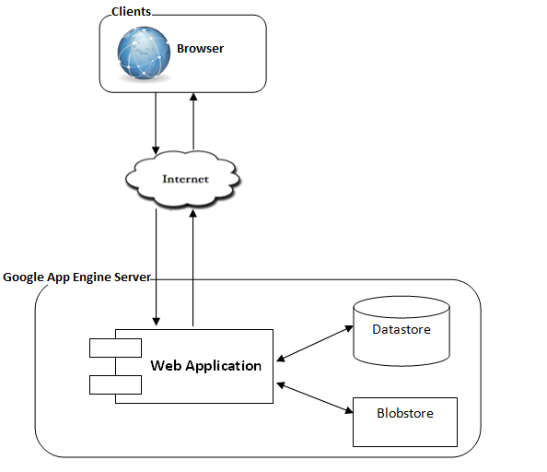

The system will use the Client-Server as the main architecture. It makes use of the Internet and common web protocols to deliver its services to the users.

The main entities of the above diagram will be described as following:

* **Google App Engine Server:**  lets you run web applications on Google's infrastructure. App Engine applications are easy to build, easy to maintain, and easy to scale as your traffic and data storage needs grow. With App Engine, there are no servers to maintain: You just upload your application, and it's ready to serve your users.
  + **App Engine Datastore:** this is the central data storage for the system. It provides a NoSQL schemaless object datastore, with a query engine and atomic transactions.
  + **The Blobstore API:**  allows your application to serve data objects, called blobs that are much larger than the size allowed for objects in the Datastore service. Blobs are useful for serving large files, such as video or image files, and for allowing users to upload large data files.
* **Clients:** these include internet browsers running on personal computers. The web browsers will interact with the web application via normal protocols (HTTP, HTTPS…). However it is also noted that they are not included in this project’s scope.

### *2.2. Web Application Architecture*

The architecture for the TLS web application will be depicted as the following diagram:



#### TLS.Client Component

#### This component is responsible for delivering the front end to the users and accepting their inputs. It be developed using MVP framework and handles event when user interact with the system. MVP application is designed and implement using the following figuge:

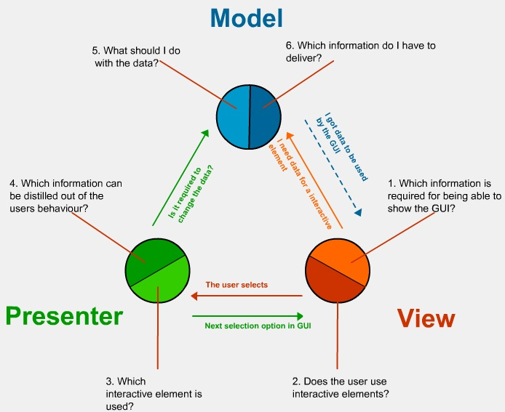

MVP is a user interface design pattern engineered to facilitate automated unit testing and improve the separation of concerns in presentation logic:

#### The model: is an interface defining the data to be displayed or otherwise acted upon in the user interface.

#### The view: is an interface that displays data (the model) and routes user commands (events) to the presenter to act upon that data.

#### The presenter: acts upon the model and the view. It retrieves data from repositories (the model), persist it, and formats it for display in the view.

#### TLS.Shared Share

#### This component includes classes that must be accessible to both the client GWT and server GAE code. Data Transfer Objects (those objects passed over GWT RPC) is saved in this component.

#### TLS.Server Component

#### This component contains all business logic of system. It includes ORM classes, data access layer.



## Detailed Design

### *3.1. <Human Resource Manager> Staff Management*

This part is the detailed design for the following use cases:

* View list of staff
* Edit a staff
* Delete a staff
* Create new a staff

#### Class diagram



#### Class Explanations

|  |  |  |  |  |
| --- | --- | --- | --- | --- |
| ***Class Name: UsersServiceImpl*** | | | | |
| Super class: | | | | |
| Sub class : | | | | |
| ***Responsibilities*** | | ***Collaborators:*** | | |
| Implement interface UsersService.java | |  | | |
|  | |  | | |
|  | |  | | |
| ***Function*** | ***Exception*** | ***Parameter*** | ***Return type*** | ***Descriptions*** |
| addUser |  | UserDTO user | UserDTO |  |
| deleteUser |  | String id | boolean |  |
| getUserList |  |  | List<UserDTO> |  |
| getUserById |  | String userId | UserDTO |  |
| updateUser |  | UserDTO userDTO | boolean |  |

### *3.2. <Human Resource Manager> Specialization management*

This part is the detailed design for the following use cases:

* View list of specialization
* Edit a specialization
* Delete a specialization
* Create new a specialization

#### Class diagram



#### Class Explanations

|  |  |  |  |  |
| --- | --- | --- | --- | --- |
| ***Class Name: SpecializeServiceImpl*** | | | | |
| Super class: | | | | |
| Sub class : | | | | |
| ***Responsibilities*** | | ***Collaborators:*** | | |
| Implement interface SpecializeService.java | |  | | |
|  | |  | | |
|  | |  | | |
| ***Function*** | ***Exception*** | ***Parameter*** | ***Return type*** | ***Descriptions*** |
| addSpecialize |  | SpecializeDTO specialize | SpecializeDTO |  |
| deleteSpecialize |  | String specializeId | boolean |  |
| deleteSpecializeList |  | List<SpecializeDTO> list | boolean |  |
| getSpecializeById |  | String specializeId | SpecializeDTO |  |
| getSpecList |  |  | List<SpecializeDTO> |  |
| updateSpecialize |  | SpecializeDTO specializeDTO | boolean |  |

### *3.3. <Human Resource Manager> Project Staff Management*

This part is the detailed design for the following use cases:

* View list of project staff
* Add staff to project

#### Class diagram



#### Class Explanations

|  |  |  |  |  |
| --- | --- | --- | --- | --- |
| ***Class Name: ProjectStaffServiceImpl*** | | | | |
| Super class: | | | | |
| Sub class : | | | | |
| ***Responsibilities*** | | ***Collaborators:*** | | |
| Implement interface ProjectStaffService.java | |  | | |
|  | |  | | |
|  | |  | | |
| ***Function*** | ***Exception*** | ***Parameter*** | ***Return type*** | ***Descriptions*** |
| addStaff |  | ProjectStaffDTO staff | ProjectStaffDTO | Create new staff |
| addStaff |  | String projectId, ProjectStaffDTO projectStaffDTO | ProjectStaffDTO | Add staff to project |
| deleteProjectStaff |  | String id | boolean |  |
| getAllPrjStaff |  |  | List<ProjectStaffDTO> |  |

### *3.4. <Admin> Account Management*

This part is the detailed design for the following use cases:

* View list of accounts
* Create new an account
* Update an account

#### Class diagram



#### Class Explanations

|  |  |  |  |  |
| --- | --- | --- | --- | --- |
| ***Class Name: UsersServiceImpl*** | | | | |
| Super class: | | | | |
| Sub class : | | | | |
| ***Responsibilities*** | | ***Collaborators:*** | | |
| Implement interface UsersService.java | |  | | |
|  | |  | | |
|  | |  | | |
| ***Function*** | ***Exception*** | ***Parameter*** | ***Return type*** | ***Descriptions*** |
| getUserListByStatus |  | String status | List<UserDTO> |  |
| getUserList |  |  | List<UserDTO> |  |
| getUserById |  | String id | UserDTO |  |
| updateUser |  | UserDTO userDTO | boolean |  |

### *3.5. <Admin> Project Space Management*

This part is the detailed design for the following use cases:

* View list of project space.
* Create new project space.
* Delete project space.

#### Class diagram



#### Class Explanations

|  |  |  |  |  |
| --- | --- | --- | --- | --- |
| ***Class Name: ProjectServiceImpl*** | | | | |
| Super class: | | | | |
| Sub class : | | | | |
| ***Responsibilities*** | | ***Collaborators:*** | | |
| Implement interface ProjectService.java | |  | | |
|  | |  | | |
|  | |  | | |
| ***Function*** | ***Exception*** | ***Parameter*** | ***Return type*** | ***Descriptions*** |
| addProject |  | ProjectDTO project | ProjectDTO |  |
| deleteProject |  | String id | boolean |  |
| deleteProjectList |  | List<ProjectDTO> list | boolean |  |
| getProjectList |  |  | List<ProjectDTO> |  |
| getProjectById |  | String projectId | ProjectDTO |  |

### 

### *3.6. <Director> Project Management*

This part is the detailed design for the following use cases:

* View list of project.
* View project Details
  + View list of project task.
  + View list of project staff.
  + View list of subcontractor.
  + View list of documents

#### Class diagram



#### Class Explanations

|  |  |  |  |  |
| --- | --- | --- | --- | --- |
| ***Class Name: ProjectServiceImpl*** | | | | |
| Super class: | | | | |
| Sub class : | | | | |
| ***Responsibilities*** | | ***Collaborators:*** | | |
| Implement interface ProjectService.java | |  | | |
|  | |  | | |
|  | |  | | |
| ***Function*** | ***Exception*** | ***Parameter*** | ***Return type*** | ***Descriptions*** |
| addProject |  | ProjectDTO project | ProjectDTO |  |
| deleteProject |  | String id | boolean |  |
| deleteProjectList |  | List<ProjectDTO> list | boolean |  |
| getProjectList |  |  | List<ProjectDTO> |  |
| getProjectById |  | String id | ProjectDTO |  |
| getListSubContructor |  | String projectId | SubConstructorDTO |  |
| getListTask |  | String projectId | ProjectTaskDTO |  |

### *3.7. <Director> Project Report Management*

This part is the detailed design for the following use cases:

* View list of project reports.
* View project report details

#### Class diagram



#### Class Explanations

|  |  |  |  |  |
| --- | --- | --- | --- | --- |
| ***Class Name: ProjectReportServiceImpl*** | | | | |
| Super class: | | | | |
| Sub class : | | | | |
| ***Responsibilities*** | | ***Collaborators:*** | | |
| Implement interface ProjectReportService.java | |  | | |
|  | |  | | |
|  | |  | | |
| ***Function*** | ***Exception*** | ***Parameter*** | ***Return type*** | ***Descriptions*** |
| addListReportDetail |  | String projectId, List<ProjectReportDetailDTO> list | boolean |  |
| addProjectReport |  | ProjectReportDTOprojectDTO, String projectId, List<ProjectReportDetailDTO> list | ProjectReportDTO |  |
| getAllProjectReport |  |  | List<ProjectReportDetailDTO> |  |
| updateStatusProjectReport |  | String id, int status | boolean |  |

### *3.8. <Project Management> Project Plan Management*

This part is the detailed design for the following use cases:

* View list of project tasks, task constrain.
* Create, update, delete and change status project tasks.

#### Class diagram



#### Class Explanations

|  |  |  |  |  |
| --- | --- | --- | --- | --- |
| ***Class Name: ProjTaskServiceImpl*** | | | | |
| Super class: | | | | |
| Sub class : | | | | |
| ***Responsibilities*** | | ***Collaborators:*** | | |
| Implement interface ProjTaskService.java | |  | | |
|  | |  | | |
|  | |  | | |
| ***Function*** | ***Exception*** | ***Parameter*** | ***Return type*** | ***Descriptions*** |
| CreateTask |  | ProjectTaskDTO taskDTO, List<ProjectTaskDTO> list | ProjectTaskDTO |  |
| deleteListTask |  | List<ProjectTaskDTO> list, List<ProjectTaskDTO> listAll | boolean |  |
| deleteSub |  | int , List<ProjectTaskDTO> list | boolean |  |
| getLastTaskId |  |  | int |  |
| getTaskById |  | String id | ProjectTaskDTO |  |
| getTaskByUserID |  | String projectId, String userId | List<ProjectTaskDTO> |  |
| updateTask |  | ProjectTaskDTO taskDTO | boolean |  |
| updateTaskForClose |  | ProjectTaskDTO taskDTO, List<ProjectTaskDTO> list | boolean |  |
| updateWorkOfParent |  | ProjectTaskDTO task, Double work, List<ProjectTaskDTO> list |  |  |

### *3.9. <Project Management> Daily report Management*

This part is the detailed design for the following use cases:

* View list of daily report.
* Update daily report.

#### Class diagram



#### Class Explanations

|  |  |  |  |  |
| --- | --- | --- | --- | --- |
| ***Class Name: DailyReportServiceImpl*** | | | | |
| Super class: | | | | |
| Sub class : | | | | |
| ***Responsibilities*** | | ***Collaborators:*** | | |
| Implement interface DailyReportService .java | |  | | |
|  | |  | | |
|  | |  | | |
| ***Function*** | ***Exception*** | ***Parameter*** | ***Return type*** | ***Descriptions*** |
| addDailyReport |  | DailyReportDTO dailyRp, String, List< DailyReportDetailDTO > list | DailyReportDTO |  |
| addListReportDetail |  | String taskId, List< DailyReportDetailDTO > list, String projectId | boolean |  |
| getAllDailyReport |  |  | List<DailyReportDTO> |  |
| getDailyReportByPM |  | String userId, int status | List<DailyReportDTO> |  |
| getDailyReportByProjectId |  | String projectId | List<DailyReportDTO> |  |
| updateStatusDailyReport |  | String id, int status | boolean |  |

### 

### *3.10. <Operator> Daily report Management*

This part is the detailed design for the following use cases:

* View list of daily report.
* Create new daily report.

#### Class diagram



#### Class Explanations

|  |  |  |  |  |
| --- | --- | --- | --- | --- |
| ***Class Name: DailyReportDetailServiceImpl*** | | | | |
| Super class: | | | | |
| Sub class : | | | | |
| ***Responsibilities*** | | ***Collaborators:*** | | |
| Implement interface DailyReportDetailService.java | |  | | |
|  | |  | | |
|  | |  | | |
| ***Function*** | ***Exception*** | ***Parameter*** | ***Return type*** | ***Descriptions*** |
| addDailyReportDetail |  | DailyReportDetailDTO dailyReport, String taskId | DailyReportDetailDTO |  |
| getDailyReportDetailByDaily |  | String id | List<DailyReportDetailDTO> |  |
| getDailyReportDetailByTask |  | String id, Date date | List<DailyReportDetailDTO> |  |
| updateReportDetail |  | DailyReportDetailDTO dailyRp, Double work | boolean |  |

### *3.11. <Operator> Project Task Management*

This part is the detailed design for the following use cases:

* View list of task that was assigned by PM

#### Class Diagram



#### Class Explanations

|  |  |  |  |  |
| --- | --- | --- | --- | --- |
| ***Class Name: ProjTaskServiceImpl*** | | | | |
| Super class: | | | | |
| Sub class : | | | | |
| ***Responsibilities*** | | ***Collaborators:*** | | |
| Implement interface ProjTaskService.java | |  | | |
|  | |  | | |
|  | |  | | |
| ***Function*** | ***Exception*** | ***Parameter*** | ***Return type*** | ***Descriptions*** |
| getLastTaskId |  |  | int |  |
| getTaskById |  | String id | ProjectTaskDTO |  |
| getTaskByUserID |  | String id, String userId | List<ProjectTaskDTO> |  |

### *3.12. Message Management*

This part is the detailed design for the following use cases:

* View list of message
* View message details
* Create new message.

#### Class Diagram

#### Class Explanations

|  |  |  |  |  |
| --- | --- | --- | --- | --- |
| ***Class Name: MessageServiceImpl*** | | | | |
| Super class: | | | | |
| Sub class : | | | | |
| ***Responsibilities*** | | ***Collaborators:*** | | |
| Implement interface MessageService.java | |  | | |
|  | |  | | |
|  | |  | | |
| ***Function*** | ***Exception*** | ***Parameter*** | ***Return type*** | ***Descriptions*** |
| getMessageList |  |  | List<MessageDTO> |  |
| sendMessage |  | MessageDTO message | MessageDTO |  |
| sendMessage |  | MessageDTO message, String projectId | List<ProjectTaskDTO> |  |
| updateParentMess |  | String parentId, int status |  |  |

### *3.13. Document Management*

This part is the detailed design for the following use cases:

* View list of documents
* Upload new document
* Delete a document.

#### Class Diagram



#### Class Explanations

|  |  |  |  |  |
| --- | --- | --- | --- | --- |
| ***Class Name: UploadServiceImpl*** | | | | |
| Super class: | | | | |
| Sub class : | | | | |
| ***Responsibilities*** | | ***Collaborators:*** | | |
| Implement interface UploadService.java | |  | | |
|  | |  | | |
|  | |  | | |
| ***Function*** | ***Exception*** | ***Parameter*** | ***Return type*** | ***Descriptions*** |
| deleteDoc |  | List<DocumentDTO> listDoc | boolean |  |
| deleteDoc |  | String id | boolean |  |
| getBlobs |  | String forId, String dataType | List<DocumentDTO> |  |
| getBlobStoreUrl |  |  | String |  |

## Sequence Diagram

### *4.1. Admin sequence diagram*



**View list of accounts sequence diagram**



**Create new an account sequence diagram**



**View list of project sequence Diagram**



**View project detail sequence Diagram**

### *4.2. Director sequence diagram*



**View project detail sequence Diagram**

**View list of project reports**



**View project report details**

### *4.3. Human resource manager sequence diagram*



**Create new Staff sequence diagram**



**Delete Staff sequence diagram**

### *4.4. Project Manager Sequence diagram*



**Create project task sequence diagram**



**Create task constrains sequence diagram**



**Update project task sequence diagram**



**View list of daily report sequence diagram**

### *4.5. Operator sequence diagram*



**View list of daily report sequence diagram**



**Create new daily report sequence diagram**

## User Interface Design

### *5.1. Login Screen*

### 

### *5.2. View list of account screen*

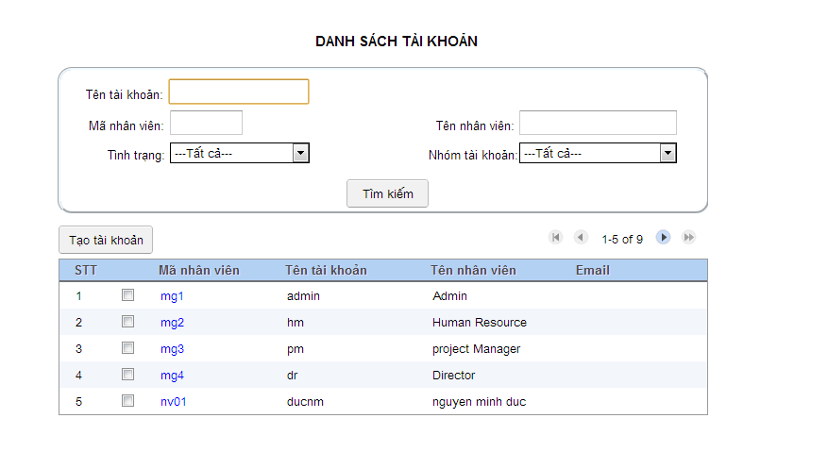

### *5.3. Create new project space screen*

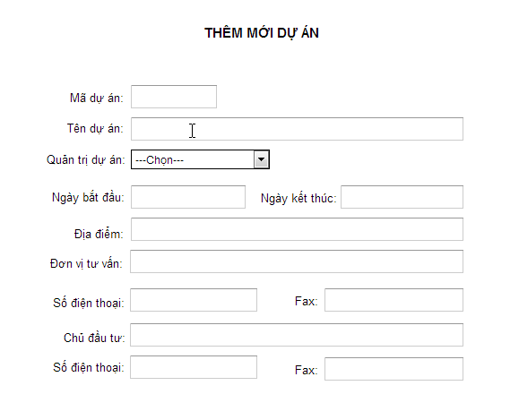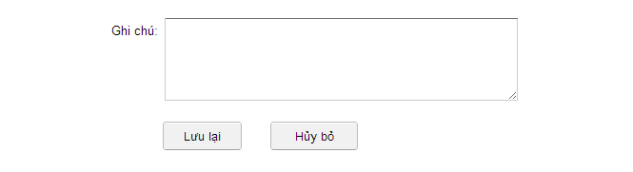

### *5.4. Create new an account screen.*

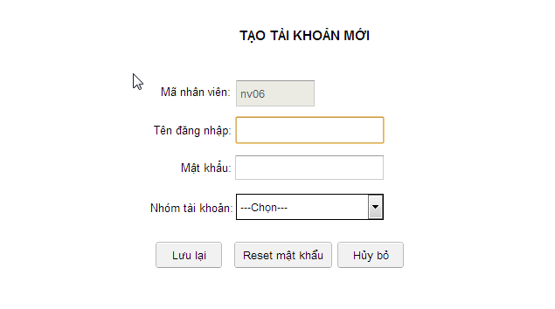

### *5.5. View list of project screen.*

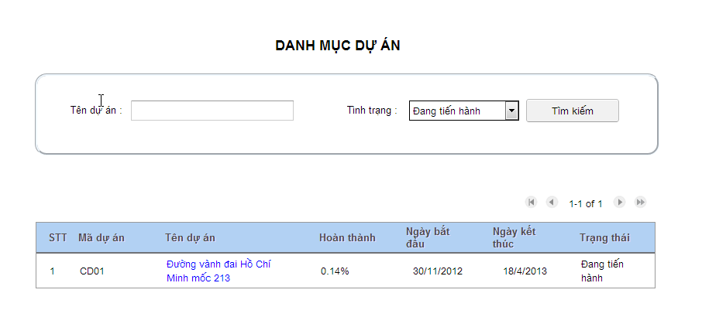

### 

### *5.6. View project plan screen.*

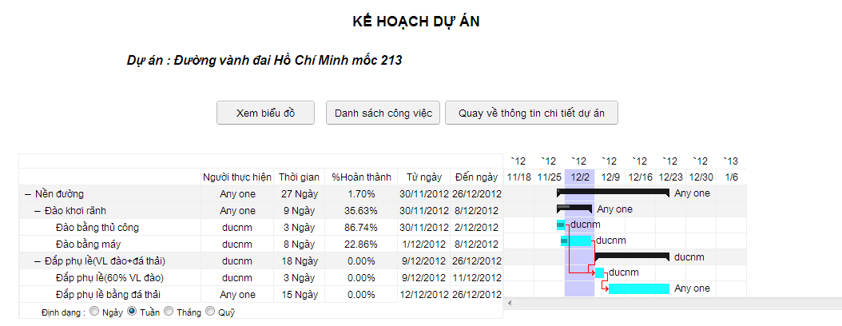

### *5.7. View list of project task screen.*

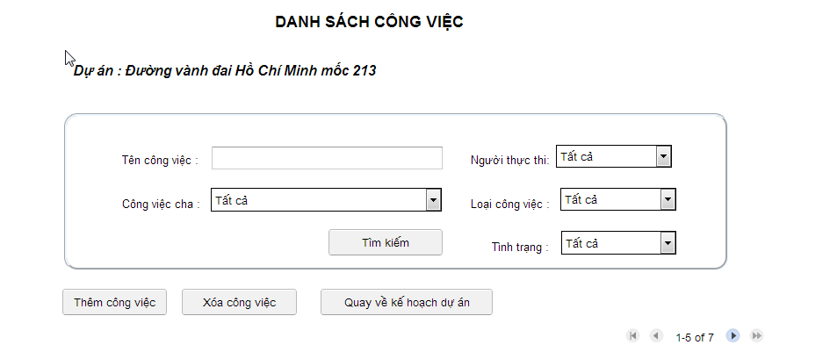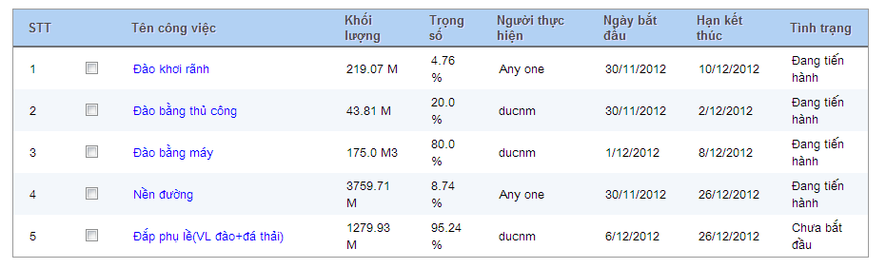

### *5.8. View list of daily report screen.*

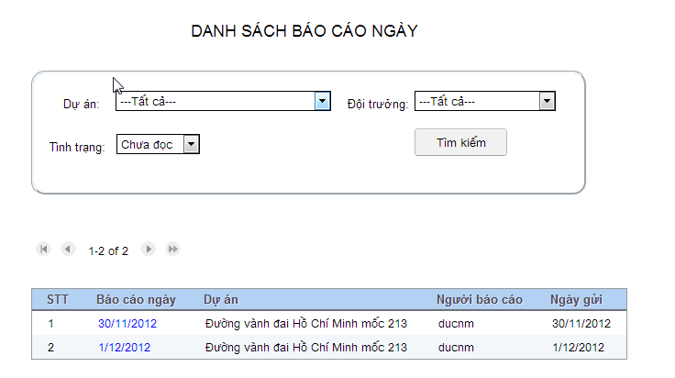

### *5.9. Create new a daily report screen.*

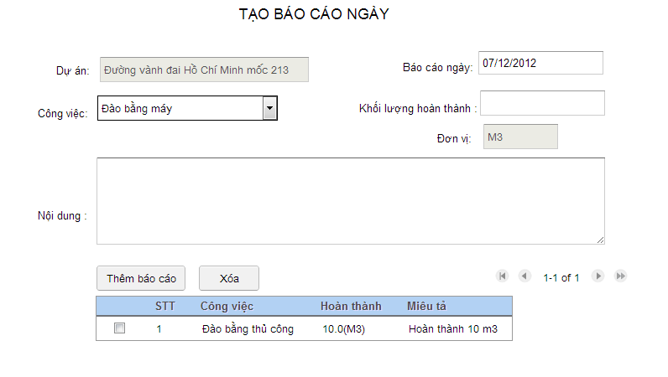

## Entity Relationship Diagram



# Software Test Documentation

## Introduction

## Documentation Overview

This document is a Software Test Documentation for the TLS system.  
It contains various resource that decide the successful of project such as Test Plan, Checklists, Test case, Test Report.

## Scope of Testing

The testing for the TLS system will consist of Unit Test, Integration/ System Test and Acceptance Test levels. It is hoped that there will be at least one full time independent test person for system/integration testing. However, with the time line established, most testing will be done by the tester with the development team’s participation.

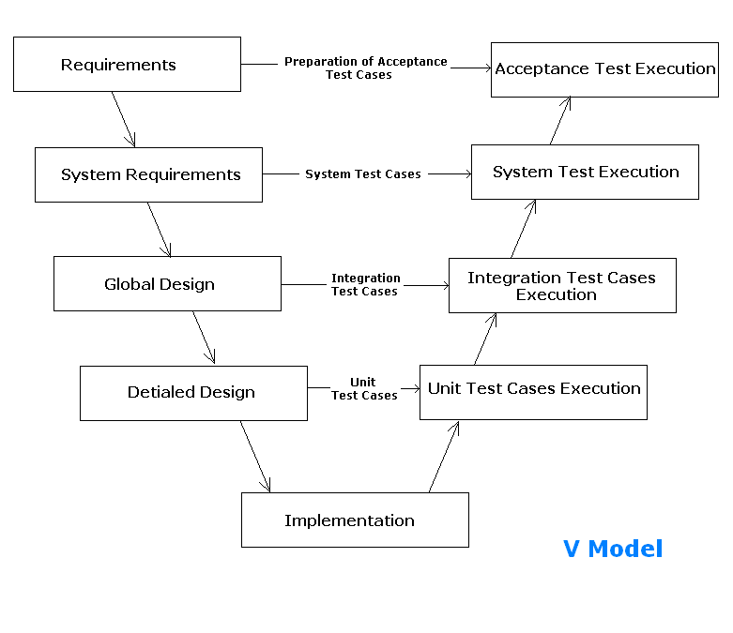

**Figure 5.0** **V Model - Software Development Life Cycle**

* Unit Testing will be done by the developers and will be approved by the implementing team leader. All unit test information (sample, output, data printouts, and defect information…) will be managed by developers and it must be showed when team required.
* System/Integration Testing will be performed by the test manager and implementing team leader with assistance from the individual developers as required.
* Acceptance Testing will be performed by the test manager and development team leader. The acceptance test will be done for a period of 2 weeks after completion of the System/Integration test process. Programs will enter into Acceptance test after all critical and major defects have been corrected. A program may have one major defect as long as it does not obstruct testing of the program (There is a work around for the error). Prior to final completion of acceptance testing all open critical and major defects must be corrected.

## Test Plan

## Features to be tested

Base on role of user, we define feature to be test as below:

To Administrator, Features to be test contain:

|  |  |  |  |
| --- | --- | --- | --- |
| **No.** | **Features** | **Description** | **Functions** |
| **1** | Log in – log out | User can log in to access specified function or log out whenever they want | Log in  Log out |
| **2** | Manage Account | User can view list, add, update and search account | View Staff List  Add Account  Update Account  Search Account |
| **3** | Manage Project Space | User can view list, create, update, delete and search project space | View project space List  Create Project Space  Update Project Space  Delete Project Space  Search Project Space |
| **4** | Manage Message | User can view list, view detail, add and search message | View Message List  Add Message  Search Message  View Message Detail & Feedback |
| **5** | View General Information | Use this function to view general information | View General Information |

To Director, features to be tested contain:

|  |  |  |  |
| --- | --- | --- | --- |
| **No.** | **Features** | **Description** | **Functions** |
| **1** | Log in – log out | User can log in to access specified function or log out whenever they want | Log in  Log out |
| **2** | Manage Project | User can view project list, search project, view project detail. | View Project List  Search Project  View Task List & Project Information  View Project Documentation List  View Subcontructor List  View Gantt Chart |
| **3** | Manage Project Report | User can view project report list, search project report, view project report detail | View Project Report List  Search Project Report  View Project Report Information |
| **4** | Manage Message | User can view list, view detail, add and search message | View Message List  Add Message  Search Message  View Message Detail & Feedback |
| **5** | Require Human Resource | Use this function to decide required human resource | View Human Resource Information  Decide Require Human Resource |
| **6** | View General Information | Use this function to view general information | View General Information |

To Human Resource Manager, features to be tested contain:

|  |  |  |  |
| --- | --- | --- | --- |
| **No.** | **Features** | **Description** | **Functions** |
| **1** | Log in – log out | User can log in to access specified function or log out whenever they want | Log in  Log out |
| **2** | Manage Staff | User can User can view list, delete, add, update, search staff | View Staff List  Delete Staff  Add Staff  Update Staff  Search Staff |
| **3** | Manage Specialty | User can view list, delete, add, update, specialty | View Specialty List  Delete Specialty  Add Specialty  Update Specialty |
| **4** | Manage Project | User can view list of project, search project, view project detail | View Project List  Search Project  View Project's Staff List  View Project Information |
| **5** | Add Resource to Project | User can search staff and add resource to project | Search Staff  Add Resource To Project |
| **6** | Manage Message | User can view list, view detail, add and search message | View Message List  Add Message  Search Message  View Message Detail & Feedback |
| **7** | Require Human Resource | User can View Require Human Resource Information | View Human Resource Information  Provide Require Human Resource |
| **8** | View General Information | Use this function to view general information | View General Information |

To Operator, features to be tested contain:

|  |  |  |  |
| --- | --- | --- | --- |
| **No.** | **Features** | **Description** | **Functions** |
| **1** | Log in – log out | User can log in to access specified function or log out whenever they want | Log in  Log out |
| **2** | Manage Project | User can view task list & project information, view task detail. | View Task List & Project Information  View Task Information  View Task Constraint List  View Task Documentation List  Create line chart |
| **3** | Manage Daily Report | User can view list, view detail, create and search daily report | View Daily Report List  View Daily Report Detail  Create Daily Report  Search Daily Report |
| **4** | Manage Message | User can view list, view detail, add and search message | View Message List  Add Message  Search Message  View Message Detail & Feedback |
| **5** | View General Information | Use this function to view general information | View General Information |

To Project Manager, features to be tested contain:

|  |  |  |  |
| --- | --- | --- | --- |
| **No.** | **Features** | **Description** | **Functions** |
| **1** | Log in – log out | User can log in to access specified function or log out whenever they want | Log in  Log out |
| **3** | Manage Task | User can view list, add, update, delete, require staff and search task | View Task List  Add Task  Update Task  Delete Task  Search Task  Require Staff |
| **4** | Manage Staff | User can view list, search, assign task, confirm human resource, remove human resource | View Staff List  Search Staff  Accept Human Resource  Remove Human Resource  Assign Task |
| **5** | Manage Subcontractor | User can view list, add, update, delete subcontractor | View Subcontractor List  Add Subcontractor  Update Subcontractor  Delete Subcontractor |
| **6** | Require Human Resource | User can view require human resource information | View Task List  View Human Resource Information  Send Require Human Resource |
| **7** | View Task Detail | User can view task information,change task status, manage task constraint,Create line chart, manage document task | View task information  Change task status  Manage task constraint  Create line chart  Manage document task |
| **8** | View Project Detail | User can view project information & task list, change project status, view project documentation list,  view gantt chart, update project's information | View project information & task list  Change project status  View project documentation list  View gantt chart  Update project's information |
| **9** | Manage Project | User can view project list, search project | View Project List  Search Project |
| **10** | Manage Daily Report | User can view list, view detail, update and search daily report | View Daily Report List  View Daily Report Detail  Search Daily Report |
| **11** | Manage Project Report | User can view list, search, create, view detail | View Project Report List  Search Project Report  Create Project Report  View Project Report Information |
| **12** | Manage Message | User can view list, view detail, add and search message | View Message List  Add Message  Search Message  View Message Detail & Feedback |
| **13** | View General Information | Use this function to view general information | View General Information |

## Features not to be tested

N/A

## Testing Tools and Environments

|  |  |
| --- | --- |
| Environment | |
| **Hardware** | Computer with CPU Intel Pentium(R) 4 2.4 GHz or higher and internet connection Ram 512Mb or higher |
| **Software** | Microsoft Word & Excel 2010 |
| **Operation system for server & client** | Windows 7 32bit |
| **Browser** | Chrome, Firefox |

## Resource

Developer, tester and project manager has to join in testing process.

|  |  |
| --- | --- |
| Resource | Responsibility |
| **Developers** | Unit test, fix all bugs after testing |
| **Tester** | Create test cases, test plan, test report, bug list report |
| Prepare data to test |
| Log bugs |
| Test and retest to limit maximize bugs |
| **Project manager** | Responsible for project schedules |

## Test Cases

## Administrator

|  |  |  |  |  |  |  |  |
| --- | --- | --- | --- | --- | --- | --- | --- |
| No | Function | Decription | No | Input | Output expected | Result | Test dae |
| 1 | Log-on | Log On | 1 | Leave any logon textbox blank and click “Đăng nhập” button | “Bạn đã nhập sai Tài khoản hoặc Mật khẩu! Hãy nhập lại!” message show to remind user input all information | Pass | 28/11/2012 |
| 2 | Input wrong account information | “Bạn đã nhập sai Tài khoản hoặc Mật khẩu! Hãy nhập lại!” message show to notice user input information incorrectly | Pass | 28/11/2012 |
| 3 | Input an inactive account information | “Bạn đã nhập sai Tài khoản hoặc Mật khẩu! Hãy nhập lại!” message show to notice that current account has been deactived | Pass | 28/11/2012 |
| 4 | Input user account information | Redirect to user page | Pass | 28/11/2012 |
| 2 | Log-out | Log-out | 1 | click “Đăng xuất” button | Redirect to “Log-in” page | Pass | 28/11/2012 |
| ***Manage Account*** | | | | | | | |
| 3 | View Staff List | View Staff list | 1 | Click on “Quản lý tài khoản”button | “Danh sách tài khoản” page will be displayed with list of staff. | Pass | 28/11/2012 |
| 4 | Add Account | Add Account page | 1 | 1. Choose only one checkbox in list of staff.  2. Clicks on “Tạo tài khoản" button. | “Tạo tài khoản mới” page will be displayed with the following information: - Titile: Tạo tài khoản mới - Labels: Mã nhân viên, Tên đăng nhập, Mật khẩu, Nhóm tài khoản. - Textfields: Mã nhân viên (is disabled), Tên đăng nhập, Mật khẩu. - DropDown List: Nhóm tài khoản. - 3 buttons: Lưu lại, Reset mật khẩu, Hủy bỏ. | Pass | 28/11/2012 |
| Add Account successful | 2 | 1. Input valid information 2. Click to "Lưu lại" button | “Thêm tài khoản thành công” message will be displayed and Redirect to”Danh sách tài khoản” page. Check in DB: all information are added. | Pass | 28/11/2012 |
| 5 | Update Account | Update Account Page | 1 | Click on “Mã nhân viên” hyperlink | “Cập nhật tài khoản” page will be displayed with the following information: - Titile: Cập nhật tài khoản - Labels: Mã nhân viên, Tên đăng nhập, Mật khẩu, Nhóm tài khoản. - Textfields: Mã nhân viên (is disabled), Tên đăng nhập (is disabled), Mật khẩu. - DropDown List: Nhóm tài khoản. - 3 buttons: Lưu lại, Reset mật khẩu, Hủy bỏ. | Pass | 28/11/2012 |
| Update Account Successful | 2 | 1. Input valid information 2. Click to "Lưu lại" button | “Cập nhật tài khoản thành công” message will be displayed and Redirect to”Danh sách tài khoản” page. Check in DB: all information are added. | Pass | 28/11/2012 |
| 6 | Search Account | Search Account Page | 3 | Click on “Quản lý tài khoản” button. | “Danh sách tài khoản” page will be displayed with the following information: - Titile: Danh sách tài khoản - Labels: Tên tài khoản, Mã nhân viên, Tên nhân viên, Tình trạng, Nhóm tài khoản. - Textfields: Tên tài khoản, Mã nhân viên, Tên nhân viên. - DropDown List: Tình trạng, Nhóm tài khoản. - 1 button: Tìm kiếm. | Pass | 28/11/2012 |
| Search Account Successful | 1 | 1. Don't input any information  2. Click on "Tìm kiếm" button | List of all staff will be displayed | Pass | 28/11/2012 |
| 2 | 1. Input existed information  2. Click on "Tìm kiếm" button | List of existed information staff will be displayed | Pass | 28/11/2012 |
| 3 | 1. Input unexisted information  2. Click on "Tìm kiếm" button | Don't display anything | Pass | 28/11/2012 |
| ***Manage Project Space*** | | | | | | | |
| 7 | View project space List | View project space List | 1 | Click on “Danh mục dự án”button | “Danh sách dự án” page will be displayed with list of project. | Pass | 28/11/2012 |
| 8 | Create Project Space | Create Project Space page | 6 | 1. Clicks on “Thêm mới" button. | “Thêm mới dự án” page will be displayed with the following information: - Titile: Thêm mới dự án - Labels: Mã dự án (is disable),Tên dự án,Quản trị dự án,Ngày bắt đầu,Ngày kết thúc, Địa điểm, Đơn vị tư vấn, Số điện thoại, Fax,Chủ đầu tư, Số điện thoại,Fax,Ghi chú. - Textfields: Mã dự án,Tên dự án, Ngày bắt đầu,Ngày kết thúc, Địa điểm, Đơn vị tư vấn, Số điện thoại, Fax,Chủ đầu tư, Số điện thoại,Fax,Ghi chú. - DropDown List: Quản trị dự án. - 2 buttons: Lưu lại, Hủy bỏ. | Pass | 28/11/2012 |
| Create Project Space Successful | 7 | 1. Input valid information 2. Click to "Lưu lại" button | “Thêm mới thành công” message will be displayed and Redirect to”Danh sách dự án” page. Check in DB: all information are added. | Pass | 28/11/2012 |
| 9 | Update Project Space | Update Project Space Page | 9 | Click on “Mã dự án” hyperlink | “Thêm mới dự án” page will be displayed with the following information: - Titile: Thêm mới dự án - Labels: Mã dự án,Tên dự án,Quản trị dự án,Ngày bắt đầu,Ngày kết thúc, Địa điểm, Đơn vị tư vấn, Số điện thoại, Fax,Chủ đầu tư, Số điện thoại,Fax,Ghi chú. - Textfields: Mã dự án,Tên dự án, Ngày bắt đầu,Ngày kết thúc, Địa điểm, Đơn vị tư vấn, Số điện thoại, Fax,Chủ đầu tư, Số điện thoại,Fax,Ghi chú. - DropDown List: Quản trị dự án. - 2 buttons: Lưu lại, Hủy bỏ. | Pass | 28/11/2012 |
| 10 |  | Update Project Space Successful |  | 1. Input valid information 2. Click on "Lưu lại" button | “Cập nhật thành công” message will be displayed and Redirect to”Danh sách tài khoản” page. Check in DB: all information are added. | Pass | 28/11/2012 |
| 11 | Delete Project Space | Delete Successful | 1 | 1. Choose checkbox in list of staff.  2. Click on "Xóa" button 3. Click on "Ok" button | 1. Popup will appear with content: "Bạn có chắc chắn muốn xóa?"  2. Project space will be deleted.  Check in DB:  Project space is deleted from Database. | Pass | 28/11/2012 |
| Delete Unsuccessful | 2 | 1. Choose checkbox in list of staff.  2. Click on "Xóa" button 3. Click on "Cancel" button | 1. Popup will appear with content: “Bạn có chắc chắn muốn xóa?"  2. Popup will be closed. | Pass | 28/11/2012 |
| 12 | Search Project Space | Search Project Page | 1 | Click on “Danh sách dự án” button. | “Danh sách dự án” page will be displayed with the following information: - Titile: Danh sách dự án - Labels: Mã dự án, Tên dự án, Tình trạng. - Textfields: Mã dự án, Tên dự án. - DropDown List: Tình trạng. - 1 button: Tìm kiếm. | Pass | 28/11/2012 |
| Search Project Successful | 2 | 1. Don't input any information  2. Click on "Tìm kiếm" button | List of all project will be displayed | Pass | 28/11/2012 |
| 3 | 1. Input existed information  2. Click on "Tìm kiếm" button | List of existed information project will be displayed | Pass | 28/11/2012 |
| 4 | 1. Input unexisted information  2. Click on "Tìm kiếm" button | Don't display anything | Pass | 28/11/2012 |
| ***Manage Message*** | | | | | | | |
| 13 | View Message List | View Message List | 1 | Click on “Danh mục tin nhắn”button | “Danh sách tin nhắn” page will be displayed with list of message. | Pass | 28/11/2012 |
| 14 | Add Message | Add Message page | 6 | 1. Clicks on “Soạn tin nhắn" button. | “Gửi tin nhắn” page will be displayed with the following information: - Titile: Gửi tin nhắn - Labels: Tài khoản, Chức vụ, Người nhận, Tiêu đề, Nội dung, Đính kèm. - Textfields: Tài khoản, Tiêu đề, Nội dung. - DropDown List: Chức vụ, Người nhận.  - Uploadform: Đính kèm. - 2 buttons: Gửi, Xóa trắng, Quay lại tin nhắn | Pass | 28/11/2012 |
|  |  | Add Message Successful | 7 | 1. Input valid information 2. Click to "Gửi" button | “Thêm mới thành công” message will be displayed and Redirect to”Danh sách tin nhắn” page. Check in DB: all information are added. | Pass | 28/11/2012 |
| 15 | Search Message | Search Message Page | 1 | Click on “Danh mục tin nhắn” button. | “Danh sách tin nhắn” page will be displayed with the following information: - Titile: Danh sách tin nhắn. - Labels: Người gửi, Chủ đề, Tin nhắn, Tình trạng. - Textfields: Người gửi, Chủ đề. - DropDown List: Tin nhắn, Tình trạng. - 1 button: Tìm kiếm. | Pass | 28/11/2012 |
| Search Message Successful | 1 | 1. Don't input any information  2. Click on "Tìm kiếm" button | List of all message will be displayed | Pass | 28/11/2012 |
| 2 | 1. Input existed information  2. Click on "Tìm kiếm" button | List of existed information message will be displayed | Pass | 28/11/2012 |
| 3 | 1. Input unexisted information  2. Click on "Tìm kiếm" button | Don't display anything | Pass | 28/11/2012 |
| 16 | View Message Detail | View Message Detail | 1 | Click on “Tiêu đề”hyperlink | “Chi tiết tin nhắn” page will be displayed. | Pass | 28/11/2012 |
| 17 | View General Information | View General Information | 1 | Click on “Thông tin tổng hợp ”button | “Thông tin tổng hơp” page will be displayed. | Pass | 28/11/2012 |

## Director

|  |  |  |  |  |  |  |  |
| --- | --- | --- | --- | --- | --- | --- | --- |
| No | Function | Decription | No | Input | Output expected | Result | Test dae |
| 1 | Log-on | Log On | 1 | Leave any logon textbox blank and click “Đăng nhập” button | “Bạn đã nhập sai Tài khoản hoặc Mật khẩu! Hãy nhập lại!” message show to remind user input all information | Pass | 28/11/2012 |
| 2 | Input wrong account information | “Bạn đã nhập sai Tài khoản hoặc Mật khẩu! Hãy nhập lại!” message show to notice user input information incorrectly | Pass | 28/11/2012 |
| 3 | Input an inactive account information | “Bạn đã nhập sai Tài khoản hoặc Mật khẩu! Hãy nhập lại!” message show to notice that current account has been deactived | Pass | 28/11/2012 |
| 4 | Input user account information | Redirect to user page | Pass | 28/11/2012 |
| 2 | Log-out | Log-out | 1 | click “Đăng xuất” button | Redirect to “Log-in” page | Pass | 28/11/2012 |
| ***Manage Project Space*** | | | | | | | |
| 3 | View project List | View project List | 1 | Click on “Danh mục dự án”button | “Danh sách dự án” page will be displayed with list of project. | Pass | 28/11/2012 |
| 4 | View Task List & Project Information | View Task List & Project Information | 1 | 1. Clicks on “Tên dự án" hyperlink. | “Thông tin chi tiết dự án” page will be displayed with “Thông tin chi tiết dự án” page will be displayed with the project information and list of task. | Pass | 28/11/2012 |
| 5 | View Project Documentation List | View Project Documentation List | 1 | Click on “Tài liệu” button. | “Danh sách tài liệu” page will be displayed with list of document. | Pass | 28/11/2012 |
| 6 | View Operator List | View Operator List | 1 | Click on “Nhà thầu phụ” button. | “Danh sách nhà thầu phụ” page will be displayed with list of operator. | Pass | 28/11/2012 |
| 7 | View Gantt Chart | View Gantt Chart | 1 | Click on “Xem biểu đồ” button. | “Kế hoạch dự án” page will be displayed with gantt chart. | Pass | 28/11/2012 |
| 8 | Search Project Space | Search Project Page | 1 | Click on “Danh sách dự án” button. | “Danh sách dự án” page will be displayed with the following information: - Titile: Danh sách dự án - Labels: Mã dự án, Tên dự án, Tình trạng. - Textfields: Mã dự án, Tên dự án. - DropDown List: Tình trạng. - 1 button: Tìm kiếm. | Pass | 28/11/2012 |
| Search Project Successful | 2 | 1. Don't input any information  2. Click on "Tìm kiếm" button | List of all project will be displayed | Pass | 28/11/2012 |
| 3 | 1. Input existed information  2. Click on "Tìm kiếm" button | List of existed information project will be displayed | Pass | 28/11/2012 |
| 4 | 1. Input unexisted information  2. Click on "Tìm kiếm" button | Don't display anything | Pass | 28/11/2012 |
| **Manage Project Report** | | | | | | | |
| 10 | View Project Report List | View Project Report List | 1 | Click on “Danh mục báo cáo dự án”button. | “Danh sách báo cáo dự án” page will be displayed with list of project report. | Pass | 28/11/2012 |
| 11 | Search Project Report | Search Project Report Page | 1 | Click on “Danh mục báo cáo dự án” button. | “Danh mục báo cáo dự án” page will be displayed with the following information: - Titile: Danh mục báo cáo dự án. - Labels: Quản lý, Dự án, Tình trạng. - DropDown List: Quản lý, Dự án, Tình trạng. - 1 button: Tìm kiếm. | Pass | 28/11/2012 |
| Search Message Successful | 2 | 1. Don't input any information  2. Click on "Tìm kiếm" button | List of project report with status “chưa đọc” will be displayed | Pass | 28/11/2012 |
| 3 | 1. Input existed information  2. Click on "Tìm kiếm" button | List of existed project report will be displayed | Pass | 28/11/2012 |
| 4 | 1. Input unexisted information  2. Click on "Tìm kiếm" button | Don't display anything | Pass | 28/11/2012 |
| 12 | Update Project Report | Update Project Report | 1 | Click on “Báo cáo ngày” hyperlink | “Chi tiết báo cáo dự án” page will be displayed with the following information: - Titile: Chi tiết báo cáo dự án - Labels: Khối lượng. - Textfields: Khối lượng. - 2 buttons: Lưu lại, Hủy bỏ. | Pass | 28/11/2012 |
|  |  | Update Project Space Successful | 2 | 1. Input valid information 2. Click on "Lưu lại" button | Success message will be displayed and Redirect to”Danh sách báo cáo dự án” page. Check in DB: all information are updated. | Pass | 28/11/2012 |
| 13 | View Project Report Information |  | 1 | Click on “Báo cáo ngày” hyperlink | “Chi tiết báo cáo dự án” page will be displayed with project report detail. | Pass | 28/11/2012 |
| **Require Human Resource** | | | | | | | |
| 14 | View Human Resource Information |  | 1 | Click on “Mã dự án” hyperlink | “Kế hoạch nhân sự dự án” page will be displayed. | Pass | 28/11/2012 |
| 15 | Decide Require Human Resource | Decide Require Human Resource Successful | 1 | Click on “Phê duyệt”button  Click on “Ok”button | 1. Popup will appear with content: "Bạn có muốn phê duyệt?"  2. Require Human Resource will be added. | Pass | 28/11/2012 |
| Decide Require Human Resource Unuccessful | 2 | Click on “Hủy yêu cầu”button  Click on “Ok”button | 1. Popup will appear with content: “Bạn có muốn hủy yêu cầu?"  2. Popup will be closed. | Pass | 28/11/2012 |
| ***Manage Message*** | | | | | | | |
| 16 | View Message List | View Message List | 1 | Click on “Danh mục tin nhắn”button | “Danh sách tin nhắn” page will be displayed with list of message. | Pass | 28/11/2012 |
| 17 | Add Message | Add Message page | 1 | 1. Clicks on “Soạn tin nhắn" button. | “Gửi tin nhắn” page will be displayed with the following information: - Titile: Gửi tin nhắn - Labels: Tài khoản, Chức vụ, Người nhận, Tiêu đề, Nội dung, Đính kèm. - Textfields: Tài khoản, Tiêu đề, Nội dung. - DropDown List: Chức vụ, Người nhận.  - Uploadform: Đính kèm. - 2 buttons: Gửi, Xóa trắng, Quay lại tin nhắn | Pass | 28/11/2012 |
|  | Add Message Successful | 2 | 1. Input valid information 2. Click to "Gửi" button | Success message will be displayed and Redirect to”Danh sách tin nhắn” page. Check in DB: all information are added. | Pass | 28/11/2012 |
| 18 | Search Message | Search Message Page | 1 | Click on “Danh mục tin nhắn” button. | “Danh sách tin nhắn” page will be displayed with the following information: - Titile: Danh sách tin nhắn. - Labels: Người gửi, Chủ đề, Tin nhắn, Tình trạng. - Textfields: Người gửi, Chủ đề. - DropDown List: Tin nhắn, Tình trạng. - 1 button: Tìm kiếm. | Pass | 28/11/2012 |
| Search Message Successful | 2 | 1. Don't input any information  2. Click on "Tìm kiếm" button | List of all message will be displayed | Pass | 28/11/2012 |
| 3 | 1. Input existed information  2. Click on "Tìm kiếm" button | List of existed information message will be displayed | Pass | 28/11/2012 |
| 4 | 1. Input unexisted information  2. Click on "Tìm kiếm" button | Don't display anything | Pass | 28/11/2012 |
| 19 | View Message Detail | View Message Detail | 1 | Click on “Tiêu đề”hyperlink | “Chi tiết tin nhắn” page will be displayed. | Pass | 28/11/2012 |
| 20 | View General Information | View General Information | 1 | Click on “Thông tin tổng hợp ”button | “Thông tin tổng hơp” page will be displayed. | Pass | 28/11/2012 |

## Human Resoure Manager

|  |  |  |  |  |  |  |  |
| --- | --- | --- | --- | --- | --- | --- | --- |
| No | Function | Decription | No | Input | Output expected | Result | Test dae |
| 1 | Log-on | Log On | 1 | Leave any logon textbox blank and click “Đăng nhập” button | Error message show to remind user input all information | Pass | 29/11/2012 |
| 2 | Input wrong account information | Error message show to notice user input information incorrectly | Pass | 29/11/2012 |
| 3 | Input an inactive account information | Error message show to notice that current account has been deactived | Pass | 29/11/2012 |
| 4 | Input user account information | Redirect to user page | Pass | 29/11/2012 |
| 2 | Log-out | Log-out | 1 | click “Đăng xuất” button | Redirect to “Log-in” page | Pass | 29/11/2012 |
| ***Manage Project*** | | | | | | | |
| 3 | View project List | View project List | 1 | Click on “Danh mục dự án”button | “Danh sách dự án” page will be displayed with list of project. | Pass | 29/11/2012 |
| 4 | View Project’s Staff List | View Project’s Staff List | 1 | Clicks on “Danh sách nhân viên" button. | “Danh sách nhân viên dự án” page will be displayed with list of staff | Pass | 29/11/2012 |
| 5 | View Project Information | View Project Information | 1 | Click on “Mã dự án” hyperlink. | “Thông tin chi tiết dự án” page will be displayed with project’s information. | Pass | 29/11/2012 |
| 6 | Search Project | Search Project Page | 1 | Click on “Danh mục dự án” button. | “Danh mục dự án” page will be displayed with the following information: - Titile: Danh sách dự án - Labels: Mã dự án, Tên dự án, Tình trạng, Từ ngày, Đến ngày. - Textfields: Mã dự án, Tên dự án. - DropDown List: Tình trạng.  - Datebox: Từ ngày, Đến ngày. - 1 button: Tìm kiếm. | Pass | 29/11/2012 |
| Search Project Successful | 2 | 1. Don't input any information  2. Click on "Tìm kiếm" button | List of all project will be displayed | Pass | 29/11/2012 |
| 3 | 1. Input existed information  2. Click on "Tìm kiếm" button | List of existed information project will be displayed | Pass | 29/11/2012 |
| 4 | 1. Input unexisted information  2. Click on "Tìm kiếm" button | Don't display anything | Pass | 29/11/2012 |
| **Manage Specialty** | | | | | | | |
| 7 | View Specialty List | View Specialty List | 1 | Click on “Danh mục Chuyên môn”button. | “Danh sách chuyên môn” page will be displayed with list of specialty. | Pass | 29/11/2012 |
| 8 | Add Specialty | Add Specialty Page | 1 | Click on “Thêm mới” button. | “Thêm mới thông tin chuyên môn” page will be displayed with the following information: - Titile: Thêm mới thông tin chuyên môn.  - Textfields: Chuyên môn, Mô tả. - Labels: Chuyên môn, Mô tả. - 2button: Lưu lại, Quay lại. | Pass | 29/11/2012 |
| Add Specialty Successful | 2 | 1. Input valid information 2. Click to "Lưu lại" button | Success message will be displayed and Redirect to”Danh sách chuyên môn” page. Check in DB: all information is added. | Pass | 29/11/2012 |
|  |
| 9 | Update Specialty | Update Specialty page | 1 | Click on “Chuyên môn” hyperlink | “Cập nhật thông tin chuyên môn” page will be displayed with the following information: - Titile: Cập nhật thông tin chuyên môn  - Textfields: Chuyên môn, Mô tả. - Labels: Chuyên môn, Mô tả. - 2button: Lưu lại, Quay lại. | Pass | 29/11/2012 |
| Update Specialty Successful | 2 | 1. Input valid information 2. Click on "Lưu lại" button | Success message will be displayed and Redirect to”Danh sách báo cáo dự án” page. Check in DB: all information is updated. | Pass | 29/11/2012 |
| 10 | Delete Specialty | Delete Specialty Successful | 1 | 1. Choose checkbox in list of specialty.  2. Click on "Xóa" button 3. Click on "Ok" button | 1. Popup will appear with content: "Bạn có chắc chắn muốn xóa?"  2. Project space will be deleted.  Check in DB:  Specialty is deleted from Database. | Pass | 29/11/2012 |
| 11 |  | Delete Specialty Unsuccessful | 2 | 1. Choose checkbox in list of specialty.  2. Click on "Xóa" button 3. Click on "Cancel" button | 1. Popup will appear with content: “Bạn có chắc chắn muốn xóa?"  2. Popup will be closed. |  | 29/11/2012 |
| **Add Resource to Project** | | | | | | | |
| 12 | Search Staff | Search Staff Page | 1 | Click on “Thêm nhân viên vào dự án” button. | “Thêm nhân viên vào dự án” page will be displayed with the following information: - Titile: Thêm nhân viên vào dự án - Labels: Từ ngày, Đến ngày, Mã nhân viên, Tên nhân viên,Chuyên môn, Kinh nghiệm. - Textfields: Mã nhân viên, Tên nhân viên. - DropDown List: Chuyên môn, Kinh nghiệm.  - Datebox: Từ ngày, Đến ngày. - 1 button: Tìm kiếm. | Pass | 29/11/2012 |
| 13 |  | Search Staff Successful | 2 | 1. Don't input any information  2. Click on "Tìm kiếm" button | Don't display anything | Pass | 29/11/2012 |
| 14 |  |  | 3 | 1. Input existed information  2. Click on "Tìm kiếm" button | List of existed information project will be displayed | Pass | 29/11/2012 |
| 15 |  |  | 4 | 1. Input unexisted information  2. Click on "Tìm kiếm" button | Don't display anything | Pass | 29/11/2012 |
| 16 | Add Resource To Project | Add Resource To Project | 1 | -Choose “Tên dự án”, “Mã nhân viên”checkbox in list staff.  -Press “>>" button to add resource or press “<<" button to remove.  -Press “Thêm” button to save or press “Quay lại” to cancel. | Success message will be displayed. Check in DB: all information is added. | Pass | 29/11/2012 |
| ***Manage Message*** | | | | | | | |
| 17 | View Message List | View Message List | 1 | Click on “Danh mục tin nhắn”button | “Danh sách tin nhắn” page will be displayed with list of message. | Pass | 29/11/2012 |
| 18 | Add Message | Add Message page | 1 | 1. Clicks on “Soạn tin nhắn" button. | “Gửi tin nhắn” page will be displayed with the following information: - Titile: Gửi tin nhắn - Labels: Tài khoản, Chức vụ, Người nhận, Tiêu đề, Nội dung, Đính kèm. - Textfields: Tài khoản, Tiêu đề, Nội dung. - DropDown List: Chức vụ, Người nhận.  - Uploadform: Đính kèm. - 2 buttons: Gửi, Xóa trắng, Quay lại tin nhắn | Pass | 29/11/2012 |
|  | Add Message Successful | 1 | 1. Input valid information 2. Click to "Gửi" button | Success message will be displayed and Redirect to”Danh sách tin nhắn” page. Check in DB: all information are added. | Pass | 29/11/2012 |
| 19 | Search Message | Search Message Page | 1 | Click on “Danh mục tin nhắn” button. | “Danh sách tin nhắn” page will be displayed with the following information: - Titile: Danh sách tin nhắn. - Labels: Người gửi, Chủ đề, Tin nhắn, Tình trạng. - Textfields: Người gửi, Chủ đề. - DropDown List: Tin nhắn, Tình trạng. - 1 button: Tìm kiếm. | Pass | 29/11/2012 |
| Search Message Successful | 2 | 1. Don't input any information  2. Click on "Tìm kiếm" button | List of all message will be displayed | Pass | 29/11/2012 |
| 3 | 1. Input existed information  2. Click on "Tìm kiếm" button | List of existed information message will be displayed | Pass | 29/11/2012 |
| 4 | 1. Input unexisted information  2. Click on "Tìm kiếm" button | Don't display anything | Pass | 29/11/2012 |
| 20 | View Message Detail | View Message Detail | 1 | Click on “Tiêu đề”hyperlink | “Chi tiết tin nhắn” page will be displayed. | Pass | 29/11/2012 |
| 21 | View General Information | View General Information | 1 | Click on “Thông tin tổng hợp ”button | “Thông tin tổng hơp” page will be displayed. | Pass | 29/11/2012 |

## Operator

|  |  |  |  |  |  |  |  |
| --- | --- | --- | --- | --- | --- | --- | --- |
| No | Function | Decription | No | Input | Output expected | Result | Test dae |
| 1 | Log-on | Log On | 1 | Leave any logon textbox blank and click “Đăng nhập” button | Error message show to remind user input all information | Pass | 29/11/2012 |
| 2 | Input wrong account information | Error message show to notice user input information incorrectly | Pass | 29/11/2012 |
| 3 | Input an inactive account information | Error message show to notice that current account has been deactived | Pass | 29/11/2012 |
| 4 | Input user account information | Redirect to user page | Pass | 29/11/2012 |
| 2 | Log-out | Log-out | 1 | click “Đăng xuất” button | Redirect to “Log-in” page | Pass | 29/11/2012 |
| ***Manage Project*** | | | | | | | |
| 3 | View Task List & Project Information | View Task List & Project Information | 1 | Click on “Thông tin dự án”button | “Thông tin chi tiết dự án” page will be displayed with list of task and information’s project. | Pass | 29/11/2012 |
| 4 | View Task Information | View Task Information | 1 | 1. Clicks on “Tên công việc" hyperlink. | “Thông tin chi tiết công việc” page will be displayed with the information’s task. | Pass | 29/11/2012 |
| 5 | View Task Constraint List | View Task Constraint List | 1 | Click on “Công việc liên quan” button. | “Công việc lien quan” page will be displayed with list of task constraint. | Pass | 29/11/2012 |
| 6 | View Task Documentation List | View Task Documentation List | 1 | Click on “Tài liệu công việc” button. | “Danh sách tài liệu” page will be displayed with list of document. | Pass | 29/11/2012 |
| 7 | Create Line Chart | Create Line Chart | 1 | 1. Input “Kiểu thống kê”,”Từ ngày”, “Đến ngày”.  2. Click on “Vẽ biểu đồ tiến độ thi công”. | Line chart will be displayed. | Pass | 29/11/2012 |
| ***Manage Daily Report*** | | | | | | | |
| 8 | View Daily Report List | View Daily Report List | 1 | Click on “Danh mục báo cáo ngày”button. | “Danh sách báo cáo ngày” page will be displayed with list of daily report. | Pass | 29/11/2012 |
| 9 | View Daily Report Detail | View Daily Report Detail | 1 | Click on “Báo cáo ngày” hyperlink. | “Chi tiết báo cáo ngày” page will be displayed with list of daily report. | Pass | 29/11/2012 |
| 10 | Create Daily Report | Create Daily Report page | 1 | 1. Clicks on “Tạo báo cáo" button. | “Tạo báo cáo ngày” page will be displayed with the following information: - Titile: Tạo báo cáo ngày. - Labels: Dự án, Báo cáo ngày, Công việc, Khối lượng hoàn thành, Đơn vị, Nội dung, Giải trình. - Textfields: Dự án, Báo (is disable) cáo ngày, Khối lượng hoàn thành, Đơn vị (is disable), Nội dung. - DropDown List: Công việc.  - Uploadform: Giải trình. - 4 buttons: Thêm thông tin, Xóa,Gửi báo cáo ngày, Quay lại tin nhắn | Pass | 29/11/2012 |
| 11 |  | Create Daily Report Successful | 2 | 1. Input valid information 2. Click to "Gửi báo cáo ngày" button | “Gửi cáo cáo thành công”message will be displayed and Redirect to”Danh sách tin nhắn” page. Check in DB: all information is added. | Pass | 29/11/2012 |
| 12 | Search Daily Report | Search Message Page | 1 | Click on “Danh mục báo cáo ngày” button. | “Danh sách báo cáo ngày” page will be displayed with the following information: - Titile: Danh sách báo cáo ngày. - Labels: Từ ngày, Tới ngày, Tình trạng. - DropDown List: Tình trạng.  - Datebox: Từ ngày, Tới ngày. - 1 button: Tìm kiếm. | Pass | 29/11/2012 |
|  |  | Search Message Successful | 2 | 1. Don't input any information  2. Click on "Tìm kiếm" button | List of all message will be displayed | Pass | 29/11/2012 |
|  |  |  | 3 | 1. Input existed information  2. Click on "Tìm kiếm" button | List of existed information message will be displayed | Pass | 29/11/2012 |
|  |  |  | 4 | 1. Input unexisted information  2. Click on "Tìm kiếm" button | Don't display anything | Pass | 29/11/2012 |
| ***Manage Message*** | | | | | | | |
| 13 | View Message List | View Message List | 1 | Click on “Danh mục tin nhắn”button | “Danh sách tin nhắn” page will be displayed with list of message. | Pass | 29/11/2012 |
| 14 | Add Message | Add Message page | 1 | 1. Clicks on “Soạn tin nhắn" button. | “Gửi tin nhắn” page will be displayed with the following information: - Titile: Gửi tin nhắn - Labels: Tài khoản, Chức vụ, Người nhận, Tiêu đề, Nội dung, Đính kèm. - Textfields: Tài khoản, Tiêu đề, Nội dung. - DropDown List: Chức vụ, Người nhận.  - Uploadform: Đính kèm. - 2 buttons: Gửi, Xóa trắng, Quay lại tin nhắn | Pass | 29/11/2012 |
|  |  | Add Message Successful | 2 | 1. Input valid information 2. Click to "Gửi" button | Success message will be displayed and Redirect to”Danh sách tin nhắn” page. Check in DB: all information are added. | Pass | 29/11/2012 |
| 15 | Search Message | Search Message Page | 1 | Click on “Danh mục tin nhắn” button. | “Danh sách tin nhắn” page will be displayed with the following information: - Titile: Danh sách tin nhắn. - Labels: Người gửi, Chủ đề, Tin nhắn, Tình trạng. - Textfields: Người gửi, Chủ đề. - DropDown List: Tin nhắn, Tình trạng. - 1 button: Tìm kiếm. | Pass | 29/11/2012 |
| Search Message Successful | 2 | 1. Don't input any information  2. Click on "Tìm kiếm" button | List of all message will be displayed | Pass | 29/11/2012 |
| 3 | 1. Input existed information  2. Click on "Tìm kiếm" button | List of existed information message will be displayed | Pass | 29/11/2012 |
| 4 | 1. Input unexisted information  2. Click on "Tìm kiếm" button | Don't display anything | Pass | 29/11/2012 |
| 16 | View Message Detail | View Message Detail | 1 | Click on “Tiêu đề”hyperlink | “Chi tiết tin nhắn” page will be displayed. | Pass | 29/11/2012 |
| 17 | View General Information | View General Information | 1 | Click on “Thông tin tổng hợp ”button | “Thông tin tổng hơp” page will be displayed. | Pass | 29/11/2012 |

## Project Manager

|  |  |  |  |  |  |  |  |
| --- | --- | --- | --- | --- | --- | --- | --- |
| No | Function | Decription | No | Input | Output expected | Result | Test dae |
| 1 | Log-on | Log On | 1 | Leave any logon textbox blank and click “Đăng nhập” button | Error message show to remind user input all information | Pass | 30/11/2012 |
| 2 | Input wrong account information | Error message show to notice user input information incorrectly | Pass | 30/11/2012 |
| 3 | Input an inactive account information | Error message show to notice that current account has been deactived | Pass | 30/11/2012 |
| 4 | Input user account information | Redirect to user page | Pass | 30/11/2012 |
| 2 | Log-out | Log-out | 1 | click “Đăng xuất” button | Redirect to “Log-in” page | Pass | 30/11/2012 |
| ***Manage Project*** | | | | | | | |
| 3 | View Project List | View Project List | 1 | Click on “Thông tin dự án”button | “Thông tin chi tiết dự án” page will be displayed with list of task and information’s project. | Pass | 30/11/2012 |
| 4 | Search Project | Search Project Page | 1 | Click on “Danh mục dự án” button. | “Danh mục dự án” page will be displayed with the following information: - Titile: Danh sách dự án - Labels: Mã dự án, Tên dự án, Tình trạng, Từ ngày, Đến ngày. - Textfields: Mã dự án, Tên dự án. - DropDown List: Tình trạng.  - Datebox: Từ ngày, Đến ngày. - 1 button: Tìm kiếm. | Pass | 30/11/2012 |
| Search Project Successful | 2 | 1. Don't input any information  2. Click on "Tìm kiếm" button | List of all project will be displayed | Pass | 30/11/2012 |
| 3 | 1. Input existed information  2. Click on "Tìm kiếm" button | List of existed information project will be displayed | Pass | 30/11/2012 |
| 4 | 1. Input unexisted information  2. Click on "Tìm kiếm" button | Don't display anything | Pass | 30/11/2012 |
| ***Manage Daily Report*** | | | | | | | |
| 5 | View Daily Report List | View Daily Report List | 1 | Click on “Danh mục báo cáo ngày”button. | “Danh sách báo cáo ngày” page will be displayed with list of daily report. | Pass | 30/11/2012 |
| 6 | View Daily Report Detail | View Daily Report Detail | 1 | Click on “Danh mục báo cáo ngày”hyperlink. | “Danh sách báo cáo ngày” page will be displayed with list of daily report. | Pass | 30/11/2012 |
| 7 | Search Daily Report | Search Message Page | 1 | Click on “Danh mục báo cáo ngày” button. | “Danh sách báo cáo ngày” page will be displayed with the following information: - Titile: Danh sách báo cáo ngày. - Labels: Dự án, Đội trưởng, Tình trạng. - DropDown List Dự án, Đội trưởng, Tình trạng. - 1 button: Tìm kiếm. | Pass | 30/11/2012 |
| Search Message Successful | 2 | 1. Don't input any information  2. Click on "Tìm kiếm" button | List of all message will be displayed | Pass | 30/11/2012 |
| 3 | 1. Input existed information  2. Click on "Tìm kiếm" button | List of existed information message will be displayed | Pass | 30/11/2012 |
| 4 | 1. Input unexisted information  2. Click on "Tìm kiếm" button | Don't display anything | Pass | 30/11/2012 |
| ***Manage Project Report*** | | | | | | | |  |  |  |  |  | Pass |
| 8 | View Project Report List | View Project Report List | 1 | Click on “Danh mục báo cáo dự án”button. | “Danh sách báo cáo dự án” page will be displayed with list of project report. | Pass | 30/11/2012 |
| 9 | View Project Report Detail | View Project Report Detail | 1 | Click on “Danh mục báo cáo dự án”hyperlink. | “Chi tiết báo cáo dự án” page will be displayed with list of project report. | Pass | 30/11/2012 |
| 10 | Create Project Report | Create Project Report page | 1 | 1. Click on “Tạo báo cáo" button.  2. Click on”Tên dự án” hyperlink. | “Tạo báo cáo ngày” page will be displayed with the following information: - Titile: Tạo báo cáo dự án. - Labels: Dự án, Đến ngày, Đính kèm. - Textfields: Dự án (is disable), Đến ngày (is disable).  - Uploadform: Đính kèm. - 2 buttons: Gửi báocáo, Quay lại danh sách báo cáo. | Pass | 30/11/2012 |
| 11 |  | Create Project Report Successful | 1 | 1. Input valid information 2. Click to "Gửi báo cáo ngày" button | “Gửi cáo cáo thành công”message will be displayed and Redirect to”Danh sách báo cáo” page. Check in DB: all information is added. | Pass | 30/11/2012 |
| 12 | Search Project Report | Search Message Page | 1 | Click on “Danh mục báo cáo dự án” button. | “Danh sách báo cáo dự án” page will be displayed with the following information:  - Titile: Danh sách báo cáo dự án. - Labels: Dự án, Từ ngày, Tới ngày, Tình trạng. - DropDown List: Dự án, Tình trạng.  -Datebox: Từ ngày,Tới ngày. - 1 button: Tìm kiếm. | Pass | 30/11/2012 |
| 13 |  | Search Message Successful | 2 | 1. Don't input any information  2. Click on "Tìm kiếm" button | List of all message will be displayed | Pass | 30/11/2012 |
| 14 |  |  | 3 | 1. Input existed information  2. Click on "Tìm kiếm" button | List of existed information message will be displayed | Pass | 30/11/2012 |
| 15 |  |  | 4 | 1. Input unexisted information  2. Click on "Tìm kiếm" button | Don't display anything | Pass | 30/11/2012 |
| ***Manage Message*** | | | | | | | |
| 16 | View Message List | View Message List | 1 | Click on “Danh mục tin nhắn”button | “Danh sách tin nhắn” page will be displayed with list of message. | Pass | 30/11/2012 |
| 17 | Add Message | Add Message page | 1 | 1. Clicks on “Soạn tin nhắn" button. | “Gửi tin nhắn” page will be displayed with the following information: - Titile: Gửi tin nhắn - Labels: Tài khoản, Chức vụ, Người nhận, Tiêu đề, Nội dung, Đính kèm. - Textfields: Tài khoản, Tiêu đề, Nội dung. - DropDown List: Chức vụ, Người nhận.  - Uploadform: Đính kèm. - 2 buttons: Gửi, Xóa trắng, Quay lại tin nhắn | Pass | 30/11/2012 |
| 18 |  | Add Message Successful | 2 | 1. Input valid information 2. Click to "Gửi" button | Success message will be displayed and Redirect to”Danh sách tin nhắn” page. Check in DB: all information are added. | Pass | 30/11/2012 |
| 19 | Search Message | Search Message Page | 1 | Click on “Danh mục tin nhắn” button. | “Danh sách tin nhắn” page will be displayed with the following information: - Titile: Danh sách tin nhắn. - Labels: Người gửi, Chủ đề, Tin nhắn, Tình trạng. - Textfields: Người gửi, Chủ đề. - DropDown List: Tin nhắn, Tình trạng. - 1 button: Tìm kiếm. | Pass | 30/11/2012 |
| Search Message Successful | 2 | 1. Don't input any information  2. Click on "Tìm kiếm" button | List of all message will be displayed | Pass | 30/11/2012 |
| 3 | 1. Input existed information  2. Click on "Tìm kiếm" button | List of existed information message will be displayed | Pass | 30/11/2012 |
| 4 | 1. Input unexisted information  2. Click on "Tìm kiếm" button | Don't display anything | Pass | 30/11/2012 |
| 20 | View Message Detail | View Message Detail | 1 | Click on “Tiêu đề”hyperlink | “Chi tiết tin nhắn” page will be displayed. | Pass | 30/11/2012 |
| 21 | View General Information | View General Information | 1 | Click on “Thông tin tổng hợp ”button | “Thông tin tổng hơp” page will be displayed. | Pass | 30/11/2012 |

## Checklists

## Checklist of Validation

|  |  |  |
| --- | --- | --- |
| **No.** | **GUI Checklist** | **Result** |
| **1** | Are the field backgrounds the correct color? | Yes |
| **2** | Are the screen and field colors adjusted correctly for non-editable mode? | Yes |
| **3** | Does the site use (approximately) standard link colors? | Yes |
| **4** | Are all the buttons are in standard format and size? |  |
| **5** | All fonts to be the same | Yes |
| **6** | Does content remain if you need to go back to a previous page, or if you move forward to another new page? | Yes |
| **7** | Is all text properly aligned? | Yes |
| **8** | Is the text in all fields specified in the correct screen font? | Yes |
| **9** | Are all graphics properly aligned? | Yes |
| **10** | Assure that command buttons are all of similar size and shape, and same font & font size. | Yes |
| **11** | Banner style & size & display exact same as existing windows | Yes |
| **12** | Can all screens accessible via buttons on this screen be accessed correctly? | Yes |
| **13** | Does a scrollbar appear if required? | Yes |
| **14** | Is there a link to home on every single page? | Yes |
| **15** | When an error message occurs does the focus return to the field in error when the user cancels it? | Yes |
| **16** | Are fonts too large or too small to read? | Yes |
| **17** | Are names in command button & option box names are not abbreviations. | Yes |
| **18** | Can the typical user run the system without frustration? | Yes |
| **19** | Does the site have a consistent, clearly recognizable "look-&-feel"? | Yes |

|  |  |  |
| --- | --- | --- |
| **No.** | **Validation Checklist** | **Result** |
| **1** | Does a failure of validation on every field cause a sensible user error message? | Yes |
| **2** | Is the user required to fix entries which have failed validation tests? | Yes |
| **3** | Have any fields got multiple validation rules and if so are all rules being applied? | Yes |
| **4** | If the user enters an invalid value and clicks on the OK button (i.e. does not TAB off the field) is the invalid entry identified and highlighted correctly with an error message. | Yes |
| **5** | Is validation consistently applied at screen level unless specifically required at field level? | Yes |
| **6** | For all numeric fields check whether negative numbers can and should be able to be entered. | Yes |
| **7** | Does a failure of validation on every field cause a sensible user error message? | Yes |
| **8** | Is the user required to fix entries which have failed validation tests? | Yes |
| **9** | Have any fields got multiple validation rules and if so are all rules being applied? | Yes |
| **10** | If the user enters an invalid value and clicks on the OK button (i.e. does not TAB off the field) is the invalid entry identified and highlighted correctly with an error message. | Yes |

## Submission Checklist -2

|  |  |  |
| --- | --- | --- |
| **No.** | **Validation Checklist** | **Result** |
| **1** | Does the title page contain the document name, version number, release date and issued date? | Yes |
| **2** | Does the header and footer correctly specify the name, and version of the document | Yes |
| **3** | Does the page – numbering scheme indicate the total number of pages in the document? | Yes |
| **4** | Is the history traceable? | Yes |
| **5** | Does it include list of reference documents? | Yes |
| **6** | Are all documents checked Spelling and Grammar in MS Word or similar tools? | Yes |
| **7** | Do test cases cover all requirements? | Yes |
| **8** | Do test cases cover all Testing types described in Test plan? | Yes |
| **9** | Has each test case been assigned a test case identifier? | Yes |
| **10** | Do the test cases for reports include the test data along with the expected output? | Yes |
| **11** | Have the inter test case dependencies been described? | Yes |
| **12** | Have all requested environments been specified? | Yes |
| **13** | Are pre-conditions for the test specified? | Yes |
| **14** | Are all metrics of test cases meeting standards? | Yes |
| **10** | Do the test cases for reports include the test data along with the expected output? | Yes |
| **11** | Have the inter test case dependencies been described? | Yes |

## Test Cases

The following test case list is not full. Please see the full list of test case in the CD enclosed with this document.

## Test Report

## Test Report

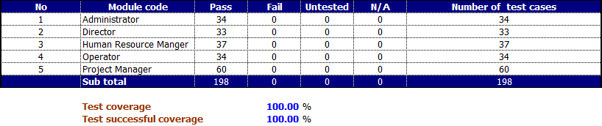

Software User Manual

## Installation Guide

## Introduction

This document contains guide-lines step by step to deploy Thanh Long System to Google Apps Engine.

This document assumes that an Eclipse IDE 3.5 and Java Development Kit 1.6 (jdk\_1.6.0\_20) have been setup properly.

## Application installation

### Setup Google plugin for Eclipse 3.5 (Gailileo)

Please follow these steps to setup Google plugin for Eclipse 3.5:

**Step 1:**

Start Eclipse, then select **Help > Install New Software...** In the dialog that appears, enter the update site URL into the **Work with** text box: <http://dl.google.com/eclipse/plugin/3.5>

Click on the **Add...** button.

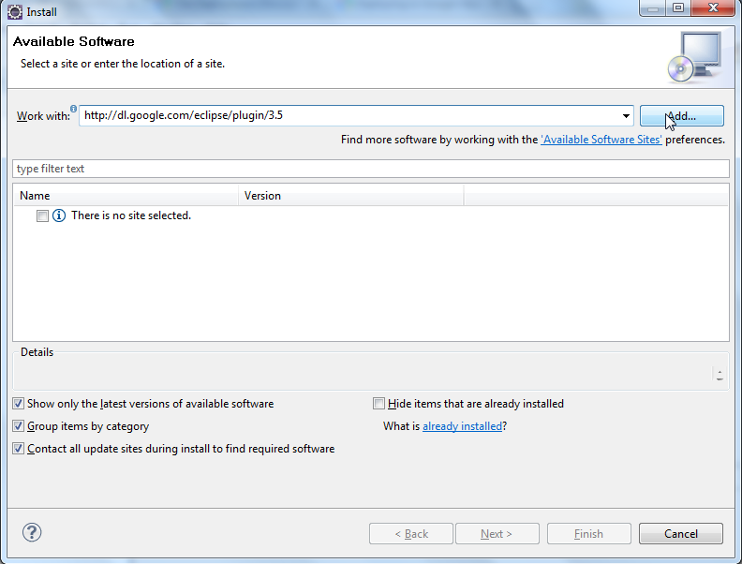

**Step 2:**

Leave the **Name** text box empty (the name will be retrieved from the update site). Click **OK**.

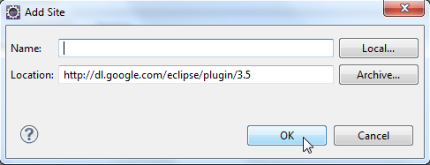

**Step 3:**

Back in the **Install** dialog, you should see the center box filled with **Plugin** and **SDKs**. Select the checkbox next to both of these. This will install the plugin, a Google App Engine Java SDK and a Google Web Toolkit SDK. Click **Next**.

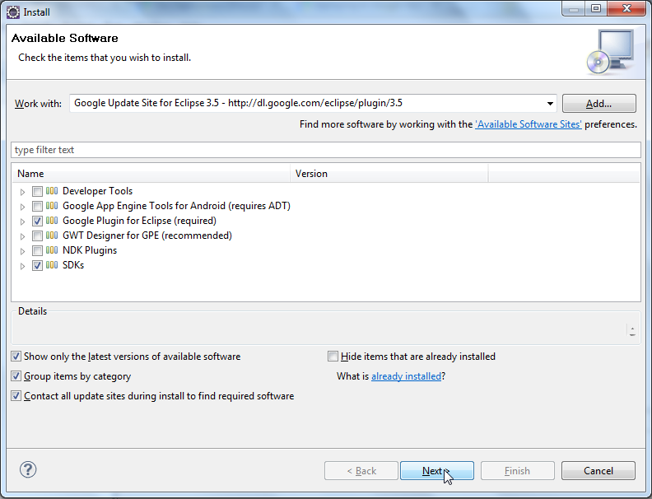

**Step 4:**

Review the features that you are about to install. Click **Finish**.

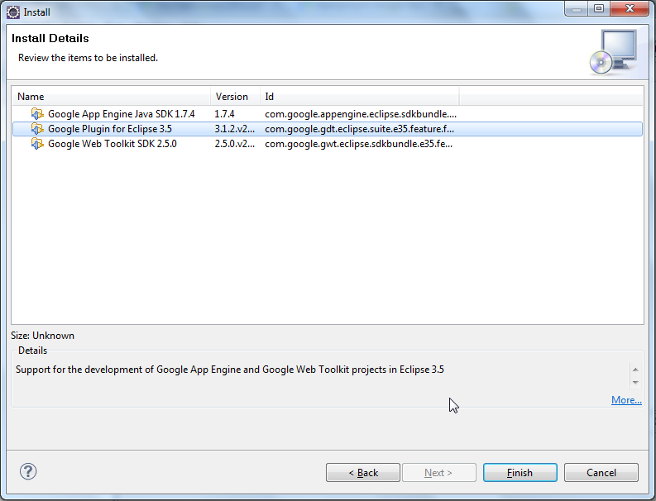

**Step 5:**

You will then be asked be asked if you would like to restart Eclipse. Click **Yes**.

**Step 6:**

Now you are ready to build Google Web Toolkit and App Engine applications!

### Deploy website

Please follow these steps to deploy website to Google app engine!

**Step 1:**

Go to <https://appengine.google.com/start/createapp> then create new an application.

+ Application Identifier:  is tied to the URL you will access the application with online.

+ Application Title:Displayed when users access your application.

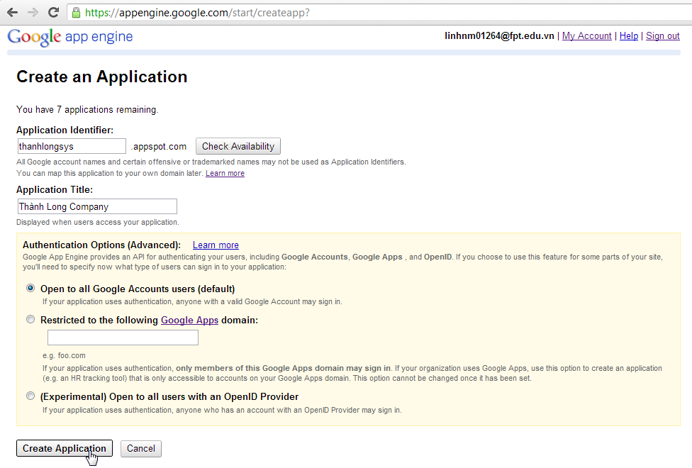

**Step 2:**

Edit the appengine-web.xml file, and then change the value of the <application> element to be your registered application ID (application identifier in step 1) and change the value of the <version> element to be your project version.

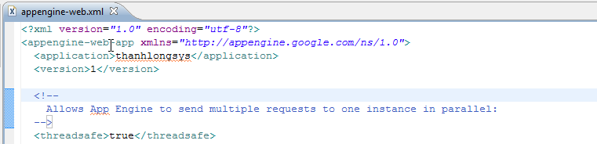

**Step 3:**

Start Eclipse; select the TLS project in the Package Explorer view. In the toolbar, click the Deploy App Engine Project button.

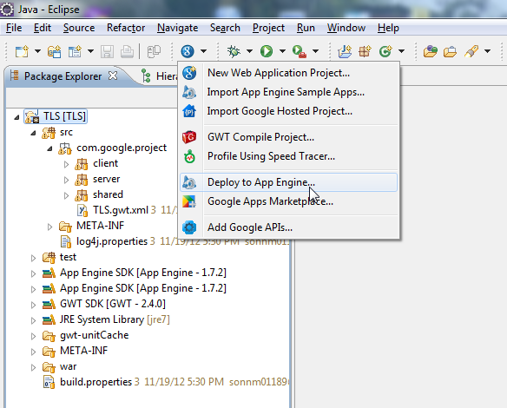

**Step 4:**

Enter your Google Accounts email and password.

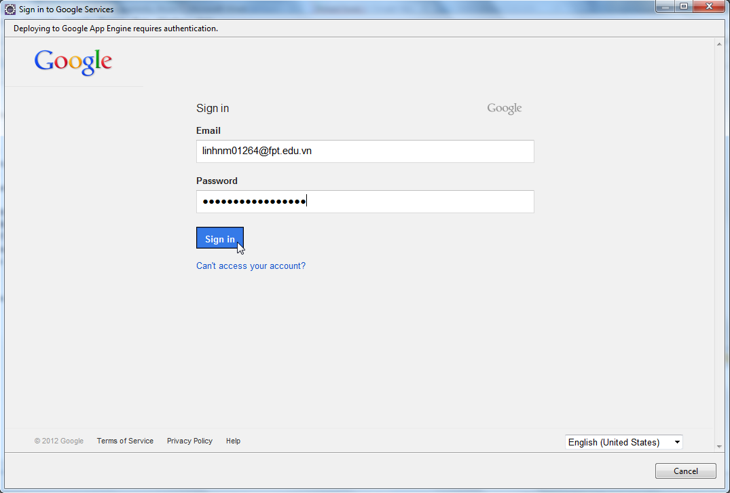

**Step 5:** Click Deploy.

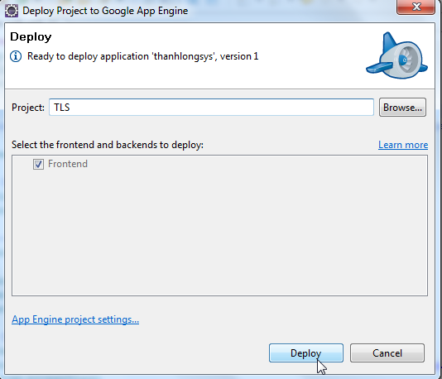

## User Guide

This user's manual has been developed to help users better understand the requirements that may apply to business by providing them simple step-by-step tutorials. This manual is intended to help make application’s functions more accessible and their associated requirements more understandable to users.

## General guide

### Login

In Login page, enter your email and password and click “Đăng nhập” button to log into our system.

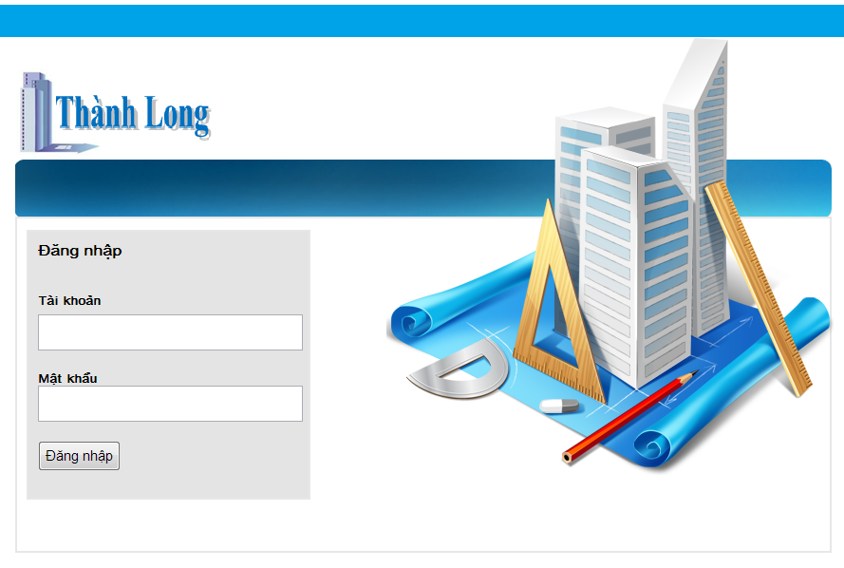

### Message Management

Click “Danh mục tin nhắn” in the left menu.

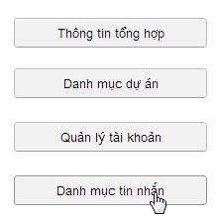

The list view of message will be displayed

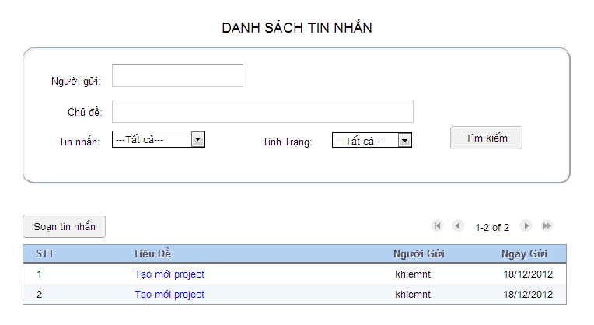

You can filter list of message by sender, subject, inbox, outbox and status.

Click hyperlink in “Tiêu đề” column to read message. In “Chi tiết tin nhắn” page. You can enter content to text area and click “Gửi phản hồi” button to response this message.

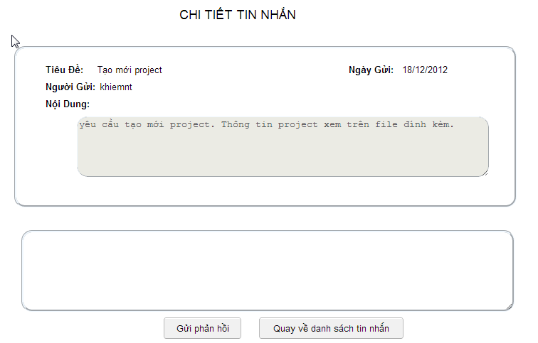

Click “Soạn tin nhắn” button to create new message.

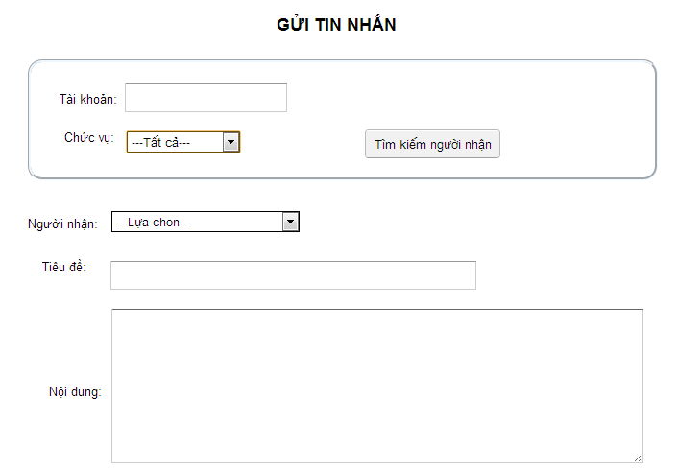

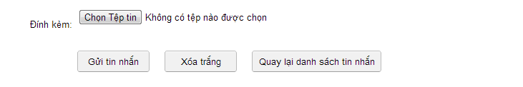

Click “Tìm kiếm người nhận” to find receiver. You can find by account name or role of recerver.

Select receiver in “Người nhận” combobox, enter subject and message’s content then click “Gửi tin nhắn” button to send messesage.

Click “Quay lại danh sách tin nhắn” button to back to View list of message page.

Click “Xóa trắng” button to delete all entered information.

### Change password

Click “Đổi mật khẩu” hyperlink in the left menu.

Change password dialog panel will be displayed. Enter “Mật khẩu hiện tại”, “Mật khẩu mới”, “Gõ lại mật khẩu”, then click “Xác nhận” button to change password.

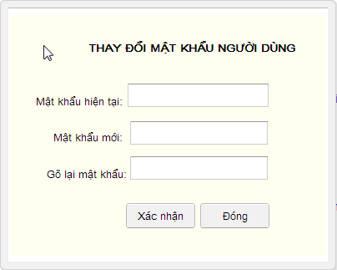

## Administrator guide

### Admin home page

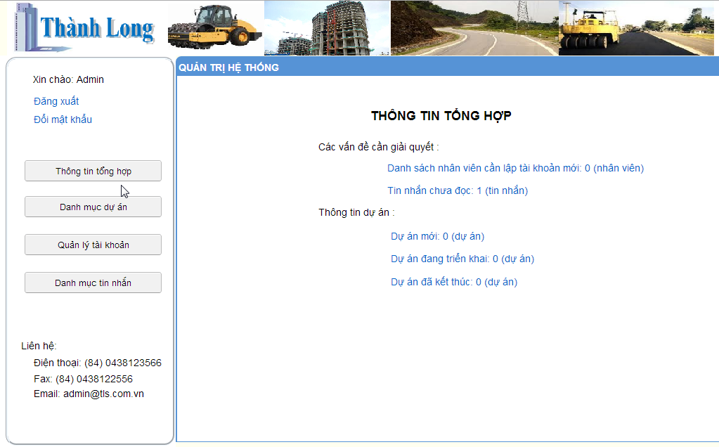Login with admin account, admin home page will be displayed.

### Project space management

Click “Danh mục dự án” in the left menu, the list of project space view will be displayed.

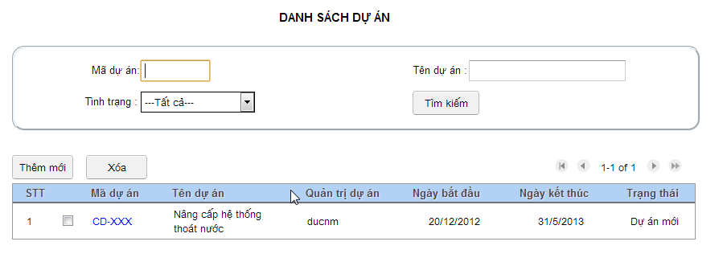

Click “Thêm mới” button to create new project space.

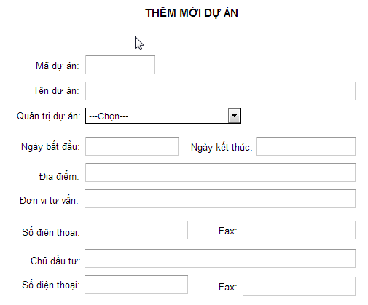

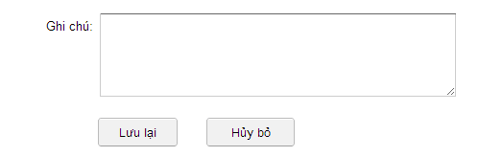

You can filter list project by project code, project name, or project status.

Select the check box and then click “Xóa” button to delete project space.

Click hyperlink in “Mã dự án” column to edit project information.

### Account management

Click “Quản lý tài khoản” in the left menu, the list of account view will be displayed.

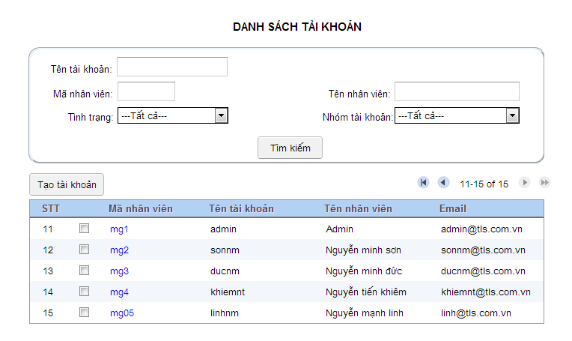

Select staff by checked the checkbox, then click “Tạo tài khoản” button to create new account. 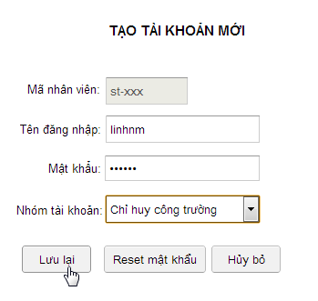

You can search account follow account name, staff code, staff name, user status or user group.

Click hyperlink in “Mã nhân viên” column to edit account of this staff.

## Project manager guide

### Project manager home page

Login with project manager account, project manager home page will be displayed.

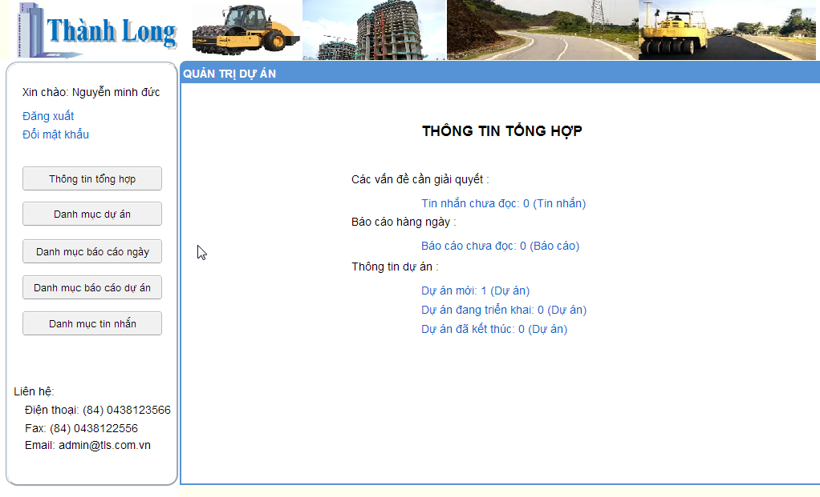

### Project management

Click “Danh mục dự án” button in the left menu, list of project view will be displayed

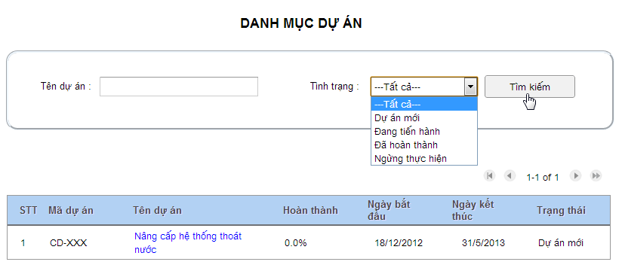

You can search project by project name or project status.

Click hyperlink in “Tên dự án” column to access to project work space.

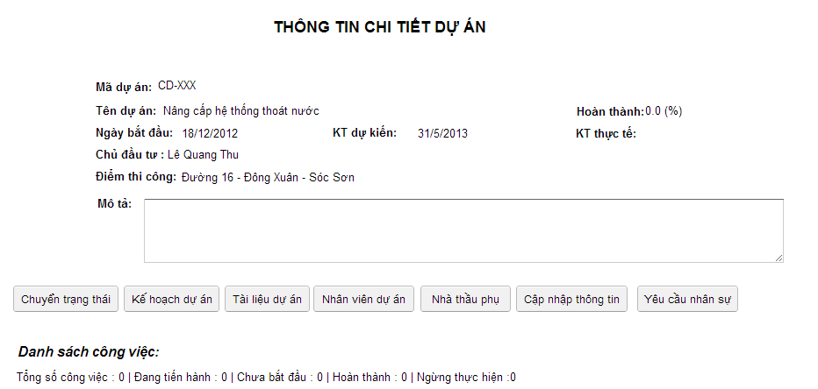

When project need change status, click “Chuyển trạng thái” button to change status for project. You can change to “Đã hoàn thành” or “Ngừng thực hiện”.

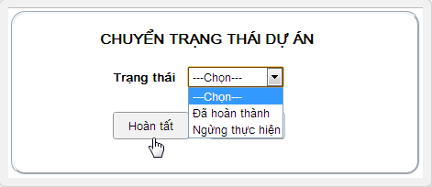

Click “Kế hoạch dự án” button, Project Plan View will be displayed. To view list of task, click “Danh sách công việc” button, click “Giao việc” button to assign task to staff and click “Xem biểu đồ” button to view project plan over gantt chart.

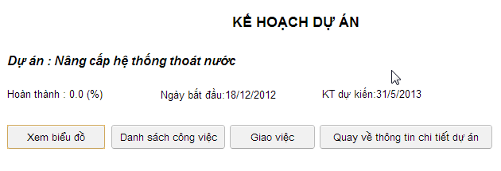

Click “Tài liệu dự án” to view list all files and documents related to project. In this page, you can upload new file, delete or download files.

Click “Thêm mới” button to upload new file.

Check the checkbox, the click “Xóa” button to delete the selected file.

To download this file, click the hyperlink in “Tên tài liệu” column.

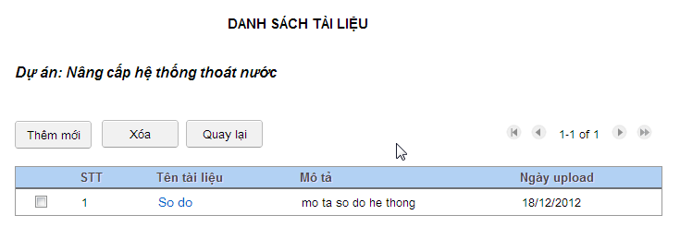

Click “Nhân viên dự án” button to view list staff join to project. 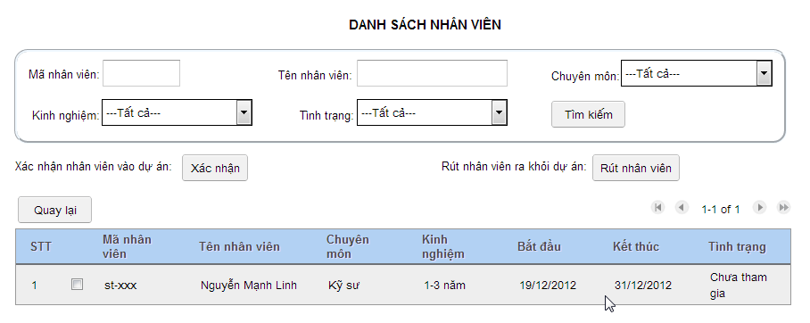

Click “Nhà thầu phụ” to view list of subcontractors. In this page, you can update, create new, or delete a subcontractor.

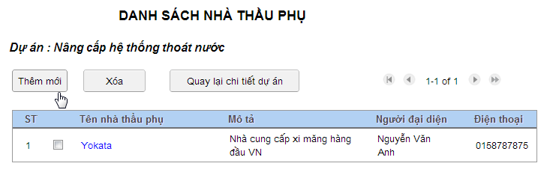

From Project Plan View, click “Xem biểu đồ” button to view project plan over gantt chart.

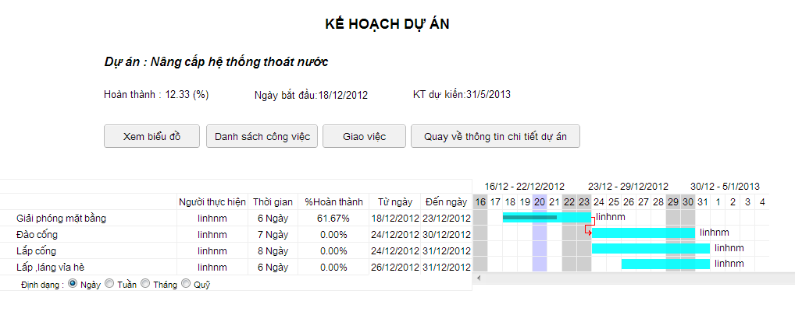Click “Danh sách công việc” button to view list of project task. Then you can select to view task details. In task details view, click “Yêu cầu nhân sự” button to request human resource for selected task.

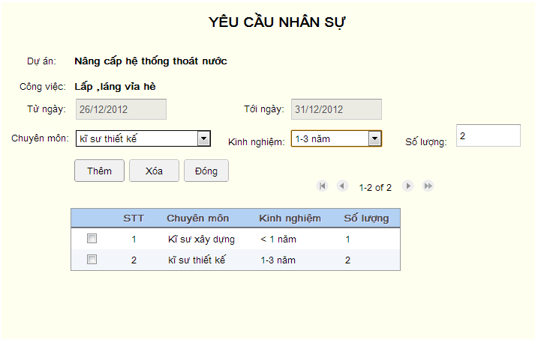

To send request human resource to director, click “Yêu cầu nhân sự” button and then click “Chuyển lên giám đốc” button.

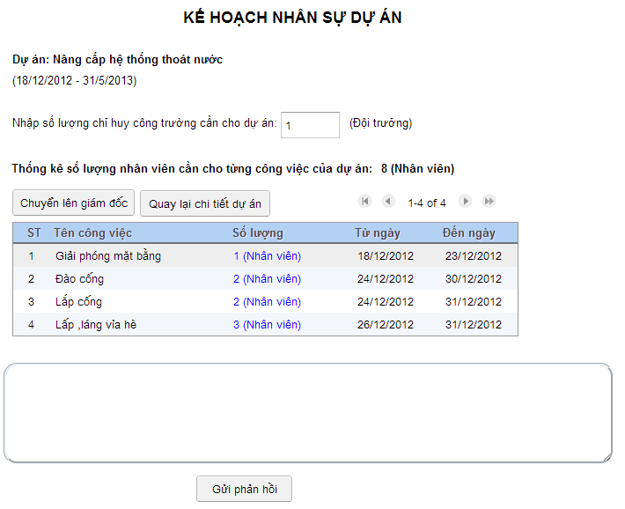

You click to “Gán việc” button to assign task for operator

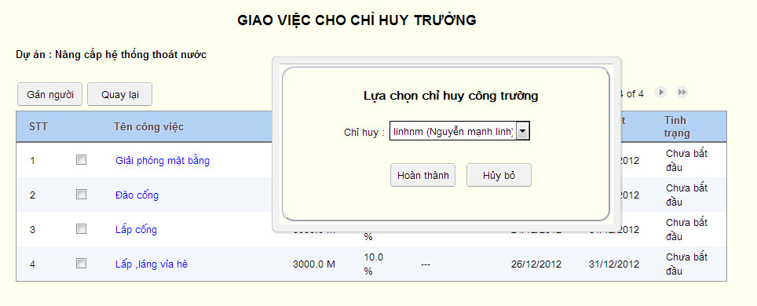

### Project report management

Click “Danh mục báo cáo dự án” in the left menu to view list of project report.

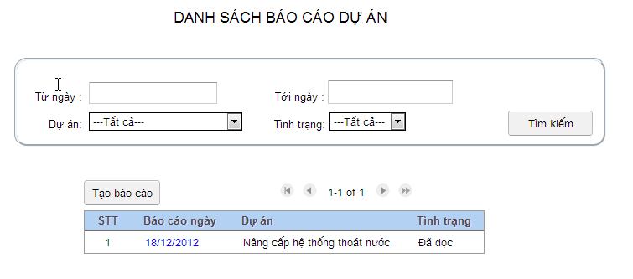

Click “Tạo báo cáo” and then select project to report.

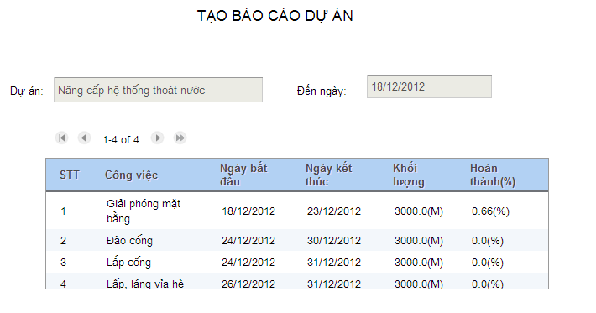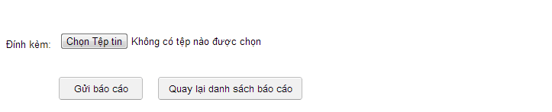

### Daily report management

Click “Danh mục báo cáo ngày” in the left menu to view list of daily report.

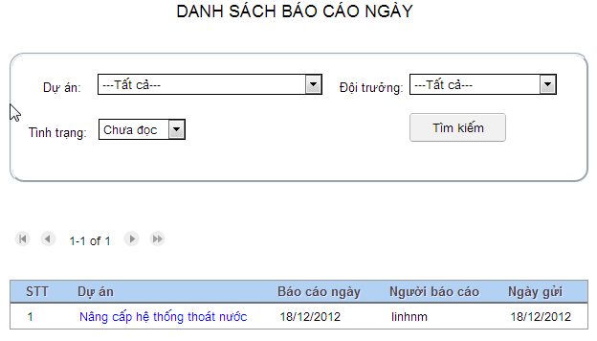

Click the hyperlink to read daily report details.

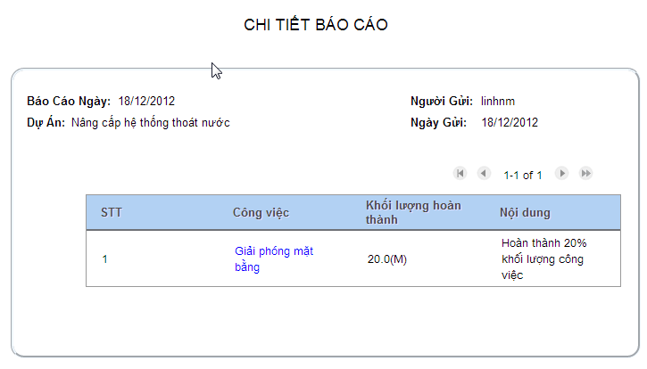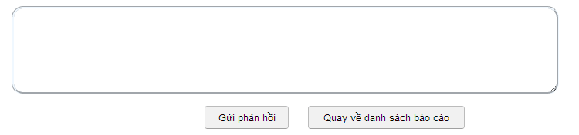

You can enter contents to text area and click “Gửi phản hồi” button to response this report to operator.

## Director guide

### Director home page

Login with director account, director home page will be displayed

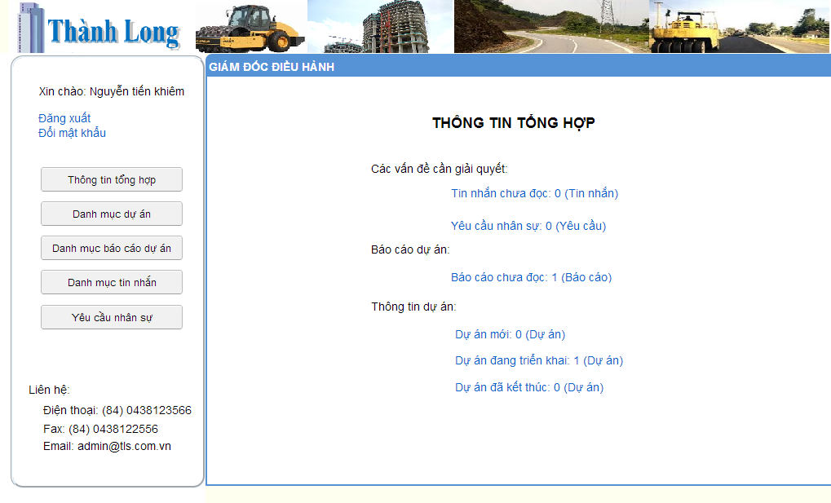

### Project management

Click “Danh mục dự án” button in the left menu to view list of project.

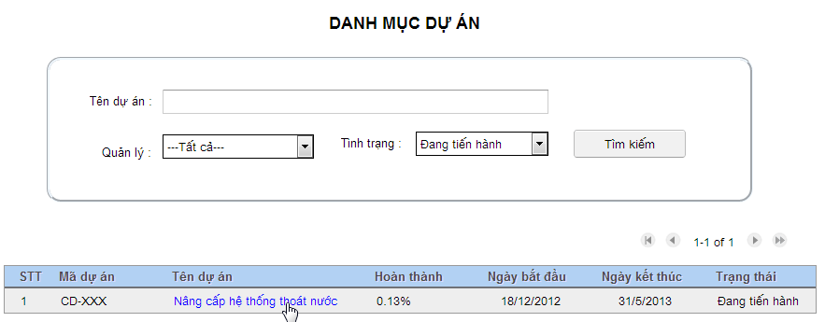

You can filter by project name or project status when you want to search project.

Click hyperlink project name to view and manage project’s progress.

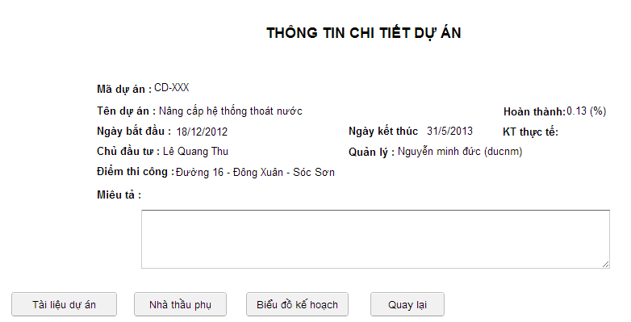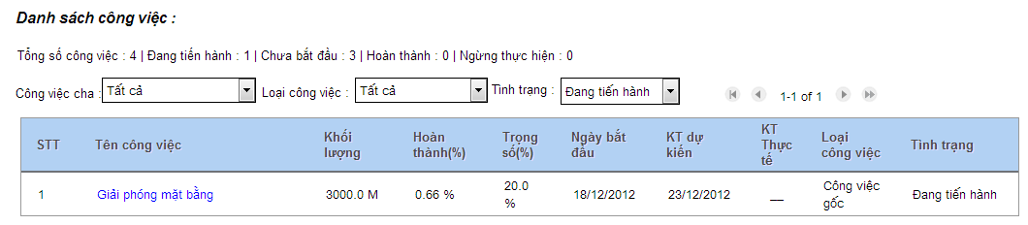

In this page, you can see list of project task and progress of each task. In addition, you can view more details about project information.

To view list of file and document realated to project and download them, click “Tài liệu dự án” button.

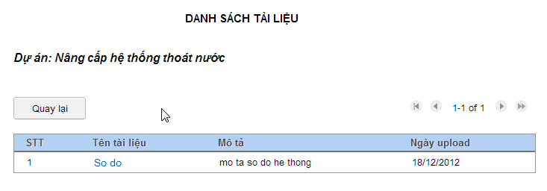

To view list of subcontractors, click “Nhà thầu phụ” button.

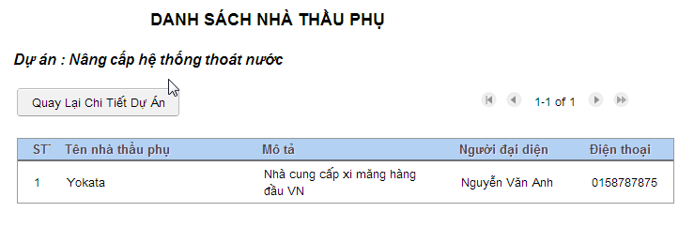

To view project plan, click “Biểu đồ kế hoạch” button.

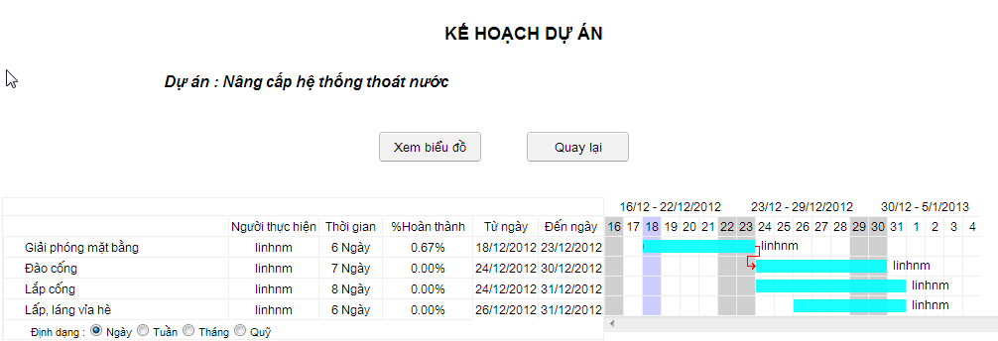

### Project report management

Click “Danh mục báo cáo dự án” button to view list of project report.

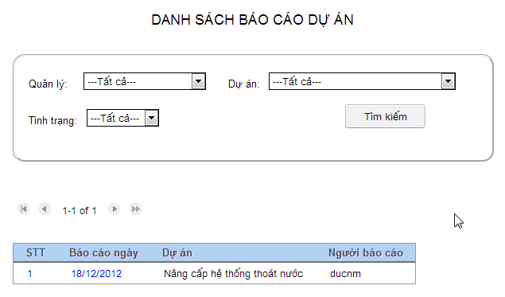

Click hyperlink to view report details. In this page, you also can response to project manager about this report.

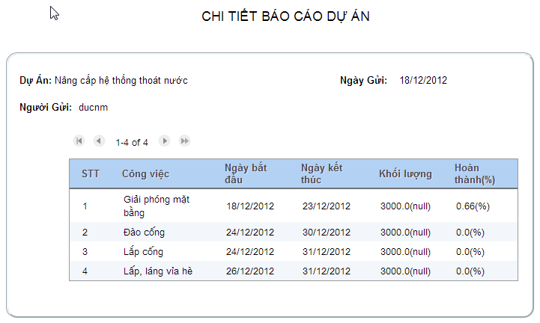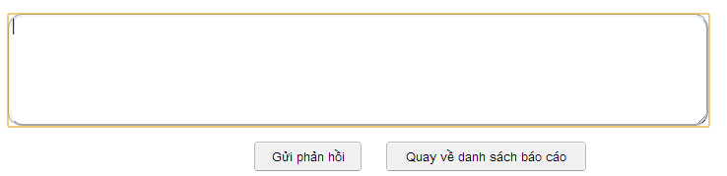

### Human resource request management

Click “Yêu cầu nhân sự” button in the left menu, the human resource request view will be displayed. In this page, director can approve or unapprove the request. You also can response to project manager. When you approve this request, it will be assigned to human resource manager.

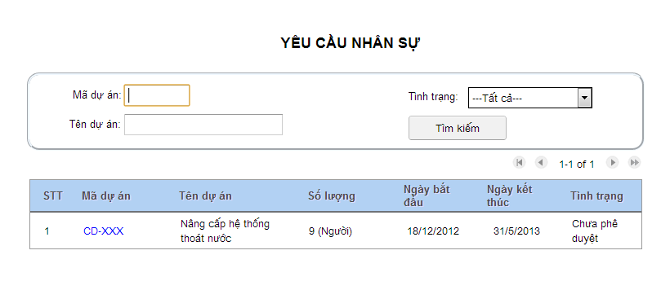

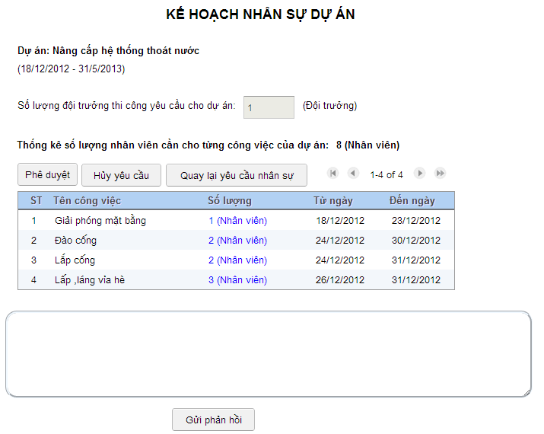

## Operator guide

### Operator home page

Login with operator account, operator home page will be displayed

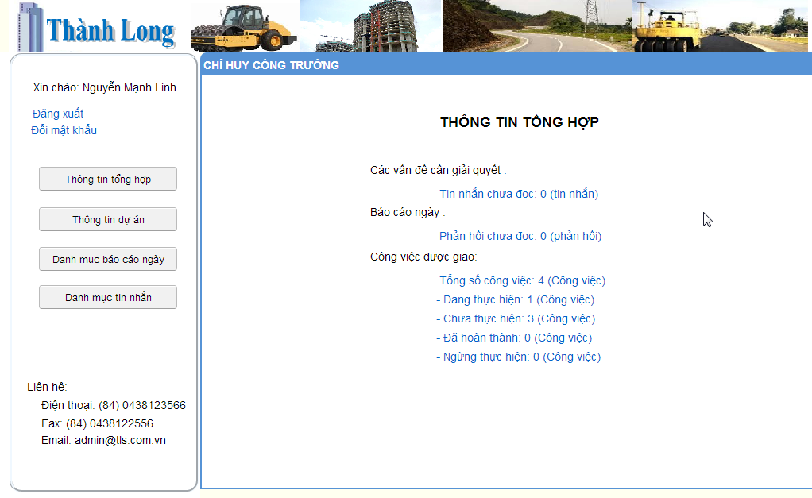

### Task management

Click “Thông tin dự án” button to view project information and task that assigned to operator. 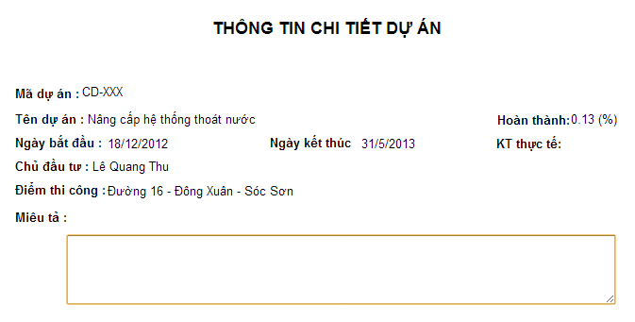

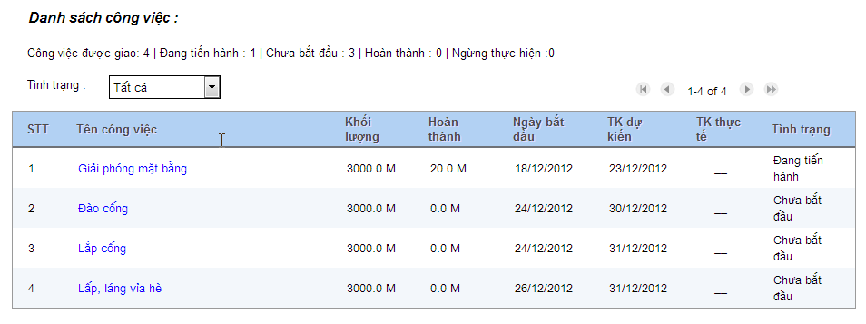

To view progress of each task, click hyperlink to view task details. Then you select from date and to date to view line chart.

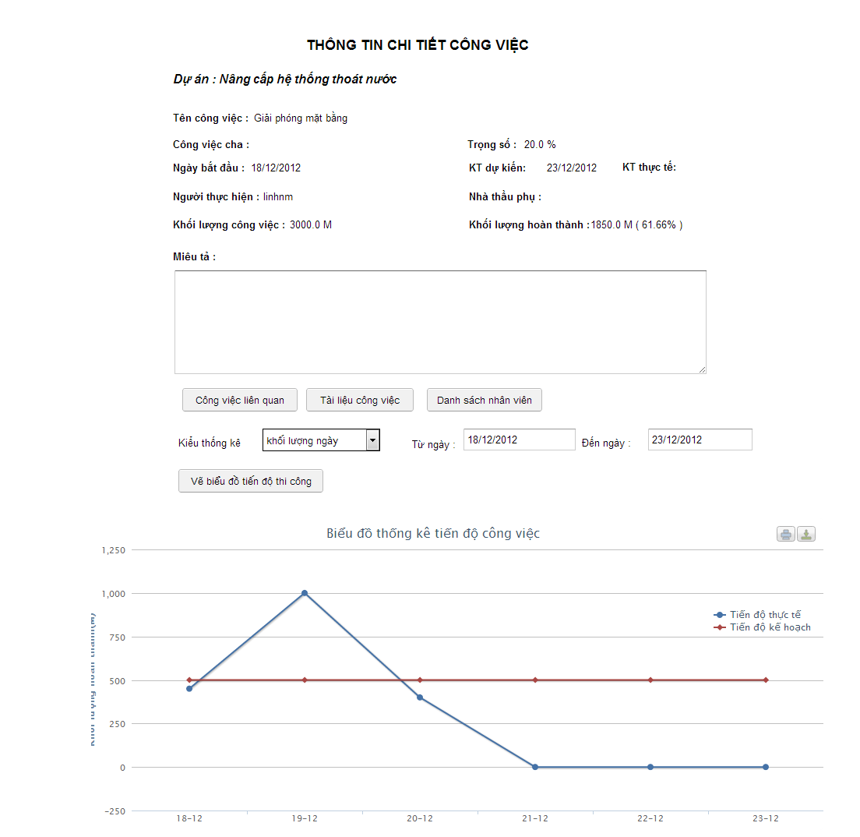

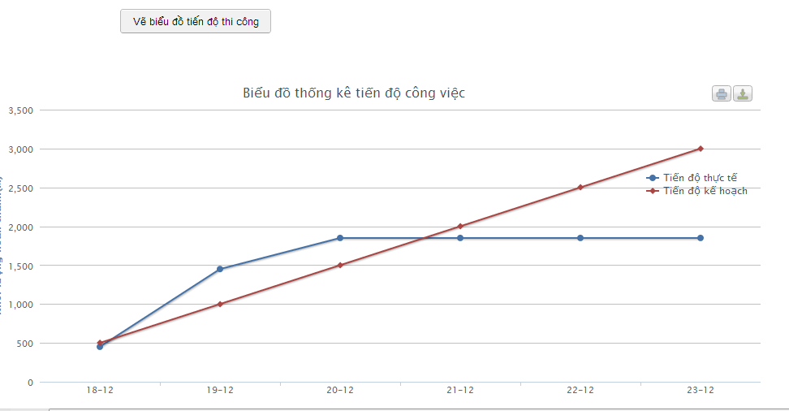

### Create daily report

Click “Danh mục tin nhắn” button in the left menu. Then click “Tạo báo cáo ngày” button in the list of daily report page.

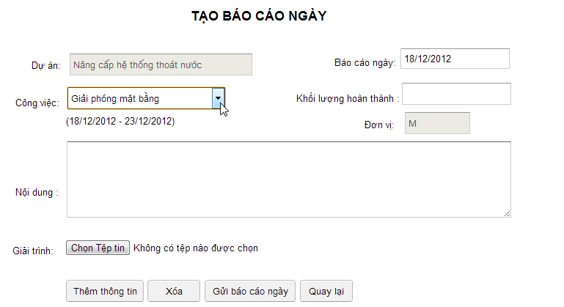

In this page, you can report for each task that assigned for you. Select task name in “Công việc” combo-box, enter “Khối lượng hoàn thành” and “Nội dung”. You also can attach file related to the report.

Then, click “Thêm thông tin” to save report for selected task and continue report for other task.

Click “Gửi báo cáo ngày” when you want to send this report to project manager.

## Human resource manager guide

### Human resource manager home page

Login with human resource manager account, the Human resource manager home page will be displayed.

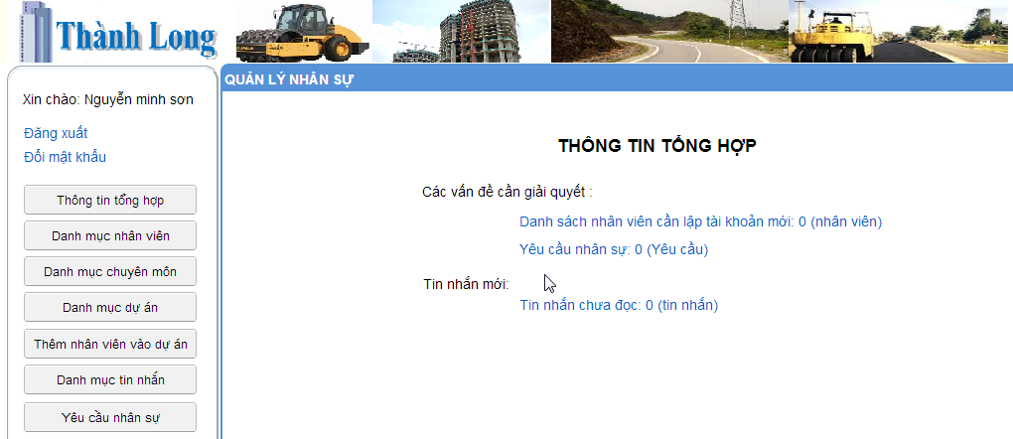

### Staff management

Click “Danh mục nhân viên” button to view list of staff.

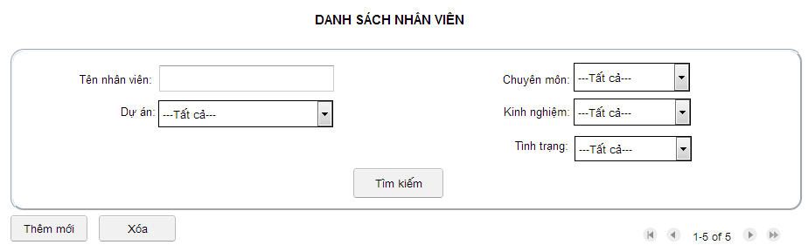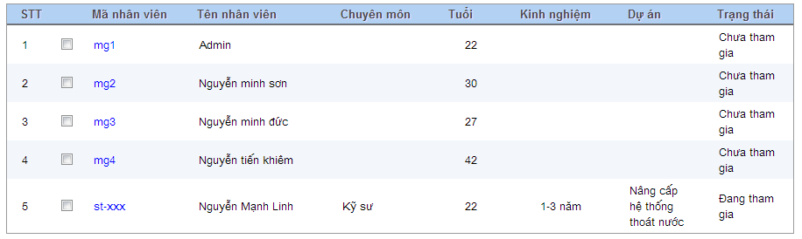

You can filter staff by name, project, status, technique, or experience.

To delete staff, select checkbox an then click “Xóa” button.

To update staff, click hyperlink user code.

Click “Thêm mới” button to create new staff.

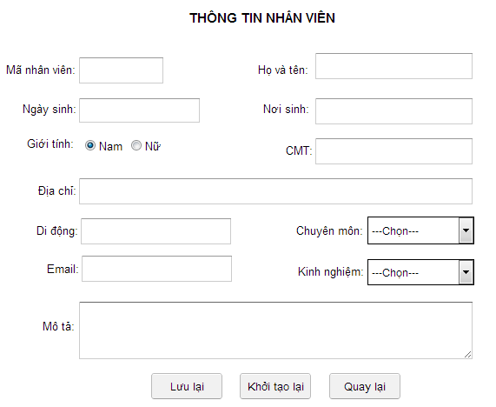

### Human resource management

Click “Yêu cầu nhân sự” button in the left menu, the list of request will be displayed.

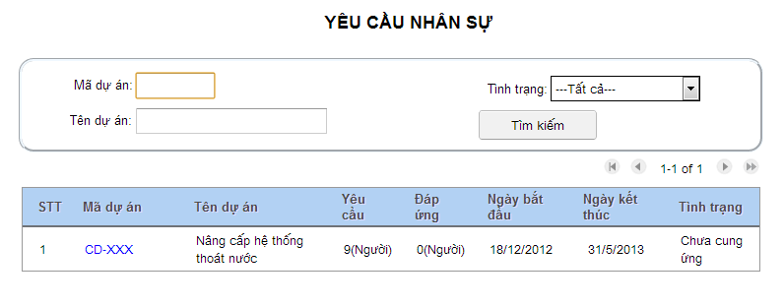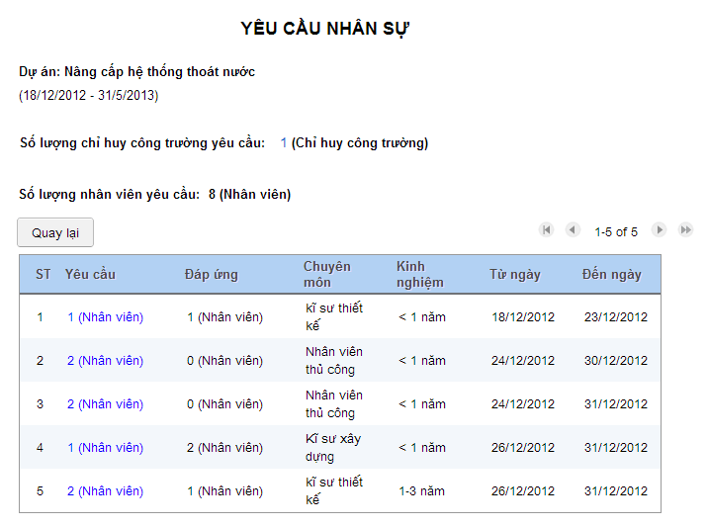

Click hyperlink in the “Yêu cầu” column to add human resource to project.

### Add human resource to project

To add human resource to project, click “Thêm nhân viên vào dự án” button in the left menu.

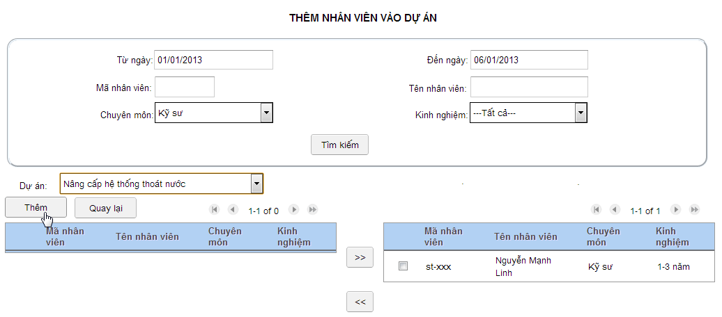

You can search staff who availble in period of time, you also can filter by technique, or experience to find staff suitable with task requirements.

Then, you select project name to add selected staff to project.

# Appendix

## Definitions and acronyms and abbreviation

|  |  |  |
| --- | --- | --- |
| Acronym | Definition | Note |
| SRS | Software requirement specification |  |
| TLS | Thanh Long System |  |
| MVP | Model – View – Presenter |  |
| GWT | Google web toolkits |  |
| GAE | Google apps engine |  |
| RPC | Remote procedure call |  |
| ORM | Object relation mapping |  |

## References

* + - “*Code Conventions for the Java Programming Language*”document by Sun

<http://www.oracle.com/technetwork/java/javase/documentation/codeconvtoc-136057.html>

* + - Schwalbe, Kathy Ph.D, PMP. *“Managing information technology projects”,* 6th ed., Cengage learning (2010), pp 422-451
    - “What is Microsoft Project?”

Available at: <http://en.wikipedia.org/wiki/Microsoft_Project>

* + - “SmartBuild“- Construction project management software

Available at: <http://smartbuild.harmonysoft.com.vn/>

* + - “Microsoft Project” - A [project management software](http://en.wikipedia.org/wiki/Project_management_software) program, developed by [Microsoft](http://en.wikipedia.org/wiki/Microsoft)

Available at: <http://www.microsoft.com/project/en-us/project-management.aspx>